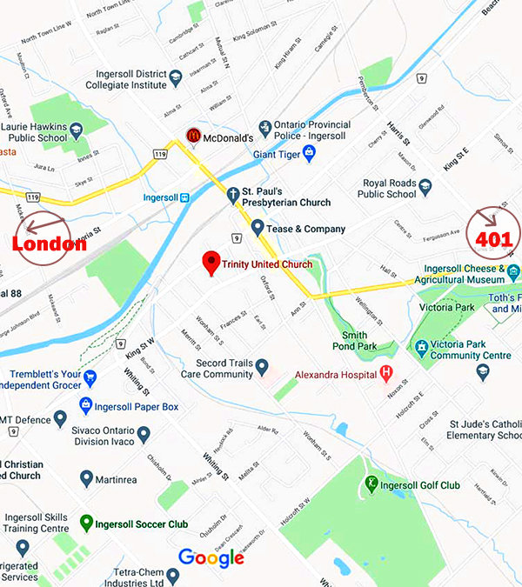

MOTELS IN INGERSOLL
Comfort Inn
20 Samnah Crescent, Ingersoll, Ontario
888-724-9250
Elm Hurst Inn
415 Harris St. Ingersoll, Ontario
888-724-9250

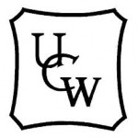
59th Annul Gathering of Antler River Watershed Regional Council
United Church Women

Saturday April 18^{th,} 2020
Hosted By: Oxford UCW

“Hands Across The Water”

Antler River Watershed Regional Council UCW President: Rev. S. Bendall

Devotion Speaker: Rev. Dr. Trapnell
Theme Speaker: Mr. Peter Wright

Location: Trinity United Church
118 Church St, Ingersoll, ON, N5C 2X6

Registration: Anne Hollis
275425 27th Line RR2 Thamesford, N0M 2M0
Email: annecoop2000@gmail.com
Phone #: 519-285-2232

Emergency Phone @ Trinity United Church
Office: 519-485-0820

FRAGRANCE FREE PLEASE!

Agenda Annual Gathering, April 18, 2020

8:45 Registration -- Oxford
Refreshments
9:15 Singing -- Anne/ Nancy
9:30 Welcome/Introduction
(Catholic women)
9:45 Acknowledgement ----Sharon
9:50 Recognize Past Presidents
9:55 Repeat UCW purpose
10:00 Break
10:15 Introduce Speaker -Lambton
10:15 Devotion/Offering/ Communion
--- Rev Margaret Trapnell
11:30 Thank Speaker --- Middlesex
11:35 Resource Centre -- Pat Gilmore
11:50 Grace --- Huron-Perth
11:50 Lunch
1:15 Singing
1:30 Women of Zambia Laurel Kenney
1:45 Business
Finances -- Linda Britton
Invitation to Summer Event
2:05 Speaker – Mr. Peter Wright
3:05 Thank the Speaker --- Essex
3:05- 3:15 Break
3:15- 3:45 Entertainment
3:45 Nominations Rev. Sandra B
Installation of Officers
Invitation by for 2021-- Middlesex
Grace - Supper

Grace-Supper
Devotion Speaker: Rev. Dr. Trapnell
The Rev. Dr. Margaret Trapnell was ordained in 1992 and has
served The United Church of Canada in pastoral charges in both Alberta and Ontario. She retired in 2016 making her home in Woodstock, a place that was closer to her family and friends. Margaret obtained her Doctor of Ministry degree in 2004 from St. Stephen's College in Edmonton, Alberta with a work of art project entitled "The Spirituality of an Iconographer: An Encounter with Mary." In retirement she has been able to concentrate on her artistic abilities, working in coloured pencil with animals being her main subject matter. Margaret is also an associate with the Sisterhood of St. John the Divine, an Anglican religious order whose mother house is in Toronto.

Theme Speaker: Mr. Peter Wright
Born in London, England, Peter Wright moved to Rhodesia as a young boy. He spent his teenage and early adult years living under sanctions and served 10 years as a part time soldier during the terrorist war. He lived for 14 years in South Africa before returning to Zimbabwe, as Rhodesia had become known. After losing his farm and being imprisoned during the illegal farm invasions in 2002, he moved to Canada. Peter is a survivor of extreme adversity, a former corporate marketing manager, business owner, ultra marathon runner, and farmer in Africa. He is now a horse owner, blogger and speaker as well as a heart attack survivor. Peter and his partner Sue have 4 children, and 12 grandchildren spread over 3 countries on 3 continents.

