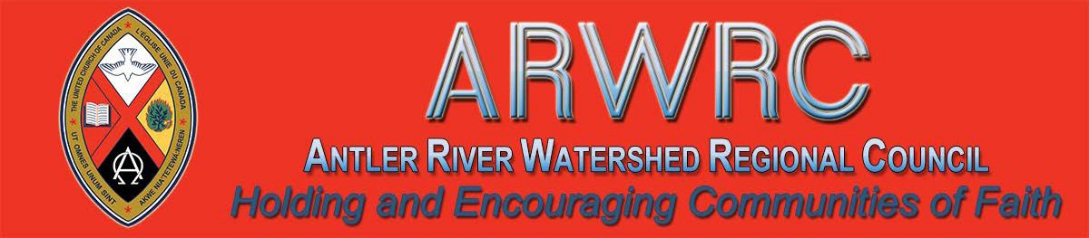
Subscribe |  | Past Issues |  | Translate |  | RSS
 | View this email in your browser

Antler River Watershed Regional Council Website https://arwrcucc.ca/

Antler River Watershed Regional Council's website is live. Check out the many tools and resources that you will find here. Content is being added regularly so be sure to check back often. Some of the current features are:

Staff Directory
Pastoral Relations Toolkits
Congregational Support Toolkits
Minutes of Transition Council and Executive
Find a Community of Faith

Stewardship Resources

https://arwrcucc.ca/

Advent Unwrapped
New Resources

Get ready for Christ(mas)! Advent—the holy, four-week countdown to Jesus’ birthday—which began on Sunday, December 1! Get ready to make room for Christ and the radical, countercultural messages that Christ brings.
United Church Video Licenses Now Available - Apply NOW Deadline: December 31st

EDGE is pleased to offer Public Performance Video Licenses at great cost savings for your community of faith!
They enable your church to show full- length or clips from movies or TV shows as a part of worship, fundraisers, family nights, youth group events or educational programs. Showing films without a public performance license is a breach of
Canadian Copyright Laws.

Throughout the season, videos, prayers, family resources, and reflections on this page will introduce and explore the Christmas story. For more worship resources visit our Advent and Christmas worship pages. Follow our Advent Unwrapped Facebook page for regular updates on all kinds of resources.

Christmas Beer & Hymns
Monday, December 16
7 - 9 pm in Kitchener

Skylight Festival, a festival of Faith, Arts and Justice, supported by the UCC EDGE Network, is hosting its first-ever event outside of festival weekend - Christmas Beer 'n Hymns in Kitchener.

We have negotiated video licensing agreements with Criterion Pictures and Audio Ciné Films (ACF) Inc. who represent most of the major distributors including Paramount, Universal, Alliance Atlantis, New Line Cinema, Miramax, Disney, Veggie Tales and many more!

Visit: http://buyingunited.net/video - licensing for all the information. Application deadline for a 2020 license is December 31, 2019. Email or call Alexandra at 1-800-268-3781 x4157.

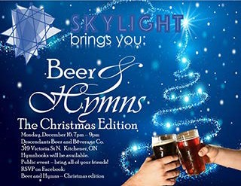Do you want to be on the
Pulpit Supply List?

We are looking for ministry personnel
who are willing to be available to do pulpit supply in our regions. Licensed Lay Worship Leaders (LLWLs) do much pulpit supply and that list is often sent out.

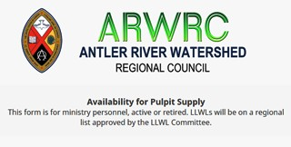Click to download the full-size
poster!

Come on out to 319 Victoria Street N. in Kitchener. Hymnbooks will be there! Bring your friends. RSVP on Facebook.

Worshiplude in Ottawa!!! January 31 - February 3

Click to go to the registration form.

Skate on the Rideau Canal, ride ice slides, see amazing ice sculptures and more, as part of Ottawa's Winterlude.

Contemporary worship, dinner and the Alt Space Event with other youth and young adults. For more information email Dana Ducette.

Go directly to the registration form.
Click on the photo to go to the form. Right now we are gathering the names of
ministry personnel who are interested in being on a list for supply. Look under
'Pastoral Relations Toolkits' on the Antler River Watershed website. We look forward to hearing from you!

Christmas SWELL
Friday, January 3 @ 7:00 pm

A worship service for high school-aged youth. A comfortable space for youth to worship - open to all denominations. Using elements from contemporary culture, including popular music
& videos to springboard into exploring scriptures and our rich United Church theology.

Designed to challenge cultural norms, provoke critical thinking & deepen the faith of teens. Parents / youth group leaders are encouraged to debrief with

their teens and young adults post-Swell.

Centre for Christian Studies
Common Threads

Cookies and Carols 2019
If you're in the Winnipeg area on December 10th, why not join us from 4-6 pm for festive singing and holiday treats ?

Companion of the Centre 2020
The Centre for Christian Studies is pleased to announce that the 2020 recipient of the Companion of the Centre Award is ...

Spiritual Practice 2019
Students spent a week exploring spiritual practice as a tool for pastoral care. Check out some images.

A Room Full of Mentors
Regional gatherings of diaconal ministers provide an opportunity for students to make connections and form identity.

What I Learned at CCS and Why Our
News Reading Habits Matter
Ray McGinnis uses the critical analysis skills he gained at CCS to take a closer look at news from Bolivia.

Sharing Our Stories, Claiming
Our Names: Kim Uyede-Kai

Kim Uyede-Kai writes from the Asian Ecumenical Women’s Assembly, a “herstorical” assembly where women could hear one another’s stories be given voice, some for the first time.
Find out more: theSwell.ca

Curriculum Worship: January 25

Confirmation PLUS!: February 21

Discoverment for YATS: February 21

A Time to Prepare for . . . Annual Meetings!

1. Extension of Voting Rights to
Adherents
A community of faith may now extend voting rights to adherents on any matter. To be able to do this, the congregation must first identify who are adherents. This information is often kept informally in a congregation. Prior to the Annual
Meeting, the governing body should recognize the names of adherents in order to be able to extend voting rights to them.

2. Budget 2020
Attendance at Regional Council Meetings Please remember to include a line to cover the cost for ministry personnel and lay representatives to attend the regional council meetings. Two meetings are planned for 2020:
May 29-31 in Port Elgin
Fall 2020 in the regional council

Assessment: An assessment update will be issued by the General Council in December.
Any community of faith that moved to the target assessment will have learned their
2020 assessment figure as the final step of submitting their 2018 statistics online.

Any community of faith that opted for the

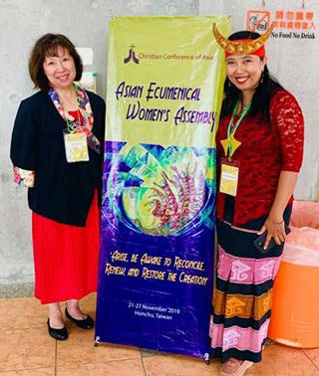

Kim starts her (first-ever) blog with a question she was asked often, "What country are you from? Indonesia? Korea? Taiwan?” “No, Canada.” “But your face looks like…!”

Read the rest of the blog ...

Meet Joan Tuchlinsky
Minister, Social Justice

10% maximum increase in assessment will have the same assessment fee in
2020. In this case, the congregation might want to consider gradually increasing their assessment over the next two years so that the end of the grace period does not bring a significant increase over the previous year.

3. Nominating Committee
Ministry personnel do not serve as part of the Nominating Committee. Please
ensure your community of faith elects its regional council representatives. There is a minimum of one representative per congregation.

Additional representatives are elected on the following basis:

Two representatives from each community of faith with 101 to 200 members;
Three representatives from each with 201 to 300 members;
Four representatives from each with more than 300 resident members

Manual (2019) Section C 1.1.2 a)

jtuchlinsky@united-church.ca

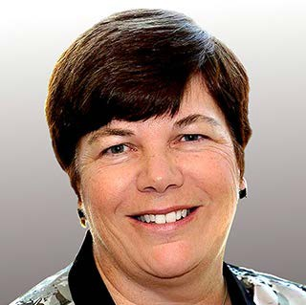"So good to meet everyone at our recent
Region Council meeting! Thank you for
4. Board of Trustees
It is helpful for the community of faith to confirm the membership of their Board of Trustees at the Annual Meeting. Please remember there is no criteria for being an "Honorary Trustee"; if a long-time Trustee has retired and the community of faith wishes to acknowledge the important role they played, please call them a "Trustee Emeritus." This avoids any confusion under the law.

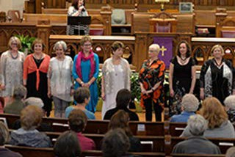
the warm welcome and your commitment
to sharing our gender-specific and
gender-neutral pronouns (download & The UCW Executive Meets
share) at the meeting. As we continue to Richards Memorial, London
do this in other gatherings and places we Monday, January 20, 9:30 am
are creating a welcoming and safe space for everyone.

If you want any support in working on a social justice issue with other communities of faith in your area, please feel free to contact me at jtuchlinsky@united-church.ca."
Holding and Encouraging Communities of Faith

Antler River Watershed Regional Council
The United Church of Canada
Sign up for our newsletters.

Copyright © 2019 Antler River Watershed Regional Council, UCC, All rights reserved.

Want to change how you receive these emails?
You can update your preferences or unsubscribe from this list.

