Subscribe Past Issues
Translate
RSS

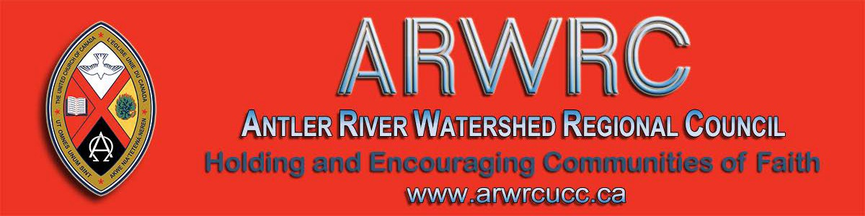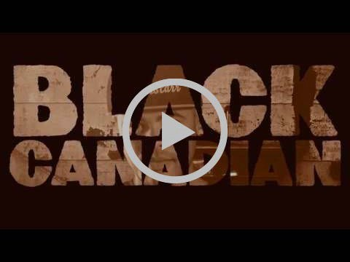

View this email in your browser

Next Deadline for submissions: February 14
Sign up for our newsletter & forward this one to friends.

BLACK HISTORY MONTH

This year is the mid-point of the
International Decade for People of African Descent

Black Canadian by Rapper D. O. Gibson
Black History Month
United Church Worship, Prayers, Resources & more
Canadian Council of Churches: Info Sheet & Resources

“During the 19th Century, thousands of slaves escaped to freedom through a secret network known as the Underground Railroad. It is believed that, along the way, spiritual songs were used as secret coded messages to escaping slaves. ‘Wade in the Water’ warned them to flee dry land for the water so that the dogs and owners
chasing them couldn’t track their scent.”

United Church Responds to the Coronavirus

Please pray for the sick and those who have lost their lives, as well as the families, caregivers, medical responders, and communities affected by this outbreak around the world.
Do you want to be on the
Pulpit Supply List?

We are looking for ministry personnel
who are willing to be available to do pulpit supply in our regions. Licensed Lay Worship Leaders (LLWLs) do much pulpit supply and that list is often sent out.

Click on the photo to go to the form.

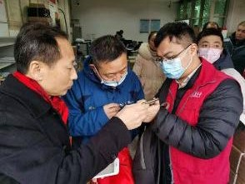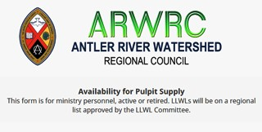

United Church Mission & Service partner, the Amity Foundation, has requested emergency medical supplies for use by
Right now we are gathering the names of ministry personnel who are interested in being on a list for supply. Look under
'Pastoral Relations Toolkits' on the Antler
River Watershed website. We look

medical first responders and communities in Wuhan. The United Church is collaborating with the American Baptist International Ministries, which is coordinating the provision of these supplies to address the crisis.

Find out more ...

Have a Heart Day
A Sunday between January 26 to February 9

A project of the First Nations Child and Family Caring Society. Led by Dr. Cindy Blackstock, the Caring Society educates about and advocates for the rights of Indigenous kids across Canada.

We hope non-Indigenous kids can learn about the different experiences of kids in Canada and take action out of a sense of compassion. We also hope Indigenous kids can speak from their hearts about what they want and need.

Download the Sunday School Activities.

The Knitting Pilgrim
Sunday, March 1 @ 3:00 pm
Thamesville United Church

forward to hearing from you!

Racial Justice Workshops
2020 Dates

For Indigenous, Racialized, Bi-racial
People: April 25
June 20
September 19
November 14

For White People:

February 1
May 2
June 27
September 26
November 21

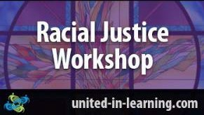

"The racial justice training is particularly commended to people serving in any leadership capacity within the church."
www.united-in-learning.com

Missional Leadership Diploma Atlantic School of Theology June 2020

Learn the keys to thriving ministry in the
21st Century. Starts in June - Apply now! Only 25 spots available. For more details on this leading edge program download this information sheet and/or contact Dr. Stephen Harper.

Kirk Dunn presents his one-man play, The Knitting Pilgrim, featuring the Stitched Glass tapestries. The large knitted panels, designed in the style of stained-glass windows, look at the commonalities and conflicts of the Abrahamic Faiths – and took Kirk an incredible 15 years to knit! The play tells the story of Kirk’s artistic and spiritual journey working on this ambitious project about interfaith empathy.

For more information or for tickets email
Tracy or call 519-692-4156. You can
also download a bulletin notice or 11X17 poster.

Licensed Lay Worship Committee Needs Members - Maybe YOU!

The Human Resources Commission is looking for individuals to be part of our Licensed Lay Worship Committee. This committee will oversee Licensed Lay Worship Leaders (LLWL) in Antler River Watershed.

We are looking for Ministry Personnel from any stream, lay people who are not LLWL and LLWLs to be on this committee. This will be a one to three year term position with the option of a renewal for one term.

The primary responsibilities for this committee will be:

Interviewing potential LLWLs and

Discoverment for YATS
'What Will Frame You' February 21-23

Whether you are creating an Instagram profile, a resume, or a life in the Way of Jesus - the decisions we make about how we frame our experience have a lot of power to shape our future. What do we focus on? What do we crop out? What opportunities do we pursue? Which ones do we forego? Who do we listen to as we make those decisions?

What Will Frame You? for YATS is open to young adults from any and all denominations and is hosted at Pearce Williams (Fingal, Ontario). The event is sponsored and led by The Centre for Practical Theology, The Swell, Ecumenical Campus Ministry of the University of Guelph, and Western Ontario Waterways.

Come find out What Will Frame You!

Confirmation Retreat & Faith Refresher 'What Will Find You' February 21-23

Confirmation PLUS is designed to prepare United Church teens for confirmation but is open to any and all teens in grades 7-12 regardless of whether or not they are confirmed or ever intend to be.

Confirmation PLUS is open to Region 7,
8, 9 and beyond and is hosted at Pearce Williams (Fingal, Ontario). It is sponsored and led by The Centre for Practical Theology, The Swell, Ecumenical

recommending licensing to the Human Resources Commission. Interviewing and recommending current LLWLs for relicensing every
3 years.
Ensuring LLWLs have completed mandatory workshops and have a current Police Records Check. Ensuring the recognition of a newly licensed LLWL at a service of worship.
Providing ongoing support and guidance to LLWLs.

If being on this committee is something that interests you, please complete an Expression of Interest form (also found on the Antler River Watershed website).

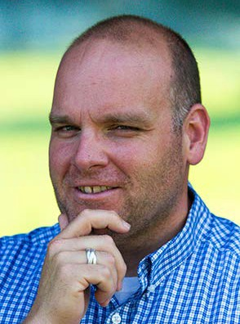Award Winning Joe

Congratulations to Joe Richards of Pearce-Williams Camp! He has been honoured with a Special Recognition Award by the Ontario Camping Association. Thanks for all you do to support camping ministry
Campus Ministry of the University of
Guelph and Western Ontario Waterways.

This retreat weekend playfully engages teens in the exploration of A New Creed, energetic worship, and lots of recreation, all lead by seasoned adult ministry personnel with decades of experience in youth ministry.

Adults/Ministers are encouraged to attend this event with their teens.

Come and find out What Will Find You!

Our Long and Winding Road Siloam United Church, London Saturday, April 4, 2:00 - 9:00 pm

Seeking our Path in the Longevity Revolution: Rabbi Richard F. Address, DMin is a leading authority on Boomer and Older Adult Ministry. He hosts the weekly radio show "Boomer Generation Radio" in Philadelphia and speaks regularly on issues related to baby boomers, aging and how Judaism can impact our lives as we age.

Download the poster and registration form. Contact Siloam United Church by email or phone at 519-455-9201.

Become a Youth Ministry Friend on Facebook

Follow Regions 7-
8-9 Youth Ministry Network on Facebook and always be in the know.

in the United Church!

SAVE-THE-DATES June 5 & 6 and September 24-26

Early Bird Rates until: March 31st!

reVITALize 4: Amazing guest speakers. Presented by the Centre for Practical Theology & The Middlesex Foundation June 5 & 6. Find out more! Download the poster.

Rekindling the Fire: Many guest speakers. Presented by the Centre for Practical Theology & The Middlesex Foundation September 24 to 26. Find out more! Download the poster.

Help Communities of Faith with
Mission/Justice/Faith Formation

Besides helping congregations with the mission, justice and faith formation, you will also help with resources, guidance and support to enable communities of faith to do the best ministry possible in their communities and the world.

The mandate includes working in right relations with Indigenous partners, supporting Affirming ministries with LGBTQ2SIA+ members, making safe space, open dialogue and strengthening relationships everywhere.

The Mission & Discipleship Commission could use your help. Read the letter and mandate from the Commission. Then apply through the Expression of Interest form. Hope to see you soon!

There is so much coming up, it's hard to stay on top of it! Here is a peek of what you'll find on Facebook:

What will Find You? Confirmation PLUS Retreat February 21-23 @ Pearce-Williams Camp
What will Frame You? Discoverment February 21-23 @ Pearce-Williams Camp
Interfaith Event for Young Adult Women. Feb 14-17 @ Five Oaks Show me the $. March 3-5 @ the Regional Office
Confirmation Event. April 3-5 @ Five Oaks
Easter/Good Friday Swell. April 10
@ Wesley Knox United Church Youth Rally. April 23-26 @ Pearce- Williams Camp

Rendez-Vous: Bold Faith. Brave
Space. Brazen Grace.

Rendez-vous, an M&S supported event, brings together youth (grade 9 and up to any age), young adults and their leaders from across the country (and beyond!) for a celebration of vibrant music, inspiring speakers, and dancing like there is no tomorrow.

Please Share this Newsletter

Please share this newsletter widely. It is especially helpful for people involved in leadership roles in your community of faith to know what upcoming events are planned that they might find helpful.

Invite people to subscribe for themselves by including the following with the announcements: Stay in touch with the wider church: subscribe to the regional council newsletter.

Liaison Training for Free! Almost ...

The Human Resources Commission is looking for people wanting to train as liaisons. Liaisons help support and equip congregations during search and in times of transition. If you are interested or if you would like more information please
contact Olav Kitchen or apply through the Expression of Interest form.

The Search Begins .....

After accepting current General
Secretary Nora Sanders’ notice that she will retire in September 2020, the Nominations Committee put out a call to the church for a search committee. Many nominations were received. Read the bios here.

Show Me the $$$ Regional Office, Hamilton Tuesday, March 3
Get involved. Find out how. Email Kathy or call her at 519-441-0656.

Question & Answer Column

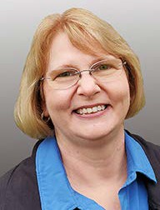Question What is surprisingly one in three in Antler River Watershed Regional
Council?

Answer
Approximately one-third of the pastoral charges in our regional council are without ministry personnel. Each one of them needs a PASTORAL CHARGE SUPERVISOR. Please contact Lynne Allin, Minister, Congregational Support & Mission at lallin@united-church.ca if you can help with this important work. Training is available and travel costs are reimbursed.

From your friendly Regional Council
Covenant Commission. :)

Christian Resource Centre
Hwy 8 & Hwy 23, Mitchell

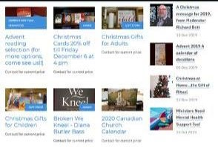

The Resource Centre: a warm & inviting space where all are welcome to browse

Finding, Writing, Getting Grant$

RSVP required by February 19. Email Ruthanna Mack or call 1-833-236-0280 ext. 0. Two opportunities: 12:00 - 2:30 pm (light lunch provided-donation) or 6:00 -
8:30 pm (light supper provided-donation).

Sisters Together: Clergy Women's Retreat for Women in Ministry - April 20 - 24

The theme of this 5-day event is 'Voices of Hope in Challenging Times'. The event features Rabbi Elyse Goldstein, Rev. Dr. HyeRan Kim-Cragg and Diamond Fotiadis. The Blanket Exercise with Kairos Canada will also be presented.

Download the poster for information, go to the Facebook page, send an email to sistersandministers@gmail.com, or go directly to the registration form.

Limited to the first 50 participants.

Week of Guided Prayer

A Unique and Meaningful Opportunity for Deepening your Relationship with God. Encourage your Congregation to Hold a Week of Guided Prayer. A Retreat Guided by the Holy Spirit in the Midst of Daily Life.

Find out more through the website. Purchase the 94-page manual and materials with this form and start your congregation on your chosen Sunday.
our vast array of theological resources, bibles, books & gift-ware. We are blessed by all who walk through our door. Give us a call, send us an email. Our common language is love & inclusivity.

Community of Faith Representative(s) to the Regional Council

Be sure to elect your community of faith’s representatives to the regional council. A position description for this role can be found on page 5 of the Governance Handbook.

The number of representatives is based on the number of full members. See Manual C.1.2.a)

SW Ontario Candidacy Board

The SW Ontario Candidacy Board is looking for new members; we meet monthly and the 2020 dates are set.

SAVE-THE-DATE
Social Justice Fair: May 9

Get the news before everyone! Read about it here . Email Carey Wagner to get on the list. A FAIR!!!! More infomation coming soon. Check the Antler River Watershed Region's website for news.

Rev. Gordon R. Geiger Want to Include Something Here

The Reverend Gordon Geiger passed Do you know of a region-wide event or
away December 20. Visitation is January happening that would be of interest to
30 from 12 - 1 pm and the service is at 1 ministry personnel and/or lay members?
pm, both at Riverside United Church. To have it posted in this regional newsletter, send an email with the
information to pkukadia@united- church.ca.

The next deadline is February 14.
Holding and Encouraging Communities of Faith

Antler River Watershed Regional Council
The United Church of Canada
Sign up for our newsletters.

Copyright © 2020 Antler River Watershed Regional Council, UCC, All rights reserved.

Want to change how you receive these emails?
You can update your preferences or unsubscribe from this list.

