Subscribe Past Issues
Translate
RSS

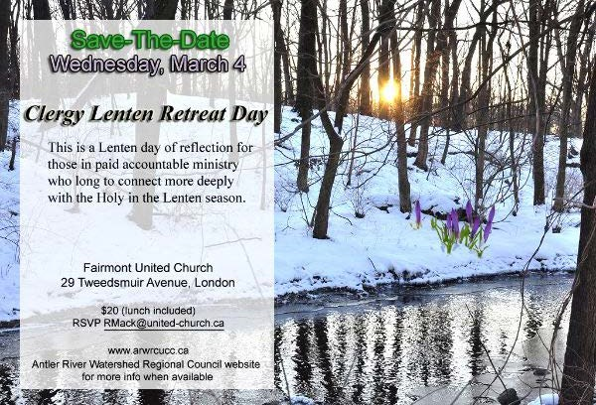

View this email in your browser

Next Deadline for submissions: February 14
Sign up for our newsletter & forward this one to friends.

Clergy Lenten Retreat Day
Wednesday, March 4

Save-The-Date
Saturday, March 7

Centering Prayer: Introductory Workshop

Learn to pray following the Christian contemplative tradition that is rooted in The Cloud of Unknowing, St. John of the Cross, Thomas Merton and Fr. Thomas Keating.

Elmwood Avenue Presbyterian Church
111 Elmwood Ave E, London

$10 (lunch included)
RSVP RMack@united-church.ca

Check the Antler River Watershed Regional Council website for more info when available.

Save-The-Date
Thursday, April 16

Medical Assistance in Dying: Crafting a pastoral response
This is a study day for clergy and pastoral care providers in the Antler River
Watershed Regional Council

St. Andrew's United Church
85 William Street S, Chatham

$20 (lunch included)
RSVP RMack@united-church.ca

Check the Antler River Watershed Regional Council website for more info when available.

Holding and Encouraging Communities of Faith

Antler River Watershed Regional Council
The United Church of Canada

Sign up for our newsletters.

Copyright © 2020 Antler River Watershed Regional Council, UCC, All rights reserved.

Want to change how you receive these emails?
You can update your preferences or unsubscribe from this list.

