Subscribe Past Issues
Translate
RSS

View this email in your browser

Next Deadline for submissions: January 24
Sign up for our newsletter & forward this one to friends.

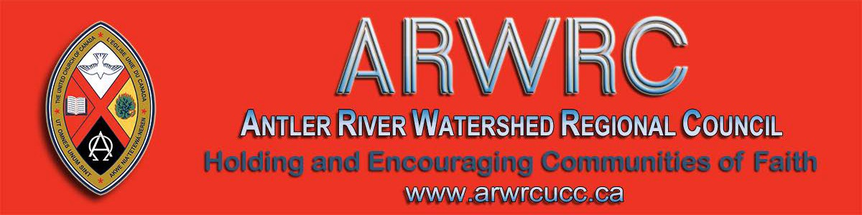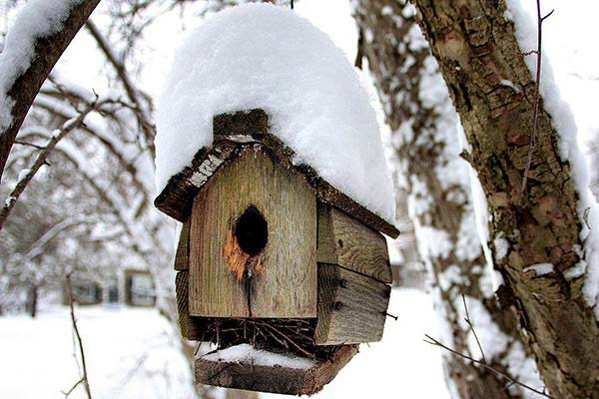Worshiplude in Ottawa!!! January 31 - February 3
Do you want to be on the
Pulpit Supply List?

We are looking for ministry personnel
who are willing to be available to do pulpit supply in our regions. Licensed Lay Worship Leaders (LLWLs) do much pulpit supply and that list is often sent out.

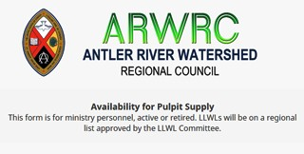Click to go to the registration form.

Skate on the Rideau Canal, ride ice slides, see amazing ice sculptures and more, as part of Ottawa's Winterlude.

Contemporary worship, dinner and the Alt Space Event with other youth and young adults. For more information email Dana Ducette.

Go directly to the registration form.

The Knitting Pilgrim
Sunday, March 1 @ 3:00 pm
Thamesville United Church

Kirk Dunn presents his one-man play, The Knitting Pilgrim, featuring the Stitched Glass tapestries. The large knitted panels, designed in the style of stained-glass windows, look at the commonalities and conflicts of the Abrahamic Faiths – and took Kirk an incredible 15 years to knit! The play tells the story of Kirk’s artistic and spiritual journey working on this ambitious project about interfaith empathy.
Click on the photo to go to the form.

Right now we are gathering the names of ministry personnel who are interested in being on a list for supply. Look under
'Pastoral Relations Toolkits' on the Antler River Watershed website. We look forward to hearing from you!

Covenanting Service
Sunday, January 26 @ 3:00 pm
St. Marys United Church

The congregation of St. Marys United Church is covenanting with Jason Richards. Presiding over the service will be Rev. Dr. HyeRan Kim-Cragg! Come celebrate with us Sunday, January 26 at
3:00 pm as we start this new ministry.

Feel free to send greetings to administrator@stmarysunitedchurch.org if you can't attend. We are at 85 Church Street S, in St. Marys.

The UCW Executive Meets Richards Memorial, London Monday, January 20, 9:30 am

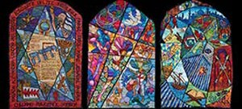

For more information or for tickets email
Tracy or call 519-692-4156. You can
also download a bulletin notice or 11X17 poster.

Licensed Lay Worship Committee is Looking for Members - Maybe you!

The Human Resources Commission is looking for individuals to be part of our Licensed Lay Worship Committee. This committee will oversee Licensed Lay Worship Leaders (LLWL) in Antler River Watershed.

We are looking for Ministry Personnel from any stream, lay people who are not LLWL and LLWLs to be on this committee. This will be a one to three year term position with the option of a renewal for one term.

The primary responsibilities for this committee will be:

Interviewing potential LLWLs and recommending licensing to the Human Resources Commission. Interviewing and recommending current LLWLs for relicensing every
3 years.
Ensuring LLWLs have completed mandatory workshops and have a current Police Records Check. Ensuring the recognition of a newly licensed LLWL at a service of worship.

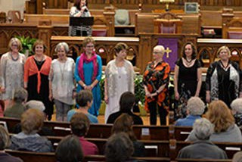

Curriculum Workshop Saturday, January 25 10-3pm Emmanuel UC, Waterloo

Curricula that engages children but it's yours on a shoe-string budget: Free!! It's
home -grown, tried and true, and best of all, it's free for those who attend. Ministers and lay leaders will be introduced to three curricula and how to
implement them in your ministry context.

Three workshops with presenters Alana
Martin and Pat Morrison.

Find out more: Curriculum Workshop

Racial Justice Workshops
2020 Dates

For Indigenous, Racialized, Bi-racial
People: January 25
April 25

Providing ongoing support and guidance to LLWLs.

If being on this committee is something that interests you, please complete an Expression of Interest form (also found on the Antler River Watershed website).

Another Great Year for The
Healing Fund - 2019

In 2019, The Healing Fund provided more than $300,000 to support Indigenous communities in language and culture programs. Read More ...

The Housing Crisis:
A Christian Response
January 21 @ 7 pm, London

The Social Justice Committee is sponsoring a presentation in the Parish Hall of St Michaels Roman Catholic Church (511 Cheapside) on the housing crisis in London.

Presenters include Douglas Calderwood- Smith, Manager of Strategic Program & Partnerships, City of London, and Stephen Giustizia, CEO of the Housing & Development Corporation for London.
June 20
September 19
November 14

For White People:

February 1
May 2
June 27
September 26
November 21

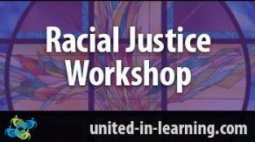

"The racial justice training is particularly commended to people serving in any leadership capacity within the church."
www.united-in-learning.com

Discoverment for YATS
'What Will Frame You' February 21-23

Whether you are creating an Instagram profile, a resume, or a life in the Way of Jesus - the decisions we make about how we frame our experience have a lot of power to shape our future. What do we focus on? What do we crop out? What opportunities do we pursue? Which ones do we forego? Who do we listen to as we make those decisions?

What Will Frame You? for YATS is open to young adults from any and all denominations and is hosted at Pearce Williams (Fingal, Ontario). The event is sponsored and led by The Centre for

Reference will be made to the recently adopted 5 year action plan Housing Stability for All. Sr. Nancy Wales, of Sisters of St Joseph, will provide the scriptural basis for the development of an effective Christian response to the housing crisis in our neighbourhood.

Songs for a Gospel People courtesy of Trinity UC, Glencoe

If your congregation or one you know can make use of the hymn books, Songs for a
Gospel People, here is your chance to get some copies. Email Linda Britton today.

SAVE-THE-DATES June 5 & 6 and September 24-26

Early Bird Rates until: March 31st!

reVITALize 4: Amazing guest speakers. Presented by the Centre for Practical Theology & The Middlesex Foundation June 5 & 6. Find out more! Download the poster.

Rekindling the Fire: Many guest speakers. Presented by the Centre for Practical Theology & The Middlesex Foundation September 24 to 26. Find out more! Download the poster.

Help Communities of Faith with
Mission/Justice/Faith Formation
Practical Theology, The Swell, Ecumenical Campus Ministry of the University of Guelph, and Western Ontario Waterways.

Come find out What Will Frame You!

Confirmation Retreat & Faith Refresher 'What Will Find You' February 21-23

Confirmation PLUS is designed to prepare United Church teens for confirmation but is open to any and all teens in grades 7-12 regardless of whether or not they are confirmed or ever intend to be.

Confirmation PLUS is open to Region 7,
8, 9 and beyond and is hosted at Pearce Williams (Fingal, Ontario). It is sponsored and led by The Centre for Practical Theology, The Swell, Ecumenical
Campus Ministry of the University of
Guelph and Western Ontario Waterways.

This retreat weekend playfully engages teens in the exploration of A New Creed, energetic worship, and lots of recreation, all lead by seasoned adult ministry personnel with decades of experience in youth ministry.

Adults/Ministers are encouraged to attend this event with their teens.

Come and find out What Will Find You!

Become a Youth Ministry Friend on Facebook - Friends4ever

Follow Regions 7-
8-9 Youth
Ministry Network

Besides helping congregations with the above, you will also help with resources, guidance and support to enable communities of faith to do the best
ministry possible in their communities and the world.

The mandate includes working in right relations with Indigenous partners, supporting Affirming ministries with LGBTQ2SIA+ members, making safe space, open dialogue and strengthening relationships everywhere.

The Mission & Discipleship Commission could use your help. Read the letter and mandate from the Commission. Then apply through the Expression of Interest form. Hope to see you soon!

Question & Answer Column

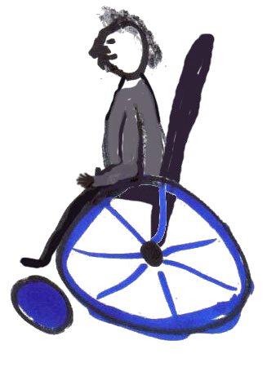Question
Does our church have to be physically accessible by
2025?

Answer
A Community of Faith is a non-profit with usually under 20 employees and does not need to make their building physically accessible by 2025. Under Ontario's Building Code, it is grandfathered. The exception is if you do a new construction or redevelopment (renovation).

For more information see: Accessing Accessibility Under the Building Code, the AODA and the OHRC.

on Facebook and always be in the know.

There is so much coming up, it's hard to stay on top of it! Here is a peek of what you'll find on Facebook:

What will Find You? Confirmation PLUS Retreat February 21-23 @ Pearce-Williams Camp
What will Frame You? Discoverment February 21-23 @ Pearce-Williams Camp
Interfaith Event for Young Adult Women. Feb 14-17 @ Five Oaks Show me the $. March 3-5 @ the Regional Office
Confirmation Event. April 3-5 @ Five Oaks
Easter/Good Friday Swell. April 10
@ Wesley Knox United Church Youth Rally. April 23-26 @ Pearce- Williams Camp

Rendez-Vous: Bold Faith. Brave
Space. Brazen Grace.

From your friendly Regional Council
Covenant Commission. :)

Liaison Training for Free! Almost ...

The Human Resources Commission is looking for people wanting to train as liaisons. Liaisons help support and equip congregations during search and in times of transition. If you are interested or if you would like more information please
contact Olav Kitchen or apply through the Expression of Interest form.

Christian-Muslim Dialogue
Seeking A Common Word

You are invited to an evening of Christian-Muslim friendship and learning to launch the new online resource for Christian-Muslim dialogue, A Common Word Canada. It will be held on January
28, from 7 - 9 pm at Huron University College in London. Download the poster.

Norwich United Church
SURPRISE!

Children have been playing and learning at Norwich United Church summer camps for over a decade. Tthis important aspect of our mission had been generously supported by our community and by government agencies.

This year though, things didn’t go according to plan. One week before camp we found out that our application to the
Rendez-vous, an M&S supported event, brings together youth (grade 9 and up to any age), young adults and their leaders from across the country (and beyond!) for a celebration of vibrant music, inspiring speakers, and dancing like there is no tomorrow.

Get involved. Find out how. Email Kathy or call her at 519-441-0656.

Songs for the Holy Other

A new resource from the Hymn Society of the United States and Canada , Hymns Affirming The LGBTQIA2S+ Community! Hymns for the Holy Other is an online hymnal that emerged from a desire to make queer hymns — hymns by, for, or about the LGBTQIA2S+ community — accessible to a wider range of congregations.

We celebrate the contributions of those who have paved the way for this collection, and hope to create a dynamic resource of additional resources that are available to congregations in the near future.

Week of Guided Prayer

A Unique and Meaningful Opportunity for Deepening your Relationship with God. Encourage your Congregation to Hold a Week of Guided Prayer. A Retreat Guided by the Holy Spirit in the Midst of Daily Life.

Find out more through the website. Purchase the 94-page manual and materials with this form and start your congregation on your chosen Sunday.

federal government was unsuccessful ... leaving us with a shortfall of $15,000.

How could we fill the gap with camp just one week away?

Read the rest of the story.

And you say Goodbye!

Thank you, Jane Van Patter, for your service and blessings on your retirement! You will be missed at St. David's in Woodstock this coming October 31, 2020.

Thanks also to Donna Kerrigan for your service and many blessings on your retirement! You will be missed at St. Andrew’s, St Thomas this coming June 30, 2020.

Show Me the $$$ Regional Office, Hamilton Tuesday, March 3

Finding, Writing, Getting Grant$

RSVP required by February 19. Email Ruthanna Mack or call 1-833-236-0280 ext. 0. Two opportunities: 12:00 - 2:30 pm (light lunch provided-donation) or 6:00 -
8:30 pm (light supper provided-donation).

SW Ontario Candidacy Board

Stewardship Updates
M&S Deadline: January 31

If you are looking for encouragement, new ways to think about stewardship, resources, help to implement Congregational Giving, Mission & Service, Planned Legacy Giving, United Church Foundation and investing opportunities
for your congregation, and personalised support to help grow strong generous thankful disciples, then contact Dave Jagger and let’s talk. January News !

Nominations: General Council
Positions

Please check the General Council Nominations page regularly. General Council is inviting Expressions of Interest:

Committees of the National Indigenous Organization Indigenous Candidacy Board National Indigenous Committees

Deadline for all of the above: January 23.

Marketing/Animation and Funding
Development Subcommittee, Sing
2025
Web Content Development
Subcommittee, Sing 2025

Deadline: February 10.

SAVE-THE-DATE
Social Justice Fair: May 9

Get the news before everyone! Read about it here . Email Carey Wagner to get on the list. A FAIR!!!! More infomation

The SW Ontario Candidacy Board is
looking for new members; we meet coming soon. Check the Antler River
monthly and the 2020 dates are set. Watershed Region's website for news.

IXThUS - The Fish Want to Include Something Here

Cozy up to some winter reading in Do you know of a region-wide event or Dunwich United Church's IXThUS happening that would be of interest to newsletter. It will keep you warm! ministry personnel and/or lay members?
To have it posted in this regional newsletter, send an email with the information to pkukadia@united- church.ca.

The next deadline is January 24.
Holding and Encouraging Communities of Faith

Antler River Watershed Regional Council
The United Church of Canada
Sign up for our newsletters.

Copyright © 2020 Antler River Watershed Regional Council, UCC, All rights reserved.

Want to change how you receive these emails?
You can update your preferences or unsubscribe from this list.

