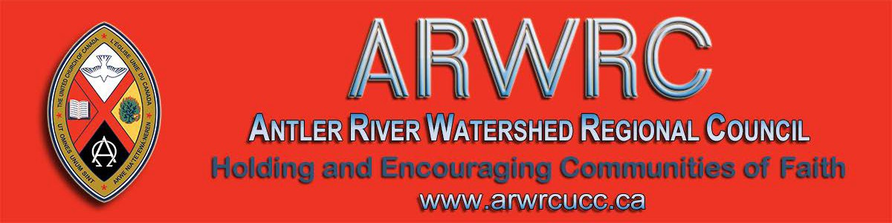
Subscribe |  | Past Issues |  |  |  | Translate |  |  |  | RSS
View this email in your browser

Next Deadline for submissions: February 14
Sign up for our newsletter & forward this one to friends.
March 18 or 19 Meetings ..... "Wait! WHAT?"
Click here to register for one of the meetings.
The Antler River Watershed Regional Council staff is holding four gatherings for Ministry Personnel, Regional Council Lay Representatives and anyone interested in the Regional Council.

According to Dean James Ryan, "Wait! What?" is the first of the five essential questions of life. It's the question that helps us seek clarification and gain understanding. It's the question that many are voicing at this time of change in the structures of the church.

Plan to attend one of the four 90 minute gatherings being offered March 18 and
March 19 to ask questions about the work of the regional council:

How is the work assigned? What values guide our work?

This is a chance to learn more about the regional council and discover how you might become more involved in it!

Please RSVP and click here to register for one of the meetings you would like to attend,by Friday, March 13th, so we can be sure to have sufficient resource materials and refreshments.

Questions? Email arwrc@united-church.ca.
DATES LOCATIONS TIMES

Strathroy United Church 1:30 - 3:00 pm
Wednesday, March 18 131 Front Street W, Strathroy 7:00 - 8:30 pm
(Google map)

Tecumseh United Church

Thursday, March 19 333 Lacasse Blvd, Windsor
(Google map)
1:00 - 2:30 pm
7:00 - 8:30 pm

Holding and Encouraging Communities of Faith

Antler River Watershed Regional Council
The United Church of Canada

Sign up for our newsletters.

Copyright © 2020 Antler River Watershed Regional Council, UCC, All rights reserved.

Want to change how you receive these emails?
You can update your preferences or unsubscribe from this list.

