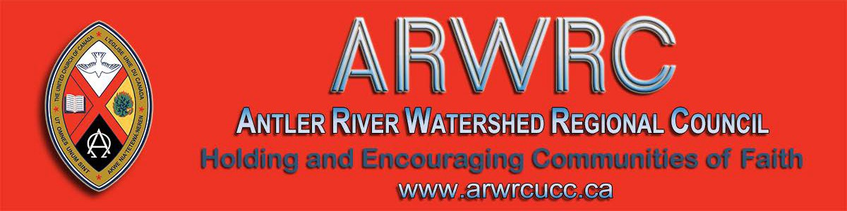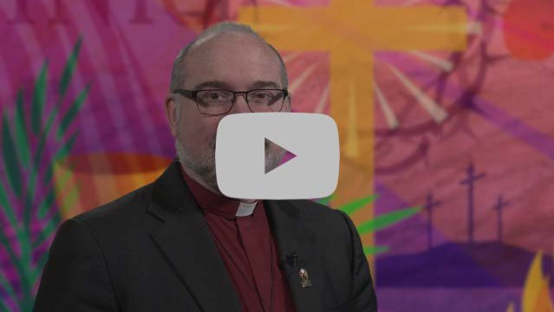
Subscribe |  | Past Issues |  | Translate |  | RSS
View this email in your browser

Next Deadline for submissions: March 6
Sign up for our newsletter & forward this one to friends.
Moderator Richard Bott's Lent message for 2020

Ash Wednesday isn’t only about lament and death—it’s also about celebrating life because the two are so deeply intertwined. For the 40 days of Lent, you are invited to join in celebrating life each day.

Visit the United Church worship page for additional Lenten resources.

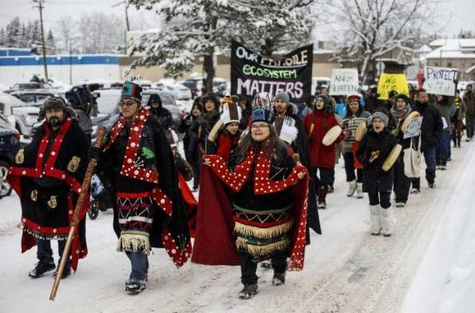

The National Indigenous Elders Council and Moderator Richard Bott have written a joint letter in support of Wet’suwet’en.

Learn how your faith community can encourage the Canadian government to embody the UN Declaration on the Rights of Indigenous Peoples in their relationships with Indigenous Peoples.
~~~~~ From the Editor's Desk ~~~~~

One year ago, the regional council staff were scrambling to assemble email lists to send newsletters. Our newsletter platform was not working for the volume of our work and our websites were a distant hope! Thank you for your patience as we have developed these communication tools.
The website and newsletter are still being reviewed and refined - we continue to make improvements.
Welcome to our newly formatted newsletter. We realize that the newsletter has a three-fold purpose:

1. to provide useful advice for communities of faith;
2. to detail upcoming events;
3. to share stories of life throughout the regional council.

We want to provide all three in a way that makes it easy to navigate the newsletter

and to skim it for selected portions if desired. This newsletter is divided into 3 sections:

For Your Community of Faith

Upcoming Events

News from Around the Regional Council

Enjoy the read!

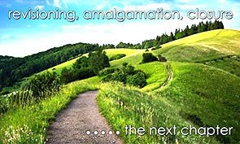
for Communities of Faith

Covenanting Service Sunday, March 29, 2:00 pm Lindsay Rd United Church

Join us for a special covenanting service with the Rev. Wanda Winfield and the Tupperville Pastoral Charge (Zion United Church and Lindsay Rd. United Church).

Our guest preacher is the Rev. Judith Fayter. Be with us for this gathering to be followed by fellowship and refreshments to continue the celebrations! Spread the word and join us at Lindsay Road United Church (Google map), 11366 Claymore Line in Dresden.

Confirmation Retreat
Five Oaks, April 3 - 5

Colour Outside the Lines, Unravel Faith, Resurrect Hope and Create Radical Beauty on Earth with Ruth Noble, Alana Martin and Kathy Douglas.

A retreat to support & enrich the confirmation process of your congregation. For both youth & leaders. Come, share the journey!

For information email Kathy Douglas.
United Church Women Annual General Celebration Saturday, May 2 - 9:15 - 3:00pm

Theme: Women for Change. At Calvary Evangelical United Church, 48 Hawksville Road in St. Jacob's (Google map).

The guest speaker is Rev. Japheth Ndhlovu, the Program Coordinator for Southern Africa & South Asia, Partnerships of the United Church.

Register by sending your name to ucw.wow@gmail.com or phone Kim at
705-734-0162. $15 is payable at the event. Please wear your UCW pin & name tag, Remember to car pool and bring your water bottle & Voices United.

Interim Ministers Spring Retreat
Five Oaks Retreat Centre
May 6 to May 7

Holy connection, worship, open space, spiritual practices, kaleidoscope Bible

study, learning experience.

Please Share this Newsletter

Please share this newsletter widely. It is especially helpful for people involved in leadership roles in your community of faith to know what upcoming events are planned that they might find helpful.

Invite people to subscribe for themselves by including the following with the announcements: Stay in touch with the wider church: subscribe to the regional council newsletter.

Video Licensing Available for May 2020 to April 2021

Video licensing information is available online at Buying United. Those who had video licenses last year should have received their invitation for this year. Please share this information as widely as you can. The deadline for applications for this round is Friday, March 27.

Contact Alexandra Belaskie or at 1-
800-268-3781 x4157 for more information.

Want to Include Something
Here

Do you know of a region-wide event or happening that would be of interest to ministry personnel and/or lay members? To have it posted in this regional newsletter, send an email with the information to pkukadia@united- church.ca.

The next deadline is March 6.

Registration deadline is March 30. Download the poster or go to the registration form.

reVITALize 4
SAVE-THE-DATES June 5 & 6

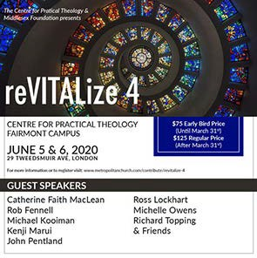

Early Bird Rate until: March 31st!

reVITALize 4: Amazing guest speakers. Presented by the Centre for Practical Theology & The Middlesex Foundation June 5 & 6. Find out more! Download the poster.

Upcoming Events

Strengthening Youth Ministry Mental Health & Well-Being Tuesday, March 10 - 7:00pm

Join this gathering of community at Wesley-Knox United Church in London (Google map). Share in a webinar as Stewart Smith explores spirituality and mental health in church work. The focus will be on how spiritual practices can support mental and emotional wellness. Concrete strategies will be presented.

Meet us at 6:45. An RSVP is helpful.

PIE Day Worship,
Facing Queerphobia Video from Affirm United

PIE Day happens every March 14! Affirm United/S’affirmer Ensemble and Affirming Connections have partnered to bring you tools and ideas to put on your own PIE event.
Rendez-Vous: Bold Faith. Brave
Space. Brazen Grace.

Rendez-vous, an M&S supported event, brings together youth (grade 9 and up to any age), young adults and their leaders from across the country (and beyond!) for a celebration of vibrant music, inspiring speakers, and dancing like there is no tomorrow.

We are planning to take 10 participants. The cost of the registration will be about
$350 and the flight will be $800-$900. We're applying for funds to help cover 1/3 of the cost.

Get involved. Find out how. Email Kathy or call her at 519-441-0656.

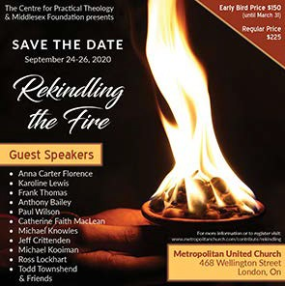Rekindling the Fire SAVE-THE-DATES September 24-26

Find out about the activities happening on
March 14. Check out www.pieday.ca.

Download the February - March newsletter from Affirm United.

Centre for Christian Studies
Annual General Meeting

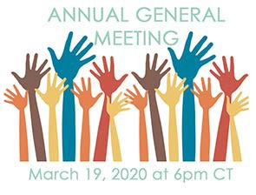

You're invited to the Centre for Christian Studies' 2020 Annual General Meeting on Thursday, March 19, from 6:00 pm to
8:00 pm Central Time. Join us in person at Woodsworth House (60 Maryland St, Winnipeg) or online via videoconferencing. (Call or email Cheryl -
204.783.4490 or office@ccsonline.ca for the link.) Agendas, reports, and documents will be posted on the CCS website soon.

Two Countries, One World
Return to Columbia
United Church Youth!

The TCOW committee is planning a return to Brisas del Mar, Colombia!
Early Bird Rate until: March 31st! Rekindling the Fire: Many guest
speakers. Presented by the Centre for Practical Theology & The Middlesex Foundation September 24 to 26. Find out more! Download the poster.

Regional Council Events

Show Me the $$$ Regional Office, Hamilton Tuesday, March 3

Finding, Writing, Getting Grant$

RSVP required by February 19. Email Ruthanna Mack or call 1-833-236-0280 ext. 0. Two opportunities: 12:00 - 2:30 pm (light lunch provided-donation) or 6:00 -
8:30 pm (light supper provided-donation).

Youth Rally 2020: Escape! April 23 - April 26
Pearce-Williams Christian Camp

High-School aged youth: Do you love to be inspired, challenged to think, meet new people & hang out with good
friends ??? Do you enjoy being in an open
& welcoming community where you are free to be completely yourself ? Well, faith, fellowship and connection is what Youth Rally is all about.

Come join us for Youth Rally 2020: Escape! Registration closes when full.

There is limited space! Register Early. Deadline for registration: April 9.

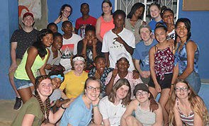

Find out more at an information night for potential participants and parents/guardians to ask questions. Check out our site to learn about us along with our frequently asked questions.

Information nights will be held in March and April. Download the poster to find out where and when.

Come with all your questions, hopes, fears and dreams!

Crossan is coming to Westdale
United Church, Hamilton
April 3 and 4

Contemporary Spiritual Voices present: A
weekend with John Dominic Crossan.
The foremost historical Jesus scholar will be at Westdale UC from a Friday evening talk through all day Saturday.

Register online or download the flyer
and get all the details and information.

Rabbi Richard Address
Our Long and Winding Road Siloam United Church, London Saturday, April 4, 2:00 - 9:00 pm

Seeking our Path in the Longevity
Revolution: Rabbi Richard F. Address,

For more information email Shannon.

SAVE-THE-DATE
Social Justice Fair: May 9

Get the news before everyone! Read about it here . Email Carey Wagner to get on the list. A FAIR!!!! More infomation coming soon. Check the Antler River Watershed Region's website for news.

Kids Across the Regions: Heroes Unite! June 6 - June 7
Camp Bimini, St. Paul's

A fun, faith filled weekend for children (grades 3 to 8) from across the three regional councils of Antler River Watershed, Western Ontario Waterways and Horseshoe Falls of The United Church of Canada! We’ll be gathering in early June after the Annual Meetings of the three regional councils to give us warmer weather and access to the beautiful pool at Camp Bimini.

Join us! Registration closes when full. Register Early. Deadline for registration: May 22.

We are inviting youth & young adult leadership for this event. If you are a high-school aged youth or young adult interested in being leadership
for Kids Across the Regions, please contact
Kathy Douglas.

DMin is a leading authority on Boomer and Older Adult Ministry. He hosts the weekly radio show "Boomer Generation Radio" in Philadelphia and speaks regularly on issues related to baby boomers, aging and how Judaism can impact our lives as we age.

Download the poster and registration form. Contact Siloam United Church by email or phone at 519-455-9201.

Pearce-Williams Camp Annual General Meeting Wednesday, April 8, 7 - 8:00pm

Join us for our Annual Meeting at beautiful Pearce-Williams Summer Camp
& Retreat Centre. We are located at 8009
Iona Road in Fingal (Google map).

Come and learn more about the exciting events planned for the 60th Anniversary Celebration! Keep up to-date on the planning through our newsletters.

Leadership Development and Continuing Education For lay people and clergy who want to learn, explore, and question, the Centre for Christian Studies is offering two one-week learning
circles: Oppression and Resistance (Apr
15-21) and Ages and Stages (April 23-
29). Application deadline this month. Both will be in Winnipeg. Click on the name of the circle to find out more. If you have questions call 204-783-4490 or e-mail info@ccsonline.ca.

For more information email Kathy
Douglas or call 519-441-0656.

Missional Leadership Diploma Atlantic School of Theology June 2020

Learn the keys to thriving ministry in the
21st Century. Starts in June - Apply now! Only 25 spots available. For more details on this leading edge program download this information sheet and/or contact Dr. Stephen Harper.

Hello & Welcome

Let's welcome Sharon Campbell Rayment to Antler River Watershed Regional Council. She just started at Trinity United Church, Wallaceburg in February.

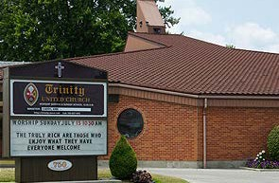

Send Sharon a greeting or call and say hello at 519-627-1472.

Question & Answer Column

Question What is Antler River Watershed Regional

United Church Women
59th Annual Gathering
Saturday, April 18 - 8:45-4:30pm

Theme: Hands Across the Water. At Trinity United Church, 118 Church Street in Ingersoll (Google map).

The Devotion Speaker is Rev. Dr. Trapnell and the Theme Speaker is Peter Wright.

Download the day's brochure and the registration form. Registration deadline is March 29.

Sisters Together: Clergy Women's Retreat for Women in Ministry - April 20 - 24

The theme of this 5-day event is 'Voices of Hope in Challenging Times'. The event features Rabbi Elyse Goldstein, Rev. Dr. HyeRan Kim-Cragg and Diamond Fotiadis. The Blanket Exercise with Kairos Canada will also be presented.

Download the poster for information, go to the Facebook page, send an email to sistersandministers@gmail.com, or go directly to the registration form.

Limited to the first 50 participants.
Council's Investment in Leaders Grant ?

Answer
An opportunity to provide both ministry personnel and lay leaders with financial assistance for learning events. Grants through the Investment in Leaders Fund are available for the 2020 calendar year.
*The form must be submitted prior to the event for review.
Find out more, download the form here . From your friendly Antler River
Watershed Regional Council . :)

Treasurers: Charity Returns
We Have An Answer for You

In response to the following question on the T3010 Charity Return: Was the
charity in a subordinate position to a head body?

Answer: The United Church of Canada
Bn # 108102435RR0003

Thanks for all you do at this busy time of year to help United Church communities of faith understand their financial picture and direct their assets to the service of God's mission.

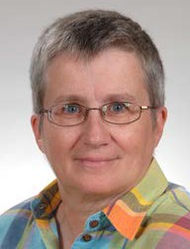

Due to having had the flu, this issue has been sent out later than planned. The

next deadline is still March 6. I welcome your submissions. Pretima Kukadia
- - - - - - - - - - - - - - - - - - - - - - - - - - - - - - - - - - - - - - - - - - - - - - - - - - -

The Antler River Watershed Regional Council newsletter welcomes submissions of upcoming events, regional news and educational opportunities. This is also the place to keep up-to-date on information from the regional office.

Holding and Encouraging Communities of Faith

Antler River Watershed Regional Council
The United Church of Canada

Sign up for our newsletters.

Copyright © 2020 Antler River Watershed Regional Council, UCC, All rights reserved.

Want to change how you receive these emails?
You can update your preferences or unsubscribe from this list.

