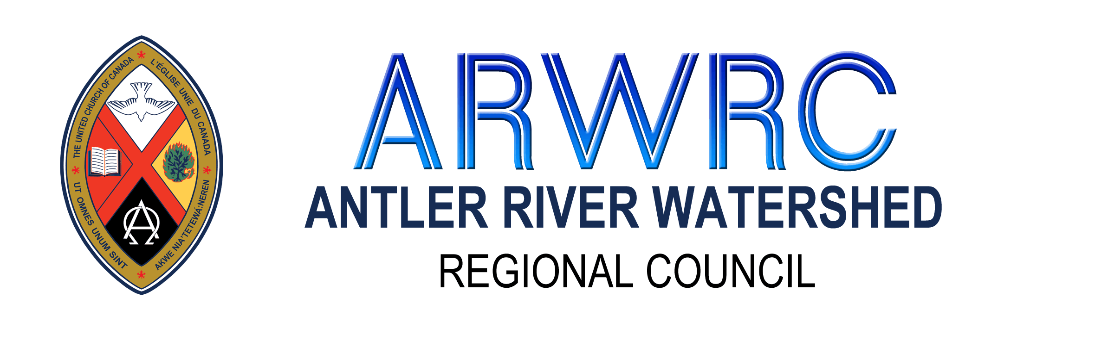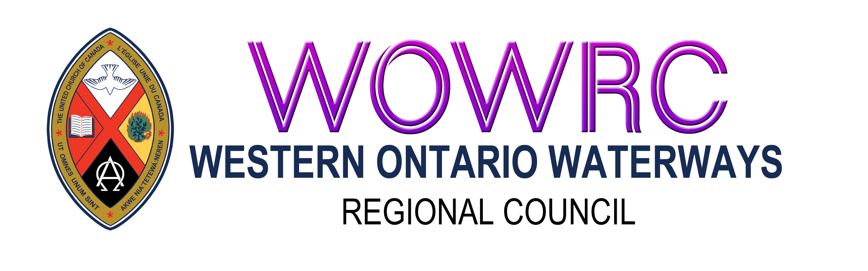
Request to Make Temporary Ministry Personnel Changes
due to Pandemic
Please complete this form and send a digital copy* to:
Minister, Congregational Support and Mission for Your Regional Council

Community of Faith/Congregation
Pastoral Charge (if different)
Regional Council
Date of Governing Body Meeting re: Ministry Personnel Employment
Contact Information: Please provide 2 contacts
Name:
Position with the Community of Faith:
Email Address: Phone Number:

Name:
Position with the Community of Faith:
Email Address: Phone Number:

Assessing Financial Need:
Please indicate that your community of faith has:
- ☐ Completed a current Financial Viability Worksheet. Please attach
- ☐ Actively encouraged stewardship and taken measures to make it easier for people to make donations. List steps taken.
- ☐ Exhausted all local resources by spending or using investments as collateral for a line of credit. List funds that have been accessed and amounts.
- ☐ Accessed funds restricted by presbytery/regional council for payroll in March-June 2020. List amounts.
- ☐ Applied for the Federal 10% and 75% wage subsidy. If you were not approved please explain why.
- ☐ Taken steps to reduce expenses for example deferring national assessment payments
- ☐ Applied for the United Church Pandemic Response Bridging Loan
List all loans/lines of credit that have already been granted for Covid-19 and the amounts.
Click or tap here to enter text.

List income and expenses for March to date.
Month | Income | Expenses
March
April
List all staff positions, hours and monthly salary costs and indicate if they are on ADP.
Position | Hours | Salary Cost | On ADP
List any staff already laid off due to the pandemic.
Click or tap here to enter text.

Request for Changes in Pastoral Relations
Please detail the proposed changes for ministry personnel.
Click or tap here to enter text.
If your proposal is to lay off ministry personnel how do you propose the ministry/work of the church will continue?
Click or tap here to enter text.
Please attach a digital copy of:
- Completed Financial Viability Worksheet Financial Viability Worksheet
- Annual Report for 2019

Note: Print copies will not be accepted. Please arrange for scanning if necessary and send a copy of this form and the necessary attachments to Minister for Congregational Support and Mission (ARWRC, HFRC, WOWRC)

Process:
Once your completed application has been received, the Covenant Commission will review it to determine viability and need for changes in pastoral relationship. A copy of their decision will be forwarded to the Human Resources Commission and the contacts provided on this form.
If it is determined that there is need for changing ministry personnel employment, the Human Resources Commission will contact the names provided regarding next steps.

