To access a link in this newsletter, please press CTRL + mouse click on the highlighted link.

View this email in your browser
Next Deadline for submissions: TBA
Forward this to a friend to sign up for this newsletter.

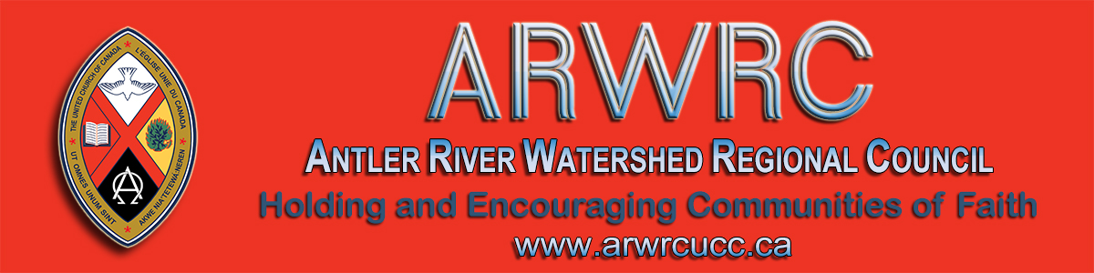

The Great Unveiling: How The World is Changing and What It Means for the Church
Register for these two webinars with Cameron Trimble
Monday, June 22, 7:00 - 8:00 pm
Thursday, June 25, 7:00 - 8:00 pm

Last year Cameron Trimble energized the regional council with her invitation to catch the view from 10,000 feet!
Since May 2019, much has changed. Cameron Trimble has offered to spend two evenings with us to help us catch the view now.

What has the church experienced during this pandemic that will change us and renew us? How is this a time for transformation and not just a period of disruption?
Please register for both sessions. Convergence is managing the technology for these events. They are able to provide for more generous participation--but not unlimited! Register early.

Please register for both sessions. Convergence is managing the technology for these events. They are able to provide for more generous participation -- but not unlimited! Register early.

Monday, June 22, 7:00 - 8:00 pm:  Cameron will invite us to consider how this moment in time might be transforming the church. Attendees will be invited to submit questions after the event. | Thursday, June 25, 7:00 - 8:00 pm:  Cameron answers our questions. (Questions will be collated according to similar themes and prioritized according to widespread applicability.)

The Antler River Watershed Regional Council newsletter welcomes submissions of upcoming events, regional news and educational opportunities. This is also the place to keep up-to-date on information from the regional office.

Holding and Encouraging Communities of Faith

Antler River Watershed Regional Council
The United Church of Canada

Sign up for our newsletters.

For information, contact Pretima: pkukadia@united-church.ca
Our phone number is: 1-833-236-0280
Our mailing address is:
Antler River Watershed Regional Council, UCC
PO Box 100
Carlisle, On L0R 1H0
Canada
Add us to your address book
Copyright © 2020 Antler River Watershed Regional Council, UCC, All rights reserved.

