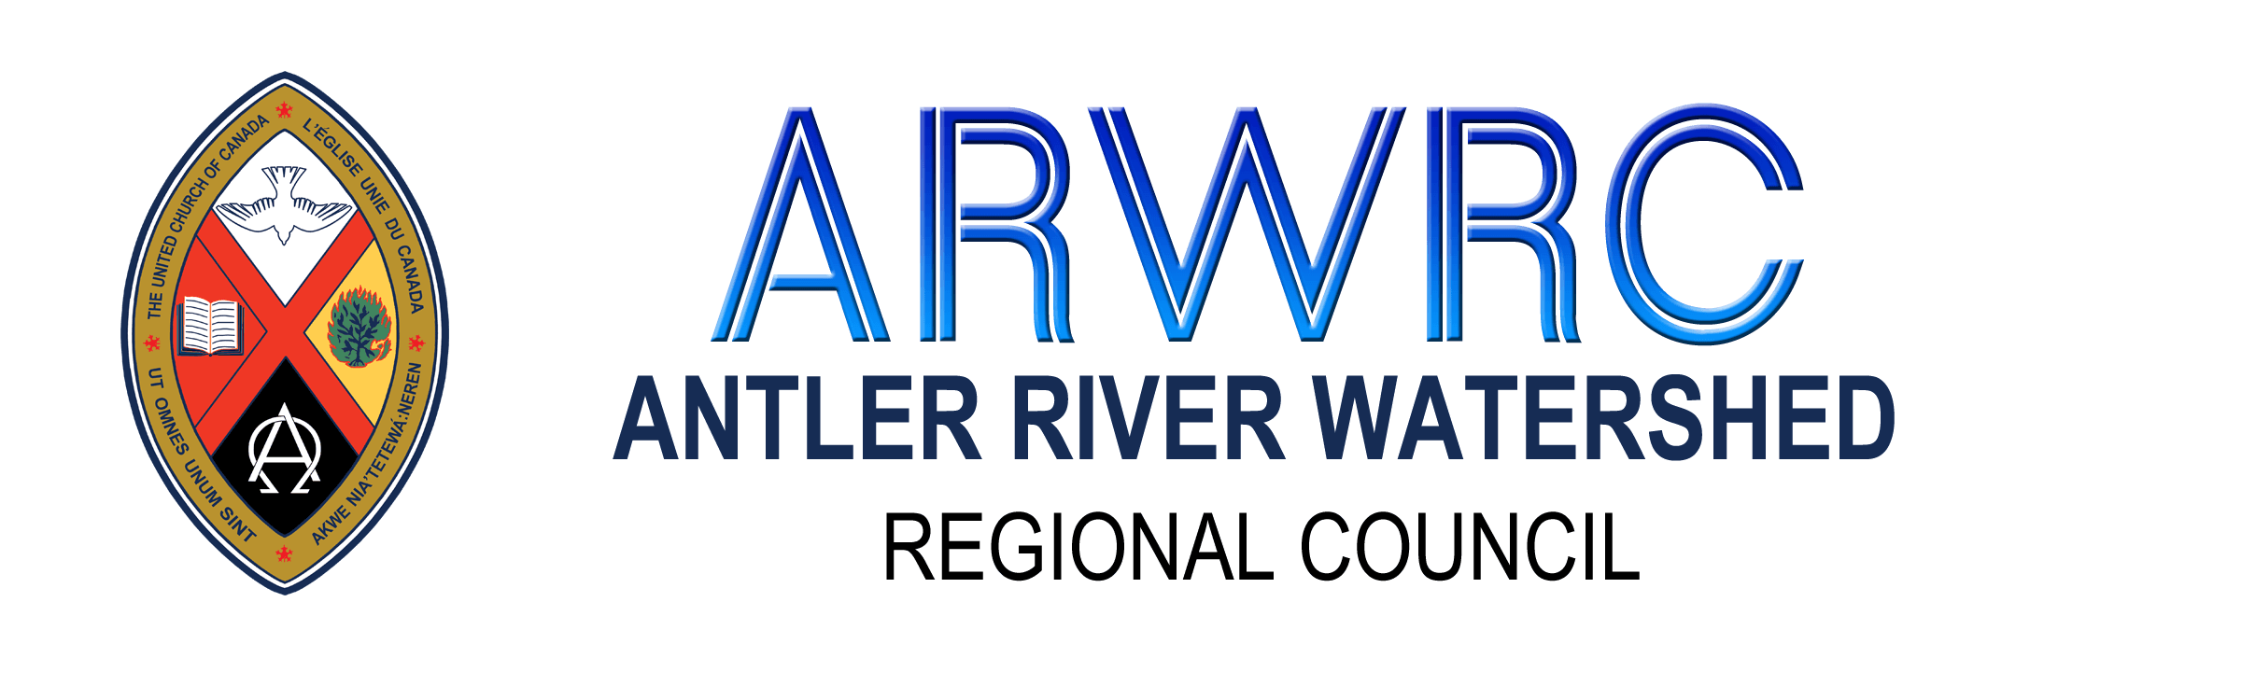
Community of Faith: Use of Restricted Funds
Information
Changes in receiving offerings and donations may lead to some temporary financial concerns for communities of faith during the Covid-19 pandemic. The good news is that the statistics from many of our pastoral charges indicates that a majority of communities of faith have reserve funds.
In support of communities of faith the Covenant Commission has approved that, if necessary, congregations with funds, whose use was restricted by presbytery or regional council, (for example manse funds) can use these funds for their payroll in March, April, May and June 2020.
How to Access Funds:
1) The decision is made by the governing body of the congregation or pastoral charge to direct trustees to withdraw funds up to the amount of the congregation’s ADP payroll costs in February 2020.
2) A record of the withdrawal is recorded on the attached form and submitted to Lynne Allin, Minister, Congregational Support and Mission.
Other Considerations:
If a community of faith does not wish to incur a penalty by “cashing in” an investment prematurely, they may be able to negotiate a line of credit with their bank using that fund as collateral.
As the Covid 19 situation continues to evolve, congregations are asked to stay in touch for updates on this motion beyond April, 2020.
Types of Restricted Funds
A congregation may have three types of restricted funds:
1) Funds restricted by presbytery or regional council. These are funds, often from the sale of property, which require regional council approval before the principle can be used. These are the funds being made available to pay ADP payroll at this time.
2) Funds collected for a specific purpose (example new roof). Donations collected for a named and specific purpose are restricted, meaning they can only be used for that purpose. These are not available to pay salaries.
3) Funds given for a specific purpose. A bequest or donation that is given with instructions from the donor that it only be used for a specific purpose such as Sunday school are restricted and can only be used for that purpose. These are not available to pay salaries.
Community of Faith: Use of Restricted Funds
Please fill in this page and send to the Covenant Commission for your regional council
Community of Faith/Congregation
Pastoral Charge (if different)
Date of Approval by Governing Body (Council/Board)
Type of Restricted Fund (Manse/other)
Amount and Date Accessed:
March 2020
April 2020
May 2020
June 2020
July 2020
August 2020
Contact Information: Please provide 2 contacts
Name:
Position with the Community of Faith:
Email Address:
Phone Number:
Name:
Position with the Community of Faith:
Email Address:
Phone Number:

