To access a link in this newsletter, please press CTRL + mouse click on the highlighted link.

View this email in your browser
Next Deadline for submissions: TBA
Forward this to a friend to sign up for this newsletter.

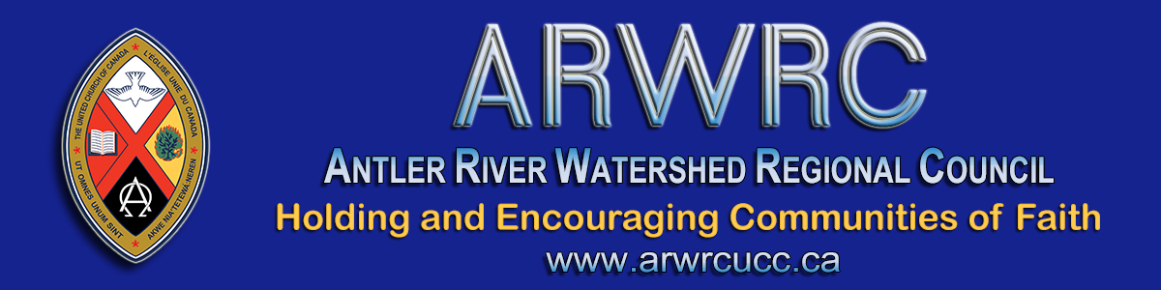

An Invitation from the Covenant Commission
To Congregations & Ministry Personnel
- - - From Marie Santos, Chair - - -
Greetings to all communities of faith in Antler River Watershed Regional Council.
On behalf of the Covenant Commission, I want to extend our appreciation to each and every community of faith for the incredible resourcefulness, flexibility, learning, planning and adapting with which you have responded to the COVID-19 pandemic. In addition to your willingness to embrace new technology, on-line communication, and styles of worship, you have also been figuring out government programs and updating your financial systems. (Special thanks to all the Treasurers!)
But we also recognize that this level of adjustment and stress can take a toll, especially when we are still living with so much uncertainty and anxiety. We also recognize that you may be experiencing significant financial challenges and concerns about how you will be able to sustain your ministry.
That is why we are inviting you to let us know how your community of faith is doing, and what type of support would be helpful as we move forward. In this letter you will find information about upcoming gatherings where you can let us know how you are doing and ask questions. I have included some updates and reminders for you to share with your governing body. Download the letter to share. We also want to encourage you to check the Antler River Watershed Regional Council Facebook group and website regularly for updates.
Once again, thank you.
Marie

A How Are You Doing? Gathering
Lay leaders and ministry personnel are invited to join an online gathering to talk about how your congregation is doing in a Covid-19 world. What has surprised you? What is troubling you? What questions do you have? What do you need?
Two different times are offered for people to gather. You can choose to join the conversation on either:
- Monday, July 13 from 7:00 - 9:30 pm (Zoom details below)
- Tuesday, July 14 from 1:00 - 3:30 pm (Zoom details below)
We encourage you to share this with your council/board members. We also ask that pastoral charge supervisors pass it along to the congregations they are working with.
* If you can't attend, but would like to check in, please send an email about how your congregation is managing in this pandemic.*

Please select the Zoom link for the date you are attending,
at the time of the meeting:

Monday, July 13 from 7:00-9:30 pm:
Click on this Zoom link. Zoom will open in your web browser. If you are asked, enter Meeting ID numbers: 919-5125-5185
Download the Zoom link info sheet.

Tuesday, July 14 from 1:00-3:30 pm:
Click on this Zoom link. Zoom will open in your web browser. If you are asked, enter Meeting ID numbers: 989-5401-9585
Download the Zoom link info sheet.

Updates
- Use of Restricted Funds:
Investments restricted by presbytery or regional council can continue to be used to cover payroll costs for the months of July and August. This is in addition to April-June. You do not need regional approval for this, but we do ask that you complete the reporting form.
- CEBA Loans:
Churches are now eligible for the Federal government CEBA loans of up to $40,000 providing you meet the criteria. This has been pre-approved by the Covenant Commission, and only requires approval by your own governing body. Please let us know if you receive this loan, and the amount you qualify for, by completing the form (also available on the regional website under Covid-19 resources).
- Reopening:
Many communities of faith are considering when to return to their building for worship. Please consider the material being provided by the provincial and federal governments, The United Church of Canada and your local public health department. Remember, that at this time, with the exception of specifically designated outreach programs, the building can only be used for worship. This includes funerals and weddings at 30% of the building capacity, with the necessary social distancing, and all other safety and cleaning protocols in place. It is not yet to be used for meetings or other gatherings.

Reminders
- Other Loans and Subsidies::
Please let us know what other loans/subsidies etc. you are accessing during this time as we are interested in knowing how congregations in Antler River Watershed Regional Council are responding financially to the pandemic.
- Annual Reports:
Please send a digital copy of you 2019 annual report to Lallin@united-church.ca. Thank you to all who have already done so.
- Funding Ministry in a Covid-19 World:
If you missed the webinar about how to raise funds safely, and want to learn about some creative options for fundraising, you can still watch the recording.
- Community of Faith Profile and Living Faith Story:
As we move into new ways of being the church, it is helpful to use the profile and living faith story worksheets to identify the gifts, challenges, and priorities of your community of faith. This is primarily a discernment process that will help you articulate your ministry and mission as well as your goals. It is the responsibility of each community of faith to complete their profile and review it annually. This information is also required background for decisions which are shared with the regional council such as property transactions, changes in pastoral relations, and grant applications. You can find the worksheets on the website in Congregational Support Toolkits, Toolkit #2.

Check the Antler River Watershed Regional Council Facebook group and website regularly for updates.

- - - From the Covenant Commission - - -

The Antler River Watershed Regional Council newsletter welcomes submissions of upcoming events, regional news and educational opportunities. This is also the place to keep up-to-date on information from the regional office.

Holding and Encouraging Communities of Faith

Antler River Watershed Regional Council
The United Church of Canada

Sign up for our newsletters.

For information, contact Pretima: pkukadia@united-church.ca
Our phone number is: 1-833-236-0280
Our mailing address is:
Antler River Watershed Regional Council, UCC
PO Box 100
Carlisle, On L0R 1H0
Canada
Add us to your address book
Copyright © 2020 Antler River Watershed Regional Council, UCC, All rights reserved.

