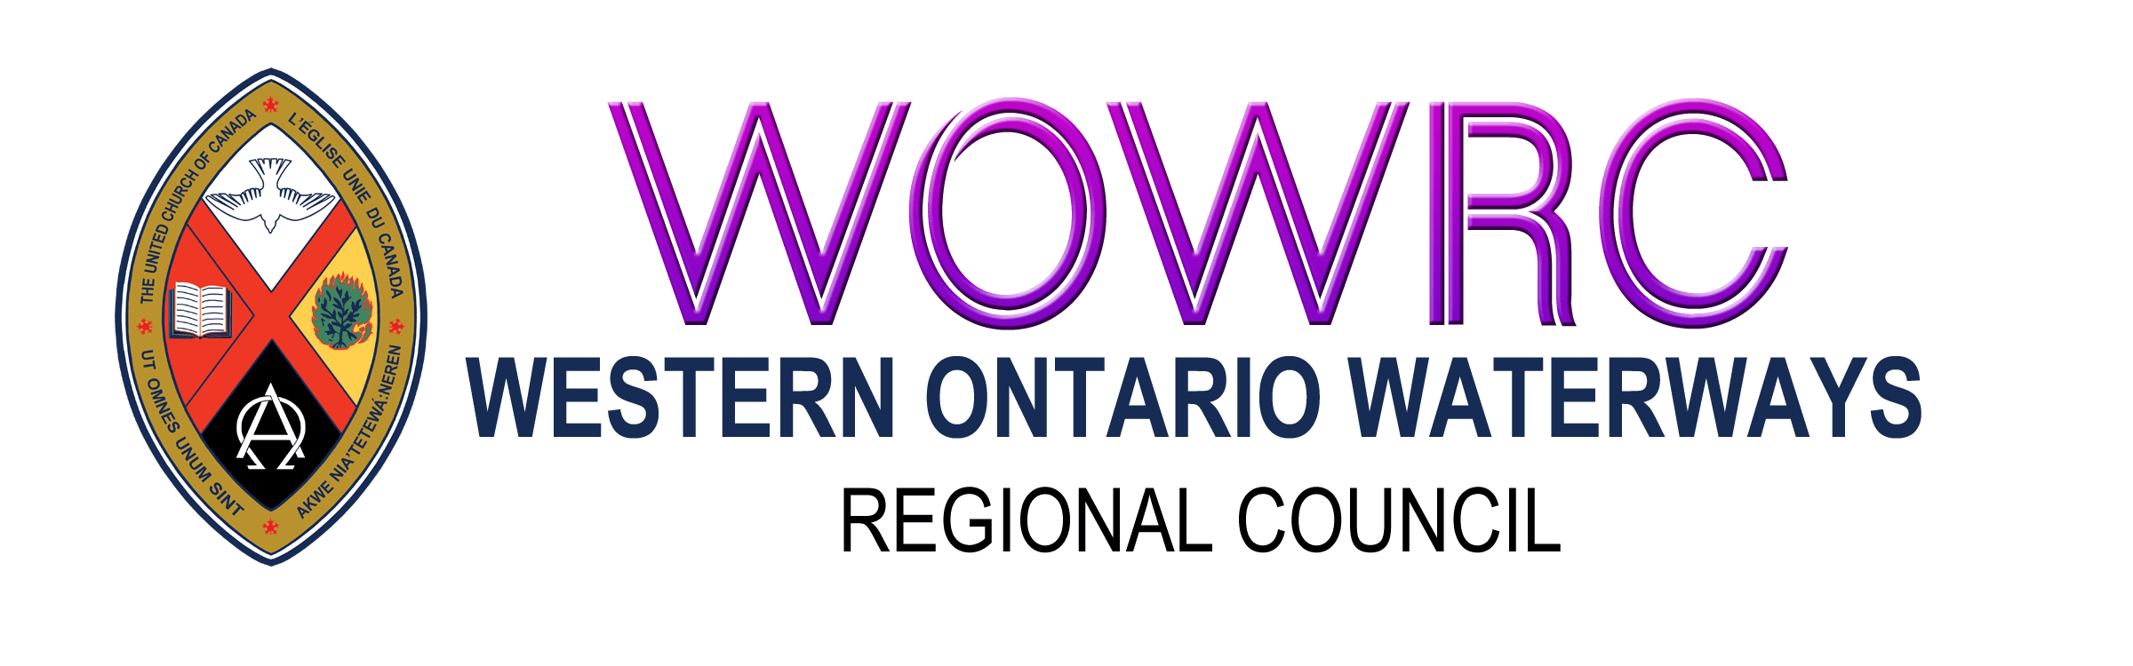
Disbanding Community of Faith: Information and Asset Disbursement

Regional Council Name:
Pastoral Charge Name:
Community of Faith Name:
Address:
Telephone: | Email:
Website Address:
Date of Disbanding:
Set by Regional Council on:
Address:
Telephone: | Email:
Community of Faith Governing Body, Secretary:
Community of Faith, Treasurer:
Address:
Telephone: | Email:
Trustee to be contacted:
Address:
Telephone: | Email:
Current Minister OR Pastoral Charge Supervisor:
Address:
Telephone: | Email:
Minister’s New Call or Appointment If Known:
Pastoral Charge:

Net Asset Calculation
Property | $ Amount
Cash  Including bank accounts and proceeds from investments | $
Sale Price of Property | $
Other | $
Total Assets | $
Expenses
Legal and Real Estate Fees | $
Unpaid Assessments for Current  and prior years | $
Other Indebtedness (please list in detail) | $
Total Expenses | $
Total Amount Available for Disbursement  (Total Assets minus Total Expenses) | $

Disbursement of Assets
Total Amount Available for Disbursement $
Recipient | Percentage | Dollar Amount | Cheque # | Date
Disbursements to UCC Ministries | 33% ARW  33% HF  30% WOW | $
1.
2.
3.
4.
5.
6.
Balance to be Disbursed according to Regional Property Policy * | 67% ARW  67% HF  70% WOW | $
Indigenous Ministries (held at General Council) | 15% ARW  12% HF  15% WOW | $
Mission and Service (current Year) | 12.5 ARW  10% HF  12.5% WOW | $
Mission and Service Endowment Fund | 12.5% ARW  15% HF  12.5% WOW | $
United Church Archives Fund | 2% ARW  5% HF  5% WOW | $
Regional Council | 25% ARW  25% HF  25% WOW | $
Total Amount of Disbursements | 100% ARW  100% HF  100% WOW | $

* Cheque Regional Council to be sent to: [name of regional council] Regional Council, P.O Box 100, Carlisle, ON L0R 1H0
Associated Motions

Motion by Community of Faith proposing disbursement to UCC Ministries (% of total)
Date:

Approval of Disbursement Proposal by Covenant Commission
Date:

Approval of Disbanding Date by Regional Council
Date:

Record of Distribution of Assets

Receipt of Funds by Regional Council for Disbursement
Date:

Funds disbursed by Regional Council
Date:

