To access a link in this newsletter, please press CTRL + mouse click on the highlighted link.

View this email in your browser
Next Deadline for submissions: TBA
Forward this to a friend to sign up for this newsletter.

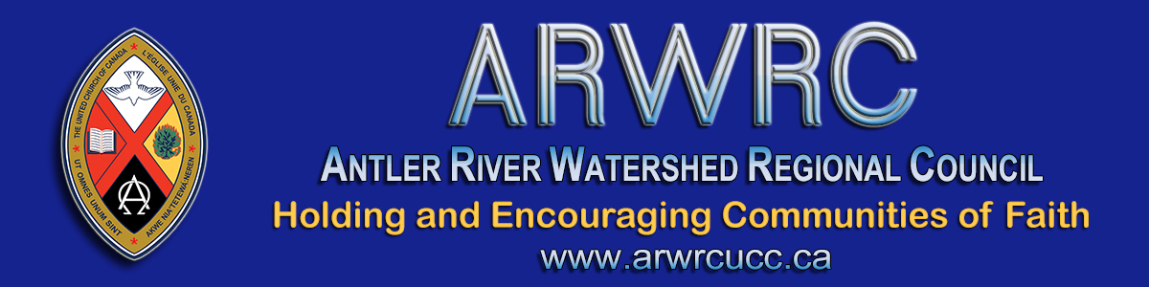

Dear Members of the Regional Council,

Are you our next regional council President? Do you care about Holding and Encouraging Communities of Faith? If so, this is one way to participate in that ministry!
At the October 2020 Fall meeting the regional council will be electing its next President. The new President will assume office immediately as of the rise (or conclusion) of the Fall 2020 meeting.
President Joyce Payne is relocating outside of our regional council and has resigned her office as of then. Her commitment to, and care for the communities of faith and ministry personnel in the regional council, has been a blessing. She will be missed! If assuming the role immediately concerns you, please talk with me.
More details, including the Position Description, can be found in the Governance Handbook.
Is this the next great adventure God has waiting for you?
Being President is an opportunity that you do not want to miss. There is no other single event in my years in ministry that had the impact being President of Conference did. It shaped my understanding of myself and of how I offer leadership. I am grateful for what I learned and how I was formed for ministry through the experience of being President.
Consider yourself tapped on the shoulder!
If you would be willing to let your name stand as a nominee for president, please complete the Expression of Interest Form by FRIDAY OCTOBER 30 at 6 PM. This information (minus your personal contact details) will be available to regional council members for consideration before voting. Nominees will be speaking to the regional council before the election for up to 5 minutes via Zoom on Saturday morning, October 31st.
Please prayerfully consider letting your name stand as a nominee.

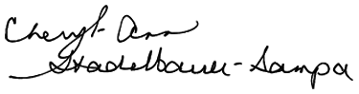
Cheryl-Ann Stadelbauer-Sampa
Executive Minister

The Antler River Watershed Regional Council newsletter welcomes submissions of upcoming events, regional news and educational opportunities. This is also the place to keep up-to-date on information from the regional office.

Holding and Encouraging
Communities of Faith

Antler River Watershed Regional Council
The United Church of Canada

Sign up for our newsletters.

For information, contact Pretima: pkukadia@united-church.ca
Our phone number is: 1-833-236-0280
Our mailing address is:
Antler River Watershed Regional Council, UCC
PO Box 100
Carlisle, On L0R 1H0
Canada
Add us to your address book
Copyright © 2020 Antler River Watershed Regional Council, UCC, All rights reserved.

