To access a link in this newsletter, please press CTRL + mouse click on the highlighted link.

View this email in your browser
Next Deadline for submissions: TBA
Forward this to a friend to sign up for this newsletter.

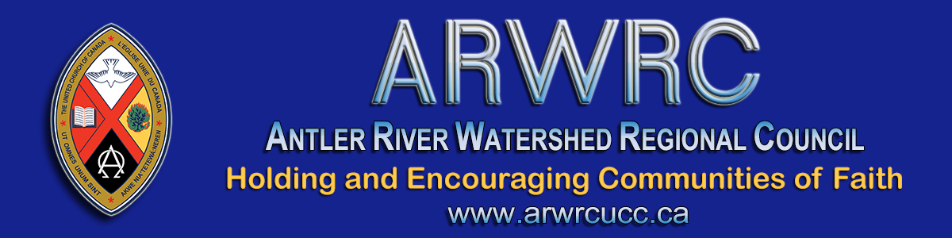

Affirming Our Communities, Affirming Our Faith
“Love one another as I have loved you.”
Join us on the Affirming Journey: Affirm Network Workshop
Tuesday, September 22 from 3:00 to 4:30 pm
What is the workshop about? At local, regional and national levels we have a part to play and this workshop offers – in plenary and small group discussion - information, education and humour for living out this call.
At the Fall Meeting of the regional council you will be asked to vote on a remit to add to the wording for Article 10.0 of the Basis of Union.
The question is: Does the regional council agree that
a) the Order of Ministry be open to persons of all gender
identities; and
b) the Basis of Union be amended to reflect this change.
Read the Affirming Ministries Action Plan.

Join us Tuesday, September 22 at 3:00 pm, click on this Zoom link

To join by webcam:  Click on the Zoom link. Zoom will open in your web browser. If asked, enter  Meeting ID numbers: 913-3888-0811 | To join by telephone audio only:  Call the Toll-free number 1-855-703-8985. When asked enter the  Meeting ID numbers 913-3888-0811

The Antler River Watershed Regional Council newsletter welcomes submissions of upcoming events, regional news and educational opportunities. This is also the place to keep up-to-date on information from the regional office.

Holding and Encouraging Communities of Faith

Antler River Watershed Regional Council
The United Church of Canada

Sign up for our newsletters.

For information, contact Pretima: pkukadia@united-church.ca
Our phone number is: 1-833-236-0280
Our mailing address is:
Antler River Watershed Regional Council, UCC
PO Box 100
Carlisle, On L0R 1H0
Canada
Add us to your address book
Copyright © 2020 Antler River Watershed Regional Council, UCC, All rights reserved.

