To access a link in this newsletter, please press CTRL + mouse click on the highlighted link.

View this email in your browser
Next Deadline for submissions: October 23
Forward this to a friend to sign up for this newsletter.

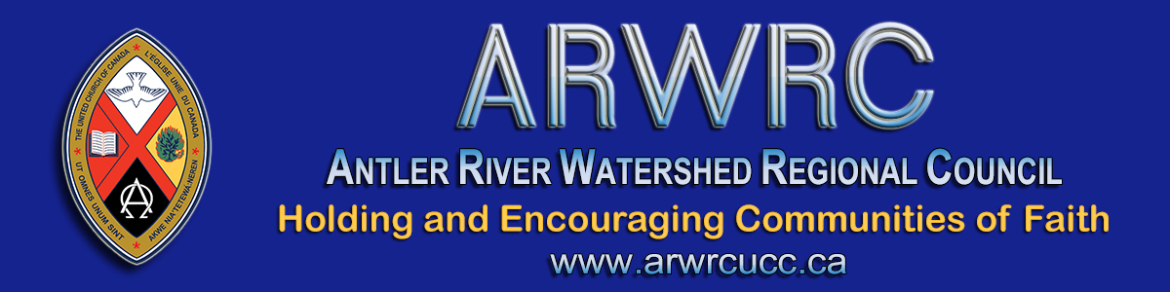

Next Week is Our First Ever
Virtual Regional Council Meeting!

Hi friends!!!!
Our first virtual meeting for Antler River Watershed Regional Council is coming up soon, October 29 through 31, with our Celebration of Ministry service live streamed on Sunday November 1st at 10:00 a.m.

October 26  Detailed Financial Review | Monday | 6:30 *Zoom help  7:00 – 8:00 pm
- - - - - - - - - - - - - - - - - - - - - - - - - - - - - - - - - - - - - - - - - - - - - - - - - - - - - - -
October 29 | Thursday | 5:45 – 7:30 pm
October 30 | Friday | 3:45 – 5:30 pm
October 31 | Saturday | 9:15 – 11:30 am  12:45 - 2:30 pm
November 1 | Sunday* | 10:00 am
*Celebration of Ministries Service will be live streamed

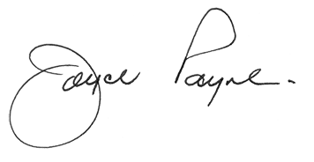
We encourage you to set this time aside to be able to engage in the work of our regional council and support the many ministries that are sharing the work of discipleship in our areas.
During our worship time on Thursday we will celebrate Holy Communion, so we would ask that you have a biscuit or cookie and something to drink available for you to participate in this sacrament of worship.
Our meeting will be one of information and inspiration, where we will learn about the work happening in our region as part of our discipleship journey. We will also conduct the business necessary for our movement forward into the future, and we will have fun together as we build community and interact with each other.
We are deeply grateful for all the work being done by our staff to support technology to enable this meeting to be the best it can be.
THANK YOU … Sue, Ruthanna, Pretima, John, Diane MJ, Kathy, Lynne, Diane B, and Cheryl-Ann for all you do and are doing to make this meeting an efficient and productive one.
A workbook, agenda and important information for you to connect to the meetings will be sent out soon (Friday).
Looking forward to being with you all.
Blessings,
Joyce Payne, President

Dear Members of Antler River Watershed Regional Council,
Click to Register before midnight Sunday!
Plans are underway for our regional council meeting and we are looking forward to seeing you there. All ministry personnel, representatives from communities of faith and guests joining the meeting must register by the registration deadline: Midnight, Sunday, October 25.
Registrants/delegates will receive:
- This is the Zoom link for the financial webinar (https://united-church.zoom.us/j/95680297134), scheduled for Monday, October 26 from 7:00 to 8:00 p.m.
***For those who may not be at ease with Zoom please join us at 6:30 this evening for assistance. It will be helpful to read the Workbook section Participation in a Virtual Meeting in advance. There is not time in the meeting itself to resolve individual participants’ technical questions. Join us to maximize your participation.
- The link to the Workbook for the meeting with reports, background information, nominee information and meeting materials will be provided to registrants on Friday, October 23. Watch for this email.
- The link for the meeting sessions will be the same link and will be used for Thursday, Friday and Saturday (will be in email on Friday also).
- The live-streamed Celebration of Ministry service on Sunday at 10 a.m. will be found on the regional council YouTube channel. We will provide a link on Friday that you can share with your community of faith - this service is open to all - share this information.
- Two key items at the regional council meeting will be:
1) The Affirm Action Plan and
2) The remit on gender identity.
The Action Plan and Remit wording will be found in Proposals 2 and 3 of the Workbook. In the meantime, be sure to review the webinar, Affirming Our Communities, Affirming Our Faith, if you missed it. It provides helpful background information.
- Please note the deadline: Thursday, October 29, Midnight, for submitting Expressions of Interest. Take an active role in your regional council and apply for a role on the Executive or a Commission. Information about nominees will accompany the link to the workbook.
- The deadline for nominations for President is: Friday, October 30 at 6:00 p.m. Consider yourself tapped on the shoulder.
- Please note: if you use a Gmail address for your email that some emails may be difficult to find. After a recent update people are finding incoming emails are often 'sorted' for you and are found in folders such as: Social, Promotions, Spam, etc. When an email is returned we are alerted to get in touch with you.This doesn't happen with gmail addresses. Be on the lookout.
- Zoom Icons: The four icons pointed out below are everything you need for successful Zooming! Super Easy Zoom Guide.
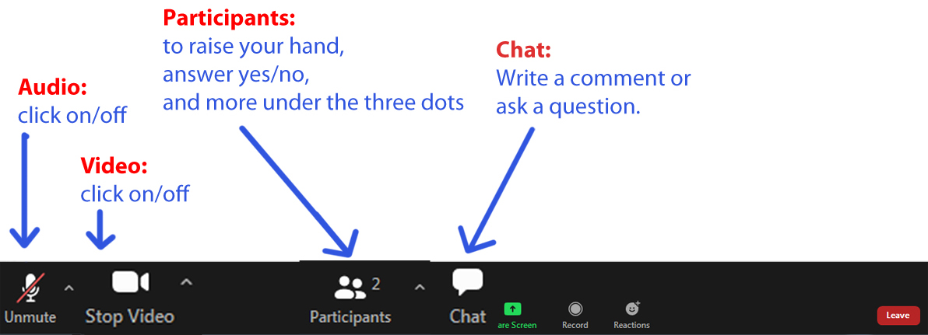
We thank you for your patience as we prepare. Enjoy the beautiful autumn weekend! Looking forward to our time together.

The Antler River Watershed Regional Council newsletter welcomes submissions of upcoming events, regional news and educational opportunities. This is also the place to keep up-to-date on information from the regional office.

Holding and Encouraging
Communities of Faith

Antler River Watershed Regional Council
The United Church of Canada

Sign up for our newsletters.

For information, contact Pretima: pkukadia@united-church.ca
Our phone number is: 1-833-236-0280
Our mailing address is:
Antler River Watershed Regional Council, UCC
PO Box 100
Carlisle, On L0R 1H0
Canada
Add us to your address book
Copyright © 2020 Antler River Watershed Regional Council, UCC, All rights reserved.

