To access a link in this newsletter, please press CTRL + mouse click on the highlighted link.

View this email in your browser
Next Deadline for submissions: October 23
Forward this to a friend to sign up for this newsletter.

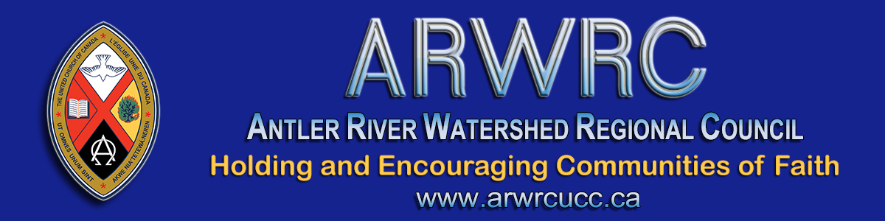

Fall Regional Council Pre-Meeting
Finance Webinar Tonight at 7:00 pm

Hello Delegates!
Join us tonight for a pre-meeting, detailed Finance Webinar. Details and information for the webinar and the Fall Antler River Watershed Regional Council Virtual Meeting below.

October 26  Detailed Financial Review | Monday | 6:30 *Zoom help  7:00 – 8:00 pm
- - - - - - - - - - - - - - - - - - - - - - - - - - - - - - - - - - - - - - - - - - - - - - - - - - - - - - -
October 29 | Thursday  * Communion | 5:45 – 7:30 pm
October 30 | Friday | 3:45 – 5:30 pm
October 31 | Saturday | 9:15 – 11:30 am  12:45 - 2:30 pm
November 1 | Sunday* | 10:00 am
*Celebration of Ministries Service will be live streamed from Grace United Church, Sarnia. President Joyce Payne preaching.

The time is NOW. The time has COME! In a very short time we will be meeting as a REGIONAL COUNCIL. There may be challenges (talking to you, technology) but we will get through them.
- This is the Zoom link for the financial webinar tonight at 7:00 pm: https://united-church.zoom.us/j/95680297134.
- This is the link to the 2020 and 2019 Budget sheets for easier viewing.
- This is the link to the 2021 and 2020 Budget sheets for easier viewing.
- This is the link for all meeting sessions, Thursday, Friday and Saturday: https://united-church.zoom.us/j/99195704462.
- This is the link to the Workbook for the meeting with reports, agenda, background information and meeting materials.
- Please view these Nominations: Expressions of Interest. This list will be updated after the deadline for submissions has passed.
- This is the link to the recorded Affirming Our Communities, Affirming Our Faith on our YouTube channel: https://youtu.be/ICeiHo2O2Bc.
- Zoom Icons: The four icons pointed out below are everything you need for successful Zooming! Download this Super Easy Zoom Guide.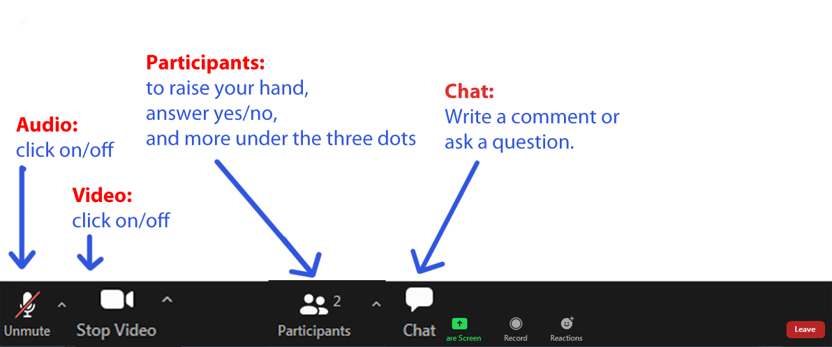
The live-streamed Celebration of Ministry service on Sunday at 10 a.m. can be found here: https://youtu.be/89d7wE0ipLY. Please share this link with your community of faith - this service is open to all.
Attached is a worship service (MS Word and for others) and sermon you can share with worshipers who do not have access to the Internet.
Thank you for your patience as we get started. Looking forward to our time together.

Blessings,
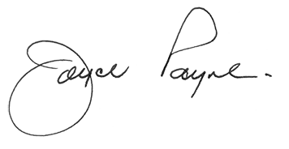
President, Antler River Watershed Regional Council

The Antler River Watershed Regional Council newsletter welcomes submissions of upcoming events, regional news and educational opportunities. This is also the place to keep up-to-date on information from the regional office.

Holding and Encouraging
Communities of Faith

Antler River Watershed Regional Council
The United Church of Canada

Sign up for our newsletters.

For information, contact Pretima: pkukadia@united-church.ca
Our phone number is: 1-833-236-0280
Our mailing address is:
Antler River Watershed Regional Council, UCC
PO Box 100
Carlisle, On L0R 1H0
Canada
Add us to your address book
Copyright © 2020 Antler River Watershed Regional Council, UCC, All rights reserved.

