To access a link in this newsletter, please press CTRL + mouse click on the highlighted link.

View this email in your browser
Next Deadline for submissions: October 23
Forward this to a friend to sign up for this newsletter.

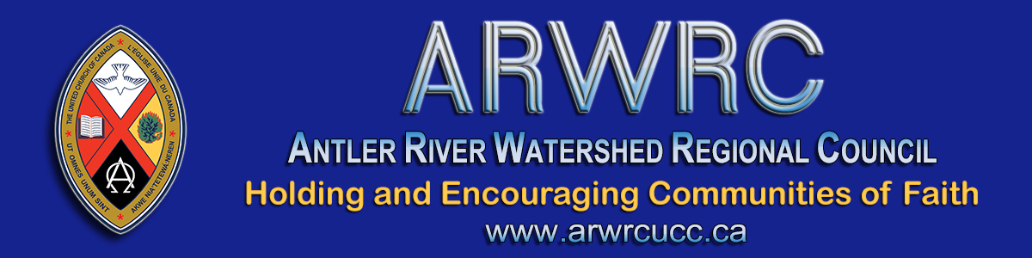

Fall Regional Council Meeting Links & Info

Hello Delegates!
The first session of the Regional Meeting is Thursday at 5:45 pm. Links and information for this session and Friday's and Saturday's are below.

October 29 | Thursday  * Communion see note | 5:45 – 7:30 pm
October 30 | Friday | 3:45 – 5:30 pm
October 31 | Saturday | 9:15 – 11:30 am  12:45 - 2:30 pm
November 1 | Sunday* | 10:00 am
*Celebration of Ministries Service will be live streamed from Grace United Church, Sarnia. President Joyce Payne preaching.

The time is NOW. The time has COME! We will be meeting as a REGIONAL COUNCIL on Thursday starting at 5:45. There may be challenges (talking to you, technology) but we are getting better all the time.
- This is the link for all meeting sessions, Thursday, Friday and Saturday: https://united-church.zoom.us/j/99195704462.
- This is the link to the Workbook for the meeting with reports, agenda, background information and meeting materials (this copy is linked!).
- This is the link to the detailed 2020 and 2019 Budget for more information. * new document
- This is the link to the detailed 2021 and 2020 Budget for more information. * new document
- Please view these Nominations: Expressions of Interest. This list will be updated after the deadline for submissions has passed. * updated document
- This is the link to the recorded Affirming Our Communities, Affirming Our Faith on our YouTube channel: https://youtu.be/ICeiHo2O2Bc.
- This is the link to the recorded pre-meeting Finance Webinar on our YouTube channel: https://youtu.be/GTgMBc5-mJI.
- Zoom Icons: The four icons pointed out below are everything you need for successful Zooming! Download this Super Easy Zoom Guide. Pages 16 - 19 in the Workbook cover Zoom essentials for our meetings.
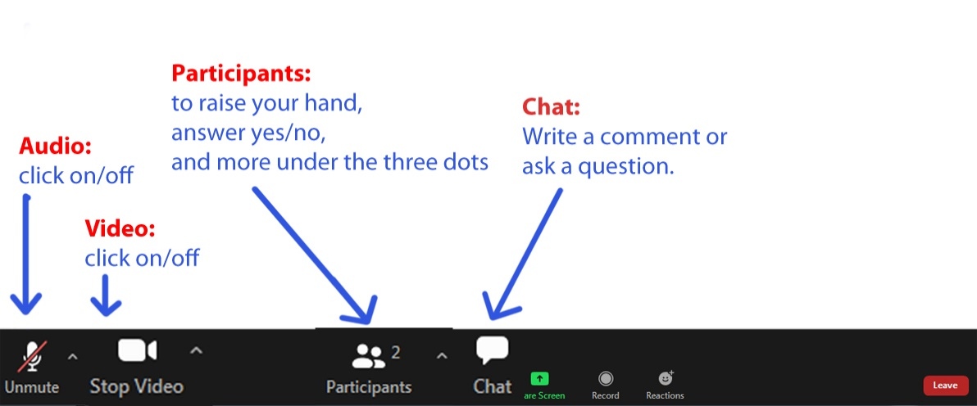
The live-streamed Celebration of Ministry service on Sunday at 10 a.m. can be found here: https://youtu.be/89d7wE0ipLY. Please share this link with your community of faith - this service is open to all.
(My apologies re the alternate worship service and sermon - these will not be available. Pretima)
Thank you for your patience as we get started. Looking forward to our time together.

Blessings,
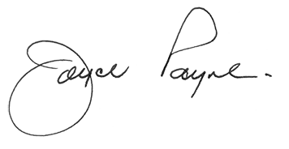
President, Antler River Watershed Regional Council

The Antler River Watershed Regional Council newsletter welcomes submissions of upcoming events, regional news and educational opportunities. This is also the place to keep up-to-date on information from the regional office.

Holding and Encouraging
Communities of Faith

Antler River Watershed Regional Council
The United Church of Canada

Sign up for our newsletters.

For information, contact Pretima: pkukadia@united-church.ca
Our phone number is: 1-833-236-0280
Our mailing address is:
Antler River Watershed Regional Council, UCC
PO Box 100
Carlisle, On L0R 1H0
Canada
Add us to your address book
Copyright © 2020 Antler River Watershed Regional Council, UCC, All rights reserved.

