To access a link in this newsletter, please press CTRL + mouse click on the highlighted link.

View this newsletter in your browser
Next Deadline for submissions: tba
Forward this to a friend to sign up for this newsletter.

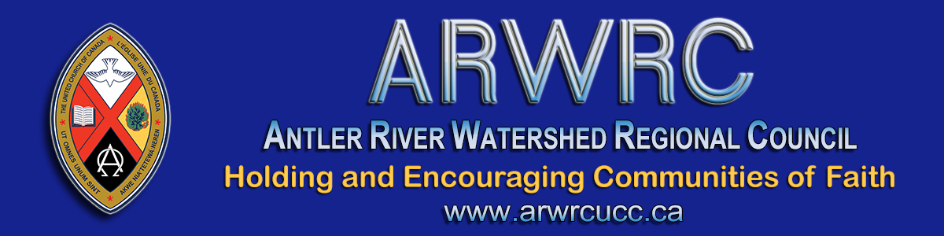

Advent Season 2020
Hello Members and Friends of Antler River Watershed Region

As the newly-elected President of Antler River Watershed Regional Council (ARWRC), the season of Advent, the beginning of a new church year, seems like the perfect time to begin our shared faith journey.
Stepping into the role of President of the ARWRC immediately, I expect to encounter some learning curves and on-the-job training experiences along the way.

Remembering my call to ministry over 40 years ago and remembering where that call has led me over the years, a recurring theme unfolds.
Whatever anxious and apprehensive feelings that accompanied me into new pastoral relationships and leadership roles within the church, they were transformed into awesome opportunities for ministry and new adventures in faith. So, it is that I embrace this new role and this new ministry with excitement and with a sense of joy and wonder. I also take comfort in familiar words found in Voices United (VU 595 v.1),
“We are pilgrims on a journey, fellow travellers on the road; we are here to help each other, walk the mile and bear the load.”
On the threshold of Advent, a time of preparing while we wait in hopeful anticipation of Christmas, an early Epiphany! Pandemic living has challenged us to travel new roads and discover news ways of being church together in a physically distanced kind of way.
In the Epiphany story that follows Christmas we read that the Magi, after visiting Jesus, returned home by a different way. It occurs to me that getting to Bethlehem for Christmas this year will find many a church family having to go a different way, travelling along new roads. Even so, I hope the experience will be one filled with much joy and wonder, especially in a time such as this.
Embarking on our shared faith journey into this new church year
“may we continue to be voices united, seeking justice,
loving kindness and walking humbly in faith in all that we do
and wherever the road leads us.
May it be so!

In Faith & Hope,
President, Antler River Watershed

The Antler River Watershed Regional Council newsletter welcomes submissions of upcoming events, regional news and educational opportunities. This is also the place to keep up-to-date on information from the regional office.
Check out the page and the channel!

Holding and Encouraging Communities of Faith

Antler River Watershed Regional Council
The United Church of Canada

SUBSCRIBE!

Copyright © 2020 Antler River Watershed Regional Council, UCC, All rights reserved.
Want to change how you receive these emails?
You can update your preferences or unsubscribe from this list.

