To access a link in this newsletter, please press CTRL + mouse click on the highlighted link.

View this newsletter in your browser
Next Deadline for submissions: January 20 (January 25 issue)
Forward this to a friend to sign up for this newsletter.

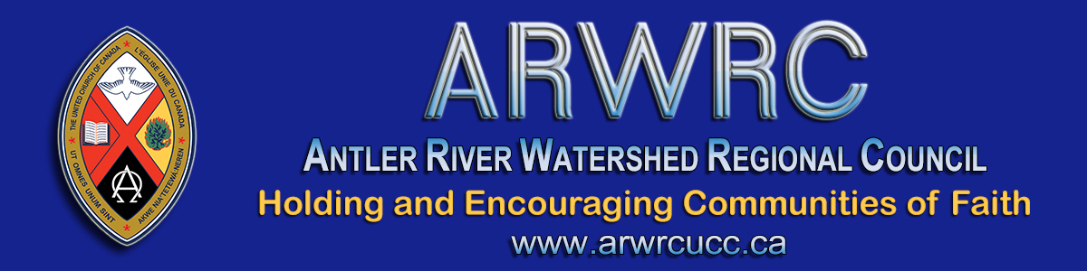

Hello Communities of Faith

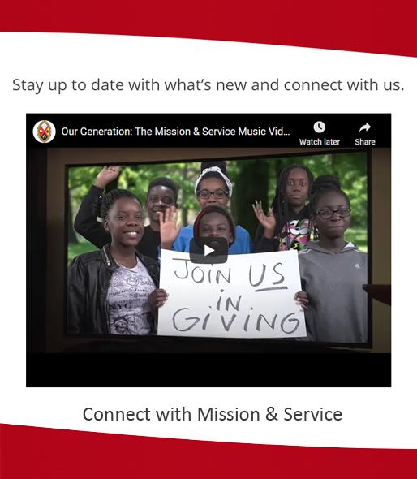
When working on year-end financials, please be sure to transfer 2020 Mission & Service monies to the General Council office before the January 31, 2021 deadline.
Money received after the deadline will be credited to the 2021 year (unless postmarked January 31, 2021 or before, just received later in the mail). The Mission & Service Information and Transfer Form outlines SIX WAYS to transfer funds.

Thanks for seeing to this. If you have any questions feel free to get in touch with me at 519-570-6892 or by email at djagger@united-church.ca.

We appreciate you!
Rev. Dave Jagger
Your Stewardship & Gifts Officer

The Antler River Watershed Regional Council newsletter welcomes submissions of upcoming events, regional news and educational opportunities. This is also the place to keep up-to-date on information from the regional office.
Check out the page and the channel!

Holding and Encouraging Communities of Faith

Antler River Watershed Regional Council
The United Church of Canada

SUBSCRIBE!

Copyright © 2021 Antler River Watershed Regional Council, UCC, All rights reserved.
Want to change how you receive these emails?
You can update your preferences or unsubscribe from this list.

