To access a link in this newsletter, please press CTRL + mouse click on the highlighted link.

View this newsletter in your browser
Next Deadline for submissions: February 24 (March 1 Issue)

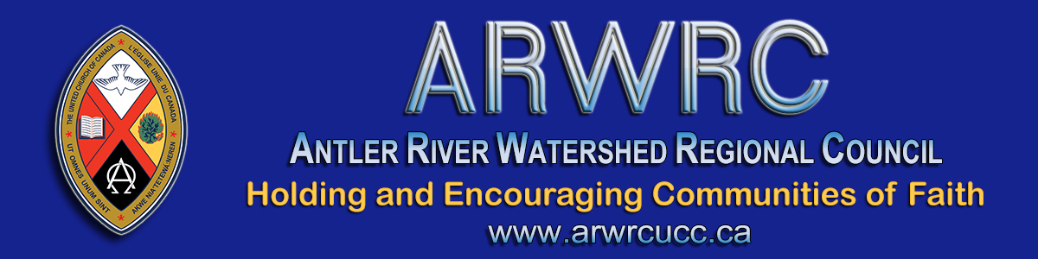

Dear Members & Friends,

On its website, The United Church of Canada affirms the value and dignity of all people and rejects any therapy or practice that labels LGBTQIA+ and Two-Spirit people as abnormal, broken or otherwise not whole individuals. We strongly condemn the practice of conversion therapy or any efforts that attempt to change a person’s sexual or gender identity through treatment that is hostile to a person’s identity, unethical, spiritually and psychologically damaging, and not supported by evidence.
With this in mind I bring to your attention a controversy being experienced in the Sarnia-Lambton area.
In an article in The Sarnia Journal (Feb 11, 2020) titled Backlash – MP Marilyn Gladu Under Fire For Her Stance On Gender Therapy Bill, Troy Shantz writes, “MP Marilyn Gladu’s opposition to a government bill that would criminalize conversion therapy is drawing harsh criticism from churches, religious leaders and community groups.” (The Sarnia Journal 'Backlash' p. 1)

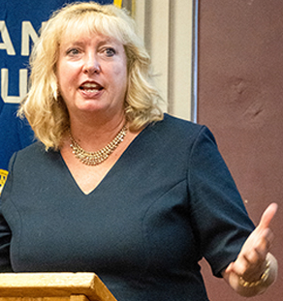
Recently Gladu petitioned the House of Commons to amend or withdraw the Bill C-6. She justified her petition which included 169 signatures in a riding of 100,000 residents by stating it was, “supported by a majority of the 91 churches in my riding … Reaction from local churches was sharp and swift after a January 28 story appeared in The Sarnia Journal.” (The Sarnia Journal 'Marilyn Gladu' p.1) …

Last May Gladu sent a letter to a local church inviting its members to sign and return her petition. “I am writing to you today because I am extremely concerned about an attack on our freedom of religion, conscience, expression, belief and our ability to speak in the public square.” (The Sarnia Journal 'Marilyn Gladu doesn't speak for our church' p.5)
Given that none of the United Church congregations, among others, within the City of Sarnia received a copy of the MP’s petition, none were able to speak to the petition before action was taken by MP Gladu. The few churches outside the city that did receive it declined to support the petition. Many congregations have expressed concern that the MP’s statement was misleading and did not fairly represent all 91 churches and the 100,000 residents in the riding of Sarnia-Lambton.
Gladu maintains that she opposes conversion therapy but is concerned that Bill C-6 is too broad in scope as it may have implications for clergy offering pastoral care to people within their communities of faith. The Government of Canada website already states the bill “would not criminalize private conversions involving teachers, faith leaders and school and pastoral counsellors.” (Bill C-6)
In the spirit of Holding and Encouraging communities of faith within the Antler River Watershed Regional Council, I want to acknowledge and affirm the excellent work of the communities of faith in the Sarnia-Lambton area for speaking up and speaking out in ‘the public square’ in support of Bill C-6.
May justice and mercy prevail.

In Faith & Hope,
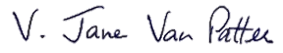
President, Antler River Watershed Regional Council

The Antler River Watershed Regional Council newsletter welcomes submissions of upcoming events, regional news and educational opportunities. This is also the place to keep up-to-date on information from the regional office.
Check out the page and the channel!

Holding and Encouraging
Communities of Faith

Antler River Watershed Regional Council
The United Church of Canada

SUBSCRIBE!

Copyright © 2021 The United Church of Canada, All rights reserved.
Want to change how you receive these emails?
You can update your preferences or unsubscribe from this list.

