To access a link in this newsletter, please press CTRL + mouse click on the highlighted link.

View this newsletter in your browser
Next Deadline for submissions: February 24 (March 1 Issue)

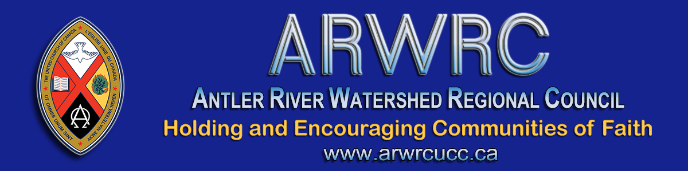

Dear Members & Friends,

This March is a month with many important days to acknowledge and act upon.

I hope you will take time during your worship services to acknowledge these important days and related themes calling us to awareness & action throughout this month & beyond.
May we "March On" in faith together!

March 8 - International Women's Day: My hope is that we will all choose to challenge gender bias and inequality as we work toward helping to create an inclusive world.
March 11: Marks the one-year anniversary of the global coronavirus pandemic being declared by the World Health Organization. We call to mind the loss, the pain, the grief, the resilience, the compassion and the extraordinary sacrifices that have been hallmarks of the past year related to the pandemic.
March 14 - P.I.E. Day: P.I.E. = Public. Intentional. Explicit. These are the standards we hold ourselves and our welcome to when we become affirming, welcoming or inclusive communities. March 14 is a chance to serve some pie and roll out the PIE by celebrating the full inclusion of LGBTQIA+ and Two-Spirit people in faith communities and beyond across Canada. See the Moderator's brief presentation about PIE Day and click the link below it for worship resources.

Moderator Richard Bott invites you to join him in celebrating Pie Day 2021!
Find out more (https://united-church.ca/worship-special-days/pie-day)!

March 21 - International Day for the Elimination of Racial Discrimination: On this day in 1960, police opened fire and killed 69 people at a peaceful demonstration in Sharpeville, South Africa, against the apartheid pass laws. Proclaiming the day in 1966, the United Nations General Assembly called on the international community to work toward eliminating all forms of racial discrimination.

In Faith & Hope,
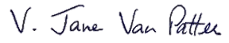
President, Antler River Watershed Regional Council

The Antler River Watershed Regional Council newsletter welcomes submissions of upcoming events, regional news and educational opportunities. This is also the place to keep up-to-date on information from the regional office.
Check out the page and the channel!

Holding and Encouraging
Communities of Faith

Antler River Watershed Regional Council
The United Church of Canada

SUBSCRIBE!

Copyright © 2021 The United Church of Canada, All rights reserved.
Want to change how you receive these emails?
You can update your preferences or unsubscribe from this list.

