Antler River Watershed Regional Council
OF THE UNITED CHURCH OF CANADA
Fall 2023 Online Meeting Minutes
“A Time of Renewal: Rebuild, Reconnect, Revitalize”

Antler River Watershed Regional Council was called to meet on Friday, October 27 and Saturday, October 28, 2023 via zoom. Approximately 107 participants joined online each day.

Meeting Session: Friday October 27 6:00 PM–8:30 PM

Gathering Music: Greg Simpson and Marque Smith

Welcome & Constitute Meeting: President Cheryl Bolton
I constitute this meeting in the name of Jesus Christ, the one true head of the Church and by the authority vested in me by the Antler River Watershed Regional Council for whatever business may properly come before it. The bounds of this meeting are the zoom call and the Best Western Stoneridge Inn, London.

Proposal 1: Opening & Procedural Motion
MOTION: Kerry Stover/Mark Laird
That the Antler River Watershed Regional Council adopt the following as a consent docket:
- Adopt the agenda as amended and authorize the Agenda and Business Committee to make any changes as necessary;
- Approve the minutes of the meeting of 2023-05-12-13;
- Receive the following minutes of the following meetings of the
- Executive
23-09-13
23-06-15
23-04-12
- Congregational Support Commission
2023-06-07
2023-05-10
2023-05-03
2023-04-05
- Human Resources Commission
2023-06-06
2023-05-09
2023-04-11
Note: Minutes are posted on the website www.arwrcucc.ca “About” page
- Appoint Brad Morrison as Parliamentarian;
- Appoint Kerry Stover as Chair, Agenda and Business Committee;
- Name George Bozanich to serve as Equity Support Team Member;
- Name President Cheryl Bolton, Chair Agenda and Business Committee Kerry Stover, Acting Executive Minister Mark Laird, and Executive Assistant Sue Duliban, as the Agenda and Business Committee;
- Name regional council staff members as scrutineers;
- Set the bounds of the meeting as the zoom call, the Best Western Stoneridge Inn & Conference Centre, 6675 Burtwistle Lane, London, ON and the sanctuary of St. Andrew’s United Church, St. Thomas, ON.
- Make the designated representative from any United Church ministry, other than a congregation, which has been invited to become a community of faith by entering into a covenant with the regional council, a member of the regional council for this meeting (Section C.1.2 c);
- Make all guests corresponding members;
- Set the deadline for new business to be submitted to the Agenda and Business Committee as 9:00 p.m., Friday, October 27, 2023.
- Receive all written reports in the workbook.
- Adopt the following method for dealing with proposals for action by the regional council
Step One:
The Presenter will outline:
- What is the issue? and
- The suggested way in which the regional council might respond to the issue.
Step Two:
The President will inquire if there are questions for clarification. Please note this is for clarification only.
Step Three:
The President will then ask if there are changes or additions being suggested for the proposal. Using warm and cool signals, the regional council will seek to come closer to agreement on how to respond to the issue.
Step Four:
Once there is significant agreement, the President will invite the Presenter to move the motion at which point the regional council enters the formal debate process.
CARRIED.

President Cheryl introduced the meeting leadership team, including herself as President:
Kerry Stover: Agenda & Business Chair
Mark Laird: Acting Executive Minister
Brad Morrison: Parliamentarian
Greg Simpson & Marque Smith: Worship/Music
George Bozanich: Equity Team Support Member
Pam Wilcox: Community Building Facilitator
Kevin Steeper: Chaplain
Sue Duliban, Executive Assistant/Minutes Secretary
John Neff, Michele Petick, Pretima Kukadia-Kinting: Zoom Tech

BRAVE, Affirming Statement
Equity Support Team Member George Bozanich introduced his role and raised up BRAVE: Commitments to Community Safety and the tri-region Affirming Statement.

Opening Worship and Land Acknowledgement: Greg Simpson and Marque Smith

President Cheryl invited those attending their first Regional Council meeting or new to the regional council, as willing, to unmute, turn on video and introduce themselves. Those introduced included: Mark Laird, Acting Executive Minister, Vanessa Benoit from Bothwell, Marilyn Barros: Grace UC, Sarnia; Martin Mwale: Chatham, Christina Paradela: Intentional Interim Minister, Riverside London, Rick Mayea, Cottam UC.

Remit Education Update & Questions for Clarification
Thérèse Samuel, Minister, Right Relations & Social Justice, and John Egger, Minister Social Justice led a time of further education, including questions, comments and discussion, on the General Council Remit #1. Question raised: are delegates required to vote on behalf of their congregation or as themselves. Thérèse noted it is up to each delegate to discern how to vote. Thérèse also noted that a frequently asked question is what are the financial implications if the remit passes; this remit is not looking at financial implications. The Indigenous church is currently funded and that will continue should the remit pass.

Concern was expressed by some participants that not enough time had been given to consider the remit vote. Others felt strongly that there had been sufficient time and information provided, as well as discussion at the spring 2023 meeting, to educate themselves for the vote.

President Cheryl asked for wisdom, compassion and discernment as the regional council moved into this very important vote.
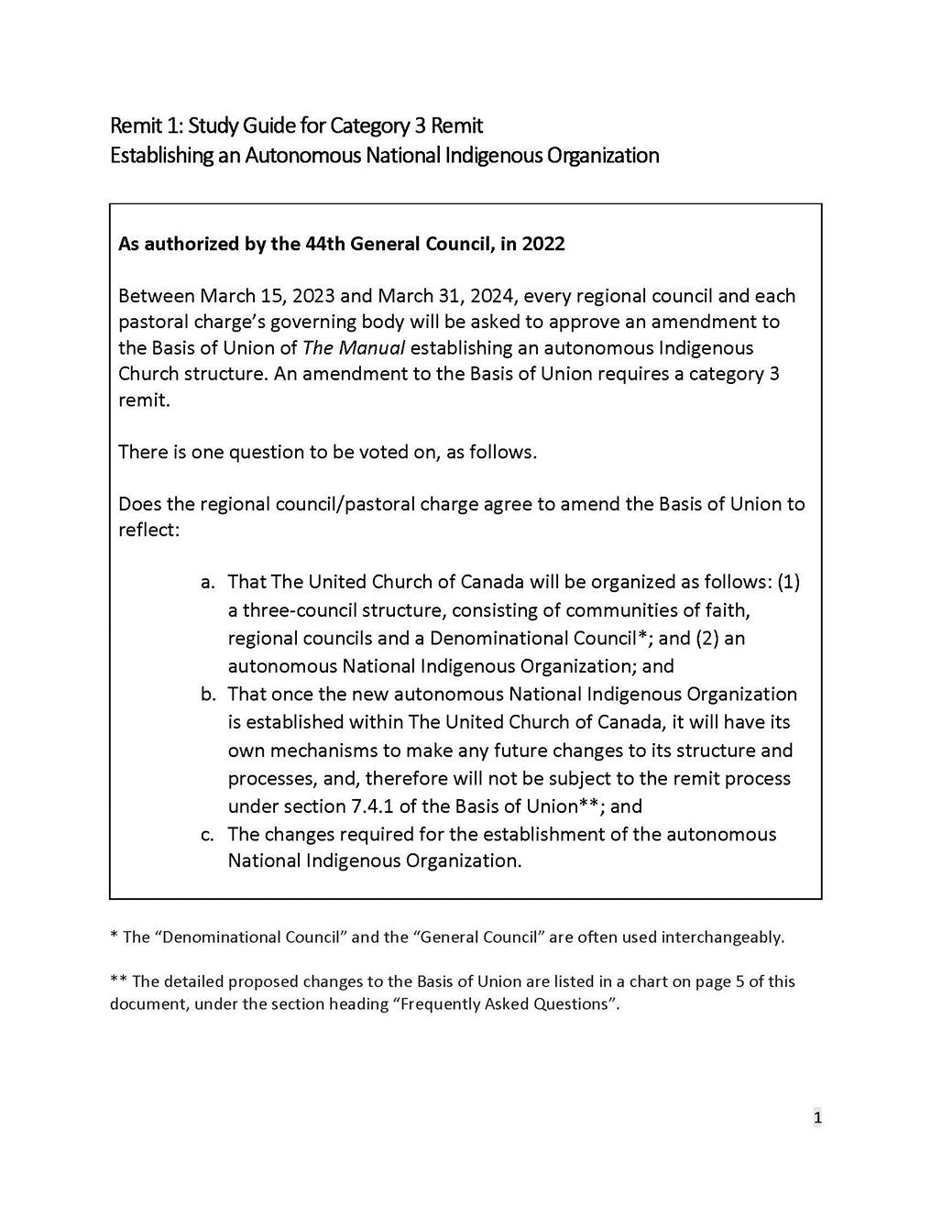
Remit Vote: Accepted by an overwhelming majority. 1 Abstention.
President Cheryl noted that it is not the practice of ARWRC to share the percentage of votes in favour/opposed.

President Cheryl shared a prayer following the vote.

A five minute break was taken.

Agenda & Business Chair Kerry Stover reminded those gathered of the deadline for new business, Friday, October 27, at 9 PM.

Congregational Support Commission: Paying Pastoral Charge Supervisors Discussion
Chair Greg Simpson shared information on Pastoral Charge Supervisors and the new policy, beginning January 1, 2024, of compensation for time spent in supervision of a PC to be paid by the Pastoral Charge. Time was provided in breakout rooms to give participants an opportunity to discuss the role of a PCS and the new policy.

Discipleship and Justice Commission Engagement
Chair Richard Auckland introduced lively and informative videos from the camps that are in ARWRC. Richard noted that some of the primary work done by the Commission has been around Remit 1. He also asked that the Camp Tanner board and employees be held in prayer, as they have decided to cease operations.

Human Resources Commission Engagement
Chair Kerry Stover led a discussion outlining the work of the Human Resources Commission. Noting that the commission meets the second Tuesday of each month. Work includes covenanting, call/appointments, liaison training, search committee training. Call Micol Cottrell, Minister Pastoral Relations, if your community of faith needs a new minister. Reminder that covenanting services are an opportunity to catch up and connect and all regional council members are encouraged to attend these services.

In Memoriam
A video presentation honoured with thanksgiving for the ministry they offered and for the witness they provided: Rev. Dr. Grafton Antone and Rev. Lorne Thrower, who guided and served the church with their living.

Community of Faith Life Cycle Changes
A video presentation honoured the following communities of faith.
Disbanding
Belle River United Church. Final worship service Sunday, October 29, 2023, With thanks for their legacy and faithful service.
Amalgamations and Name Changes
Guilds Pastoral Charge name changed to Rondeau Pastoral Charge
Parkhill United Church and Thedford United Church amalgamated to form Ausable United Church.
Zion United Church and Thorndale United Church amalgamated to form Thorndale United Church.
Working towards amalgamation: Bryanston United Church and Villages United Church, Granton; Kerwood-Bethesda United Church and Strathroy United Church.
Wesley United Church, sold their building and nesting with Charing Cross United Church.

The Friday session closed with prayer.

Meeting Session: Saturday October 28 9:00 AM–2:30 PM (including one-hour lunch break)

Gathering Music: Greg Simpson and Marque Smith

President Cheryl welcomed back all those gathered online.

Worship: Greg Simpson and Marque Smith

George Bozanich brought forward a care and concern and asked that the gathering pray for Rev. Colin Swan, facing a serious health situation, and his family.

Going Deeper on the Regional Council Evaluation: Conversation Groups
Those gathered were invited to self-select a topic from the regional council evaluation to explore in depth in breakout room conversation.

The goal for this time of conversation being to focus on how the regional council might move forward with the evaluation recommendations by providing input and ideas that can help strengthen the regional council’s work together. Each breakout group had a facilitator and a recorder. A compilation of notes taken will be available to the Executive and Commissions and Staff whose work they relate to.

Introduction of Candidate
Laurie O’Leary, Chair Southwestern Candidacy Board, introduced candidate for ordination, Janine Lunn, sharing a biography of her gifts.

Candidate Addresses the Court
Janine Lunn addressed the court, reflecting on Romans 12:2. Janine has a provisional call to Foldens Pastotral Charge and will be ordained.

Proposal 2: Budget 2024
Treasurer Doug Cameron reviewed the proposal and, with Acting Executive Minister Mark Laird, clarified questions about specific lines in the budget, referencing current investment and property policy and noting cost of living amount is based on best practices provided by GCO. Year to date is up to the end of August 2023.
MOTION: Doug Cameron / Kerry Stover
- Receive the internal 2023 operating statement to date for information;
- Receive the 2022 Auditors’ Report;
- Endorse the following principles for the 2024 budget:
- Operating expenses increased by 4.5% for inflation and as the basis for investment income.
- Prioritize Mission & Service grants.
4. Appoint KPMG LLP as auditors for the 2023 Financial Year.
5. Adopt the proposed 2024 budget authorizing the Executive to adapt as necessary within the
above guidelines. CARRIED.

Grace and Lunch

The meeting resumed with gathering music following an hour break for lunch.

Congregational Support Commission Engagement
Chair Greg Simpson shared a video about the commission that highlighted church community projects undertaken in the regional council. Greg shared some further verbal stories, noting the Siloam young at heart program and shared service agreements. Also reminded those gathered that it is critically important to pause and recognize those have disbanded and honour all of those churches, people, congregations who have made tough decisions.

Proposal 3: GC45 Commissioners Election in 2024
Discussion/questions for clarification included discussion on diversity of slate, entrusting the slate to the executive, concern about regional council voices being heard when determining the commissioners, streamlining the voting process. Acting Executive Minister Mark Laird clarified that if the slate is not accepted as presented, it will go back to the Executive. The Executive will then work to prepared a revised slate to bring forward at the spring meeting.

MOTION: Kerry Stover / Greg Simpson
The Antler River Watershed Regional Council agrees:
- To close nominations for Commissioners to GC 45 as of midnight April 15, 2024; to publicize the deadline in advance (website, newsletter, with registration materials).
- To direct the Executive to review the nominations with a view to:
- Ensure a diverse cohort of Commissioners and alternates who bring both experience and new energy to the role and who are committed to the preparation and online prior requirements for General Council;
- Recruit nominees to address gaps in representation.
- To vote on the slate as a whole at the spring 2024 regional council meeting. CARRIED.

Community Building: “What’s On Your Heart?”
Pam Wilcox, Community Building Facilitator, invited those gathered to share, in zoom breakout rooms, “what’s on your heart”. Notes from breakout rooms can be sent to President Cheryl.

Unfinished/New Business: There was no unfinished or new business brought forward.

Save the Dates: Spring 2024 Tri-Regional Council Meeting, online and in-person. May 24, 25, 26, 2024
at the UNIFOR Centre, Port Elgin. Speaker: Moderator Carmen Lansdowne.

Courtesies
President Cheryl expressed thanks to all those gathered for being the regional council. Thanks were expressed to staff, tech, facilitators/notetakers, worship team, equity support, community facilitator, for all their work.

Thanking the President
Past President Jane Van Patter thanked President Cheryl on behalf of the regional council; extending deepest thanks, tremendous appreciation and gratitude for her leadership, and for the theme “Rebuild, reconnect revitalize”.

Proposal 4: Closing Motion
MOTION: Kerry Stover / Mark Laird
The Antler River Watershed Regional Council agrees to
- Entrust any unfinished business from its October 27-28, 2023 meeting to the Executive;
- Authorize the Executive to fill any vacancies (on the Commission/Executive, see if anyone picks up on that) on the understanding that appointments will be confirmed at the next regional council meeting;
- Direct the Executive to plan to convene a meeting of the regional council in the spring of 2024;
- Entrust the Executive and Commissions with the responsibilities and authority of Antler River Watershed Regional Council in accordance with The Manual of The United Church of Canada and the Governance Handbook of the Antler River Watershed Regional Council.
- Close the October 27-28, 2023 meeting of the Antler River Watershed Regional Council at the close of the Celebration of Ministry Service on Saturday, October 28, 2023. CARRIED.

Closing Worship: Greg Simpson and Marque Smith
Adjournment: 2:07 PM
Celebration of Ministry Service held following the meeting session at 4 PM at St. Andrew’s United Church, 60 West Ave., St. Thomas.

