Antler River Watershed Regional Council

Holding and Encouraging Communities of Faith

Governance Handbook
March, 2024

The United Church of Canada/L’Église Unie du Canada

Antler River Watershed Regional Council
GOVERNANCE HANDBOOK

Purpose of Antler River Watershed Regional Council
Holding and Encouraging Communities of Faith

The following governance model has been designed to:
- Serve the purpose of the regional council.
- Support communities of faith in naming and claiming their role in God’s mission.
- Provide support for the formation of healthy pastoral relationships.
- Keep before communities of faith the call to be the church.
- Promote an open healthy and strong relationship between the regional council and communities of faith.
- Offer regional council representatives a variety of ways of serving.

As the regional council experiments with this model, there may be refinements along the way due to insights learned. There will be no change in the delegation of responsibilities of The Manual, Section C, without the approval of the regional council.

Contents
Governance Schematic 4

Position Description: Regional Council Representative 5

Regional Council 6

Regional Council Executive 8

Congregational Support Commission 10

Discipleship and Justice Commission 11

Human Resources Commission 12

Staff Support Committee Mandate 13

Volunteer Recruitment Committee Mandate 14

Funds and Grants 15
Congregational Support Fund………………………………………………………………………………………..……….…. 15
Engaging Stewardship Fund 15
Institute for Specialized Ministry Fund 16
Investment in Leadership Fund 16
Middlesex Resource Centre Fund 17
Ministry with Youth and Young Adults Fund 17
Networks and Cluster Fund 18
Rural Ministry Leadership Fund 18
Vision Fund 19

Appendix A The Manual Section C.2 20

Appendix B ARWRC Investment Policy 25

Appendix C ARWRC Business Trust 27

Governance Schematic

Regional Council (RC)
(See The Manual, 2019 C.1 for Membership)
Elects

Regional Council Executive
(12 members plus President, President-Elect or Past President, Treasurer and Executive Minister)

RC also elects

Congregational Support Commission | Discipleship and Justice Commission | Human Resources Commission

Congregational Support Commission  Staff Resources:  - Minister, Congregational Support  - Administrative Support Staff | Discipleship & Justice Commission  Staff Resources:  - Minister, Faith Formation  - Minister, Right Relations and Indigenous Justice  - Minister, Social Justice  - Administrative Support Staff | Human Resources Commission  Staff Resources:  - Minister, Pastoral Relations (primary)  - Minister, Pastoral Support (more limited)  - Administrative Support Staff

Position Description: Regional Council Representative
Membership of the Regional Council can be found in The Manual, Section C.1.

Skills and Gifts
A combination from among the following:
- An interest in fostering connections within various parts of the church.
- An interest in the life and work of the United Church.
- Energy and time.
- Curiosity and a willingness to learn.
- Interpersonal skills.
- Experience in wider church work would be helpful but is not required.

Requirements of Position
- For lay members - must be a full member of a community of faith within the regional council.
- Attend and participate in the regional council meetings.
- Serve as the connection in the covenant between the regional council and the community of faith bringing the experience of each to the other.
- Serve in one of either the two following ways:
  - Commitment of 3 years, renewable once as a member of:
    - Regional Executive OR
    - One of three Regional Council Commissions
(Congregational Support Commission, Human Resources Commission, Discipleship and Justice Commission)
OR
  - Short-Term Volunteer working as the representative of the regional council with communities of faith OR working in the organizing and delivering of regional council events.
- Have access to technology along with a commitment to learn how to use it.
- A current police record check may be required for some roles.

Renewal of Term
Commission members may renew their appointment for another term beyond the initial two term limit if requested of the Executive by the Commission on which they serve.

Time Commitment
This is an estimate and will be tracked and adjusted based on experience.
An average of two half days/evenings per month. Depending upon the role chosen, the time commitment may be spread consistently over the year or may involve more intense involvement for a briefer period of time during the year.

Support and Benefits for Regional Council volunteers as they serve the church
- Training to cover the role chosen and to improve use of technology.
- Opportunity to develop skills that will strengthen the life of the representative’s home community of faith.
- Opportunity to develop leadership skills.
- Opportunity to deepen and widen relationships across the church.
- Opportunity to learn from one another.

Regional Council
Mandate
The regional council will fulfill the following responsibilities as outlined in The Manual, Section C.2.

Delegation of Responsibilities
Appendix A reflecting Section C.2 of The Manual
Responsibilities are assigned to: Regional Council (full meeting of the region): RC
Executive: EX
Congregational Support Commission: CS (formerly CC)
Human Resources Commission: HR
Discipleship and Justice Commission: D&J (formerly M&D)
Please note the following responsibilities as outlined in sections G, H, I and J of The Manual.
- Section G: Any references to the regional council in Section G are the responsibility of the Congregational Support Commission.
- Section H: Any references to the regional council in Section H are the responsibility of the full regional council.
- Section I: Any references to the regional council in Section I are the responsibility of the Human Resources Commission, with the exceptions of I.1.3.2a), I.1.4.1 concerning community of faith profiles which are delegated to the Congregational Support Commission.
- Section J: Any references to the regional council in Section J are the responsibility of the regional council Executive.
In some cases, two bodies share responsibility for the effective fulfillment of The Manual requirements.

Officers
President *4-year term in total: serving as President-Elect for 1 (one) year,
President for 2 (two) years, Past-President for 1 (one) year.
The Regional Council will elect a President for a two-year term. The President will:
- Preside at the communion table and business table of the regional council and its Executive.
- Serve as the spiritual leader for the regional council, offer a theme and vision for the regional council.
- Serve, along with the Executive Minister, as the official representative of the regional council.
- Strive to inspire the members of the regional council and its communities of faith toward health, joy and excellence.

During the two-year term as President, the home community of faith of a President who is in a pastoral relationship will receive an honorarium in the amount of $1,200.00 per year to assist with coverage for any absences of the President. Any President not in a pastoral relationship will be invited to designate to the UCC ministry of their choice a donation of $1,200.00 per year.

At the conclusion of the term, the former President, once no longer serving in that capacity, will receive an honorarium of $2,000.00.

Travel expenses of the President, President-Elect and Past-President associated with the fulfilment of their roles will be reimbursed.

Treasurer
The regional council will elect a Treasurer for a three-year term, renewable once. The Treasurer will:
- Serve as one of the signing officers for financial matters of the regional council.
- Oversee the financial management of the regional council in partnership with the Executive Minister.
- Assist with the preparation of the budget for the regional council in partnership with the regional council Executive.

The Treasurer will have travel expenses associated with this role reimbursed. Each December, the Treasurer will be invited to name a United Church ministry to receive a donation of $1,000.00 in recognition of the Treasurer’s service.

Membership
See The Manual, Section C.1.
Under section C.1.2b, the following are also members of the Regional Council:
- Any Past President of Antler River Watershed Regional Council.
- Any past president of London Conference or past chair of Elgin, Essex, Kent, Lambton, Middlesex or Oxford Presbyteries who is a member of a community of faith in the regional council.
- Any retired Designated Lay Minister who retired while serving a community of faith in the regional council who is a member of a community of faith in the regional council.

Under Section C.1.2, the Regional Council recognizes the following as members:
- Any past president of one of the Conferences (London Conference) that became part of the regional council along with any past Chair of one of the Presbyteries (Elgin, Essex, Kent, Lambton, Middlesex, Oxford) that became part of the regional council, who is a member of a community of faith in the regional council.
- Youth (under 19 years of age)
Up to 20 youth members:
18 selected by the youth of the regional council at an earlier gathering
2 reserved for youth selected from Indigenous communities of faith
- Young Adults (19 - 30 years of age)
All young adults who wish to attend will be welcome to participate. The registrants will select up to 12 to be voting members of the regional council. The remaining young adults will be corresponding members.

To honour the separation of oversight and discipline of ministry personnel established by the Office of Vocation and in recognition of the workload attached to Office of Vocation roles, those members serving with the Board of Vocation or the Committees of the Office of Vocation will not be considered for decision-making responsibilities in the regional council. Their involvement as members of a resource pool would be most welcome if their Office of Vocation duties allow for such a time commitment.

Meetings
The regional council shall have at least one in-person meeting per year.

Regional Council Executive
Mandate
The regional council Executive will fulfill the following responsibilities as outlined in The Manual, Section C.3.1.

The regional council Executive will also:
- Keep the purpose statement before the regional council and evaluate the life and work of the regional council and its commissions against this.
- Hold accountable the Congregational Support Commission, Discipleship and Justice Commission, and Human Resources Commission, for the responsibilities delegated to each respectively.
- Deal with any matter referred to it for action by one of these three commissions.
- Oversee the finances of the regional council including preparing a budget for the consideration of the regional council and taking responsibility for the administration of the assessment funds, Mission & Service grants and other resources of the regional council.
- Be accountable for the number and position descriptions of regional council staff.
- Serve as the Nominating Committee, preparing a proposed slate for the consideration of the regional council.
- Work with the Executive Minister to ensure clear and timely communication within the regional council.
- Meet annually with the Executive of the neighbouring regional councils served by the same Executive Minister and Executive Assistant.
- Facilitate an annual event with the Congregational Support Commission, Human Resources Commission, and Discipleship and Justice Commission to focus on purpose and planning.

All members of the regional council Executive will be required to sign a confidentiality agreement concerning any information to which they may have access regarding pastoral relationships.

Membership
12 Members, plus President, President-Elect or Past President, Treasurer, and Executive Minister.
To be elected to the Executive by the Regional Council.

A. 5 to be named by office or other
3 – 1 representative from each of the Commissions
Note: Commission members are elected by the regional council.
The members of the Commission will name their representative to Executive.
1 representative to be chosen by the Indigenous Ministries who belong to the regional council
1 representative of the United Church Women (UCW) to be named by the UCW of the regional council

B. Of the remaining 7 positions, 3 are preferred positions:
1 position reserved for a youth or young adult
1 position to ensure racialized representation
1 position to represent sexual orientation/gender identity diversity
Any nominee not elected on the preferred position ballot, will be placed on the ballot for the election of the remaining four positions.

Any groups not named specifically are encouraged to complete an expression of interest through the nomination process.

Nominations will be encouraged in advance of the regional council meeting and from the expressions of interest received this way a slate of nominees will be presented to the regional council for election.

Two key principles will be considered when preparing the list of nominees:
- Living into the mandate of diversity adopted by the preceding Conference(s) in the process by which it/they were named an Affirming ministry; and
- supporting the development of leaders by providing opportunities and support.

Meetings
The schedule for meetings will be reviewed following the election of new members and set for the coming year with a view to workload and personal schedules. The majority of meetings happen virtually.

Congregational Support Commission
Mandate
The Congregational Support Commission carries primary responsibility for the relationship between communities of faith and the regional council and their partnership on matters requiring a decision by both the community of faith and the regional council, other than the pastoral relationship.

The responsibilities of the Commission include:
- The articulation of ministry and mission.
- The use of financial and property resources.
- Local governance.
- The overall health and well-being of communities of faith, such as changes in the life cycle, dealing with real property etc.

The Congregational Support Commission may assign a volunteer to resource a community of faith on matters requiring a joint decision.

The Congregational Support Commission will meet with representatives from a community of faith before acting on requests from the community of faith or exercising oversight and discipline of it.

All members of the Congregational Support Commission are required to sign a confidentiality agreement.

See The Manual, Section C.2 references for responsibilities delegated to the Congregational Support Commission (CS).

The Commission is accountable to the Executive through:
- A representative of the Commission who also serves as a member of the Executive (may be the Chair but not necessarily so); and
- the timely provision of minutes of its meetings according to the format established by the regional council Executive.

Membership
Minimum of 7 members and a maximum of 12 members, at least one-third of total membership to be ministry personnel and one-third of membership to be lay, elected by the regional council, one of whom serves on the Executive.

Meetings
The schedule for meetings will be reviewed following the election of new members and set for the coming year with a view to workload and personal schedules. The majority of meetings happen virtually.

Discipleship and Justice Commission
Mandate
The purpose of the Discipleship and Justice Commission is to provide information, education and opportunities for communities of faith and their members to deepen faith and strengthen service and witness.

The Commission provides both training and development opportunities as well as offering informed and timely responses to enable communities of faith to respond to emerging social and political situations.

The Commission encourages and equips communities of faith to enable their members to discern God’s call to different ministries and ways of service.

All members of the Discipleship and Justice Commission are required to sign a confidentiality agreement.

See The Manual, Section C.2 references for responsibilities delegated to the Discipleship and Justice Commission (D&J).

The Commission is accountable to the Executive through:
- A representative of the Commission who also serves as a member of the Executive (may be the Chair but not necessarily so); and
- the timely provision of minutes of its meetings according to the format established by the regional council Executive.

Membership
Minimum of 7 (seven) members and a maximum of 12 (twelve) members, at least one-third of total membership to be ministry personnel and one-third of membership to be lay, elected by the regional council, one of whom serves on the Executive.

Meetings
The schedule for meetings will be reviewed following the election of new members and set for the coming year with a view to workload and personal schedules. The majority of meetings happen virtually.

Term
Commission members may renew their appointment for another term beyond the initial two term limit (each term is 3 years) if requested by the Commission on hat the ARWRC Executive agrees to allow commission members to renew their appointment for another term beyond the initial two term limit if requested by the Commission on which they serve and that the ARWRC Governance Handbook be updated to reflect this change

Human Resources Commission
Mandate
The Human Resources Commission carries responsibility for:
- The formation and nurturing of healthy pastoral relationships.
- The equipping and licencing of lay worship leaders.

In light of the sensitive nature of its work, all members of the Human Resources Commission are required to sign a confidentiality agreement.

The Human Resources Commission will meet with representatives from a community of faith before acting on requests from the community of faith.

See The Manual, Section C.2 references for responsibilities delegated to the Human Resources Commission (HR).

The Commission is accountable to the Executive through:
- A representative of the Commission who also serves as a member of the Executive (may be the Chair but not necessarily so); and
- the timely provision of minutes of its meetings according to the format established by the regional council Executive.
- A Commission can choose to refer any matter delegated to it to the regional council Executive.

Membership
Minimum of 7 members and a maximum of 12 members, at least one-third of total membership to be ministry personnel and one-third of membership to be lay, elected by the regional council, one of whom serves on the Executive.

Meetings
The schedule for meetings will be reviewed following the election of new members and set for the coming year with a view to workload and personal schedules. The majority of meetings happen virtually.

Staff Support Committee Mandate
The Staff Support Committee oversees the implementation of the Ministry Sharing Agreement signed by Antler River Watershed Regional Council, Horseshoe Falls Regional Council and Western Ontario Waterways Regional Council as that agreement pertains to staff positions.

The Ministry Sharing Agreement states:
Staff Support
A Staff Support Committee will be formed to:
- Resource the Executive Minister in discussions of staff complement, recruitment, oversight and development.
- Serve as the caring presence of the regional councils with their staff.
The Staff Support Committee will consist of six (6) members, two (2) from each regional council who are appointed by the regional council Commission or the regional council Executive and who serve for a period of three (3) years renewable once. Each regional council commits to provide the Staff Support Committee with a budget of $1,000 per year.

Resourcing the Executive Minister
The Staff Support Committee will meet with the Executive Minister regularly to review:
- Position Descriptions.
- Staff Changes: resignations, recruitment.
- Staff Development: supervision, performance reviews.
- Staff Team Building: meetings, retreats.
Any changes/decisions arising from the foregoing will be taken to the regional council Executives for action.
Serving as the Caring Presence of the Regional Councils
The Committee will consider ways to express care and appreciation:
- To the staff as a whole (e.g. such as at Christmas time).
- To assist the Executive Minister with recognizing individual staff at particular milestones (years of service, life events, resignation, etc.).
- To individual staff by serving as a liaison. Each member of the staff support committee will be available to up to two staff to meet with them one-on-one for support and also available to accompany to performance reviews.
Concerns re: Performance
If concerns about the performance of a member of the staff team are brought to the attention of the Staff Support Committee, the Committee member will share them with the Staff Support Committee and Executive Minister to enable the Executive Minister to follow up on the matter.

If the concern involves inter-personal conflict, efforts will be made to facilitate face-to-face mediation between the individuals involved with the Staff Support Committee’s assistance.

If the concern involves the Executive Minister, the Staff Support Committee will bring this to the attention of the Executive Minister for discussion. Any matter not resolved in this way will be forwarded to the General Secretary as the supervisor of the Executive Minister.

Volunteer Recruitment Committee Mandate
The Volunteer Recruitment Committee will
- Seek and contact potential volunteers throughout the year to fill vacancies as required on the Executive, Commissions, Staff Support Committee as well as the election of commissioners to General Council when required.

- Track all volunteers in the Regional Council ensuring diversity and best use of volunteers’ gifts and experiences.

- Communicate with Communities of Faith through different mediums to raise awareness of the importance of appointing Regional Council Representatives and encourage networking.

- Acknowledge receipt of and review Expressions of Interest forms.

- Review expressions of interest and prepare a slate to be accepted at the Spring Regional Council Meeting.

- Appointments outside of the Spring Regional Council meeting will be authorized by the Executive and confirmed at the next Regional Council meeting. The term of executive/commission members runs from calendar year when the appointment commenced to the regional council meeting three years later.

- Will regularly review and update the Expression of Interest form on the website and update with staff.

- Communicate the decision of the Regional Council with thanks and connect the volunteers with their respective Chairs.

- Thank outgoing volunteers.

Three key principles will be considered when preparing the list of nominees:
- Living into the mandate of diversity adopted by the regional council
- Commitment to be an Affirming ministry; and
- Supporting the development of leaders by providing opportunities and support.

Membership
1 member from each of the commissions, 2 members from the Regional Council to be appointed by the Executive and with a commitment of 3 years, renewable once.

Meetings
The schedule for meetings will be based on the needs of the ARWRC and particularly in preparation for elections/appointments at Regional Council meeting and the needs of Executive, Commissions and Staff support throughout the year. Workload and personal schedules will be taken into consideration. The majority of meetings to happen virtually.

Funds and Grants

Candidate Support Fund

Source: $11,468 from Elgin Presbytery for students
$2,871.96 from Lambton Presbytery for students
50% of the balance of the Oxford Legacy Fund as at December 31, 2022 (approx. $25,000)
Terms of Reference
Purpose
To provide financial support for candidates.
Available Funds
Interest and principal.
Granting Body and Oversight
Executive Minister and Treasurer.
Criteria
- Available to candidates
- from communities of faith in Antler River Watershed Regional Council or serving a community of faith in Antler River Watershed Regional Council;
- pursuing theological studies in a recognized United Church of Canada program;
- with candidacy status and school enrolment confirmed through the Office of Vocation.
2. A bursary of $2,000 per calendar year to a maximum of $6,000 in total (a T-4A will be issued for
tax purposes).
*A candidate is expected to seek support only from either the regional council out of which
they became a candidate or the regional council in which they serve, but not from both.

Engaging Stewardship Fund
Terms of Reference
Available Funds
This is ARW’s share of the remaining balance of funds entrusted to London Conference for this purpose. The fund will be expended and not replenished.
Purpose
To promote support of the Mission and Service Fund.
Granting Body and Oversight: Discipleship and Justice Commission
The Discipleship and Justice Commission will report annually to the regional council on how the funds have promoted Mission and Service.
Criteria
The Discipleship and Justice Commission will have access to the fund to support events promoting stewardship and Mission and Service.

Procedure
The decision to access the fund will be made by the Discipleship and Justice Commission.
Grant Payment
Approval will be forwarded to the Treasurer and Executive Minister for payment and tracking.

Institute for Specialized Ministry Fund
Terms of Reference
Available Funds
Up to 30% of the principal per calendar year.
Purpose
Events/Training for youth ministry leaders.
Granting Body and Oversight: Discipleship and Justice Commission
The Discipleship and Justice Commission will report annually, starting in 2021, to the regional council on how the funds have supported training for youth leaders and ministers.
Criteria
Applications will be considered to assist with the sponsorship of events and training provided through or in partnership with Antler River Watershed regional council for youth leaders and ministers.
Procedure
Applications will be submitted to the Discipleship and Justice Commission.
Grant Payment
Approval will be forwarded to the Treasurer and Executive Minister for payment and tracking.

Investment in Leadership Fund
Terms of Reference
Purpose
To provide both ministry personnel and lay leaders with financial assistance for learning events.
Criteria
To share equitably the funding allotted to our Regional Council, grants will be limited to one-third (1/3) of the associated costs, to a limit of five hundred dollars ($500). There is no longer an expectation that the Community of Faith and applicant must share the remaining costs equally.
- Applications can only be received by an individual once per calendar year.
- At least half (1/2) of the entire fund is reserved for grants to lay leaders.
Granting Body and Oversight: Executive

Middlesex Resource Centre Fund
Terms of Reference
Available Funds
All prior year interest earned plus up to 15% of principal available to be granted annually.
Purpose
To support resource centre ministries and camps.
Granting Body and Oversight: Discipleship and Justice Commission
The Discipleship and Justice Commission will report annually to the regional council on how the funds have supported resource centres and camps.
Criteria
Applications will be considered for:
- Resource centre events.
- The purchase of resources for a specific camp program.
- Recipients will submit a report and evaluation of the grant receiving project to the Discipleship and Justice Commission within one month of a resource centre event.
Procedure
Applications will be submitted to the Discipleship and Justice Commission.
Grant Payment
Approval will be forwarded to the Treasurer and Executive Minister for payment and tracking.

Ministry with Youth and Young Adults Fund
Terms of Reference
Available Funds
All prior year interest earned plus up to 15% of principal available to be granted annually.
Purpose
Support for ministry with youth and young adults.
Granting Body and Oversight: Discipleship and Justice Commission
The Discipleship and Justice Commission will report annually to the regional council on how the funds have supported ministry with youth and young adults.
Criteria
- Grants will normally be for one-time grants to a maximum of $5,000.
- Grants in excess of this amount or for a multi-year project will require the applicant to meet with the Discipleship and Justice Commission.
- Recipients will submit a report and evaluation of the grant receiving project to the Discipleship and Justice Commission within one month of the event.
Procedure
Applications will be submitted to the Discipleship and Justice Commission.
Grant Payment
Approval will be forwarded to the Treasurer and Executive Minister for payment and tracking.

Networks and Cluster Fund

Source: 50% of the balance of the Oxford Legacy Fund at December 31, 2022 (approx. $25,000)
Terms of Reference
Purpose
Support for the formation of clusters and networks.
Available Funds
All prior year interest plus up to 15% of principal to be available for grants annually
Granting Body and Oversight
ARWRC Executive
Criteria
- assists with events/opportunities for networks or clusters that include communities of faith within Antler River Watershed regional council;
- requests must be endorsed by at least two pastoral charges as a sign of partnership.

Rural Ministry Leadership Fund
Terms of Reference
Available Funds
All prior year interest earned plus up to 15% of principal available to be granted annually.
Purpose
To support training for rural ministry.
Granting Body and Oversight: Executive
The Executive will report annually to the regional council on how the funds have supported rural ministry leadership.
Criteria
- Licensed Lay Worship Leader (LLWL) training and support and support for rural ministry events.
- Up to 30% of the annual grants will be made available for LLWL leadership training.
- Resource opportunities focused on rural leadership. Evaluation within one month of the event.
Procedure
Applications to be submitted to the Executive. The application form will be designed for events to which communities of faith with a rural postal code can apply.

Vision Fund
Terms of Reference
Available Funds
Funds up to a maximum of $15,000 per calendar year are available to assist in innovation in multi-partner endeavours.
Purpose
To support regional council visionary initiatives. This fund enables the regional council to work in partnership with others in experiments in innovation.
Granting Body and Oversight: Executive
The Executive will report annually to the regional council on how the funds have been used to spark ministry innovation.
Recipients will submit a report and evaluation of the grant receiving project to the Executive in time for the next regional council meeting.
Criteria
Applications will be considered for innovations in which the regional council might be a partner or sponsor.
Procedure
Applications will be submitted to the Executive.
Grant Payment
Approval will be forwarded to the Treasurer and Executive Minister for payment and tracking.

See: Financial Support on the regional council website for detailed criteria and application procedure.

Appendix A The Manual Section C.2
Note: CC, C now CS (Congregational Support Commission); M&D now D&J (Discipleship & Justice Commission)

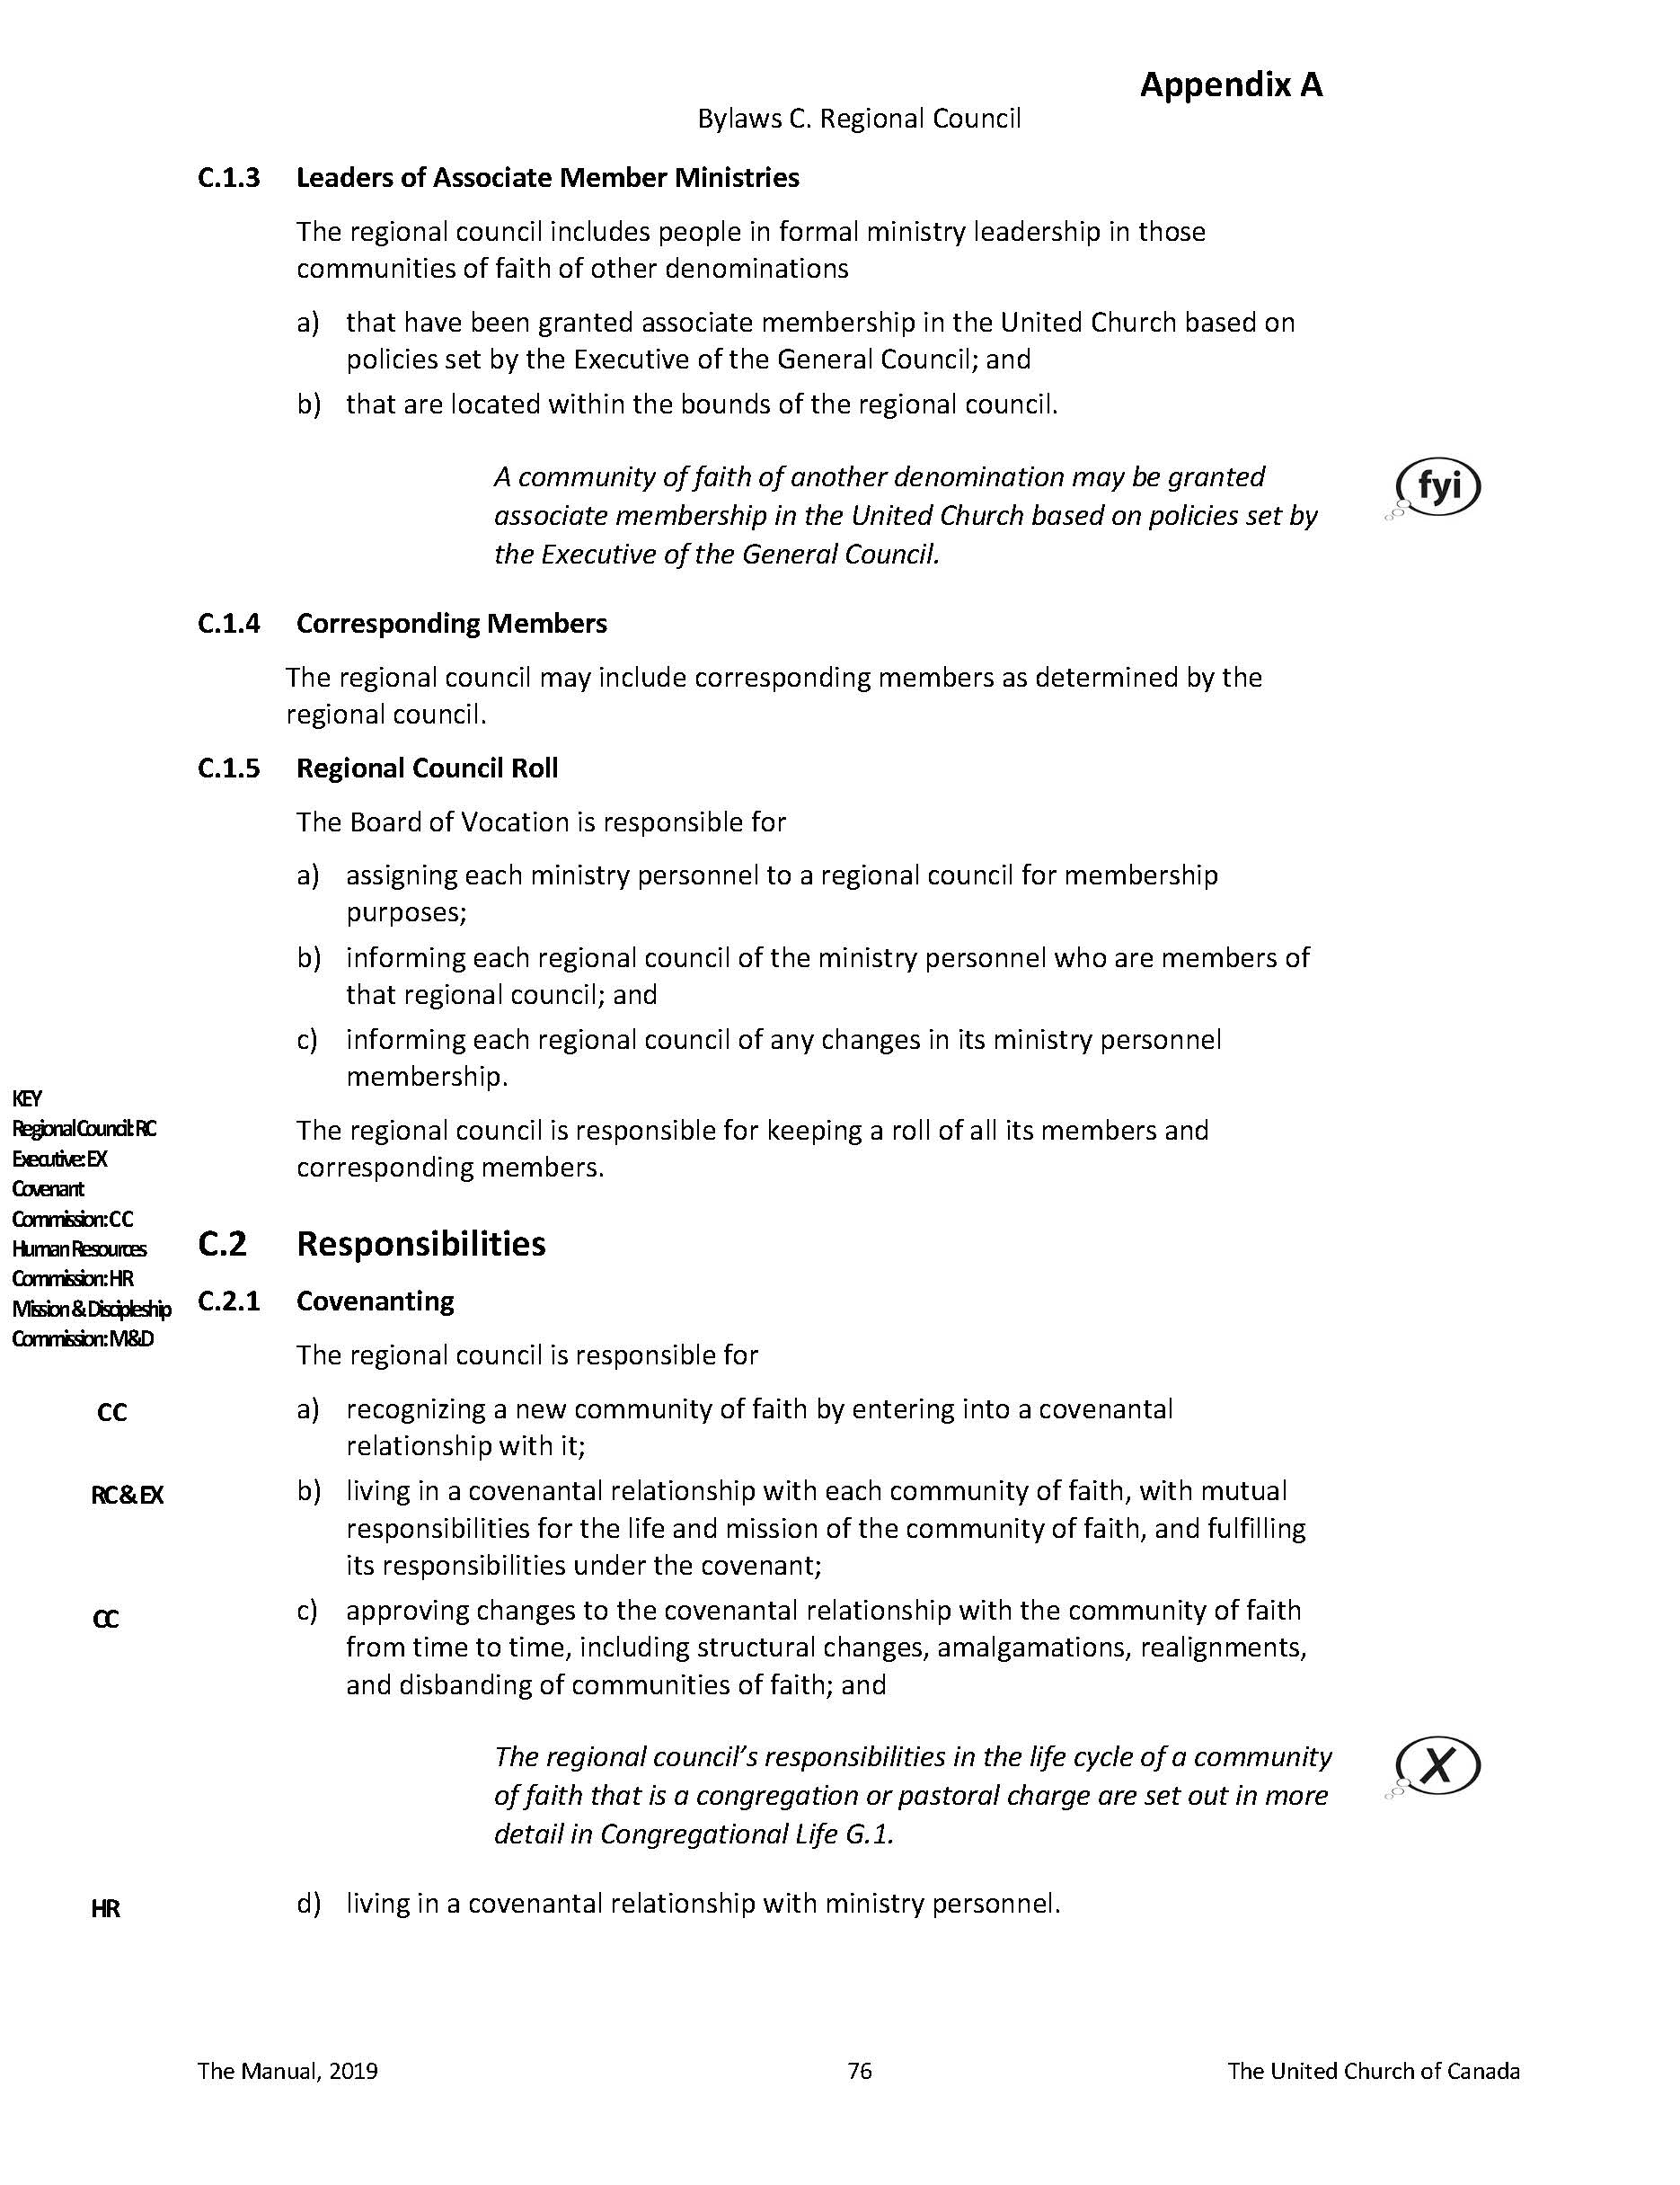
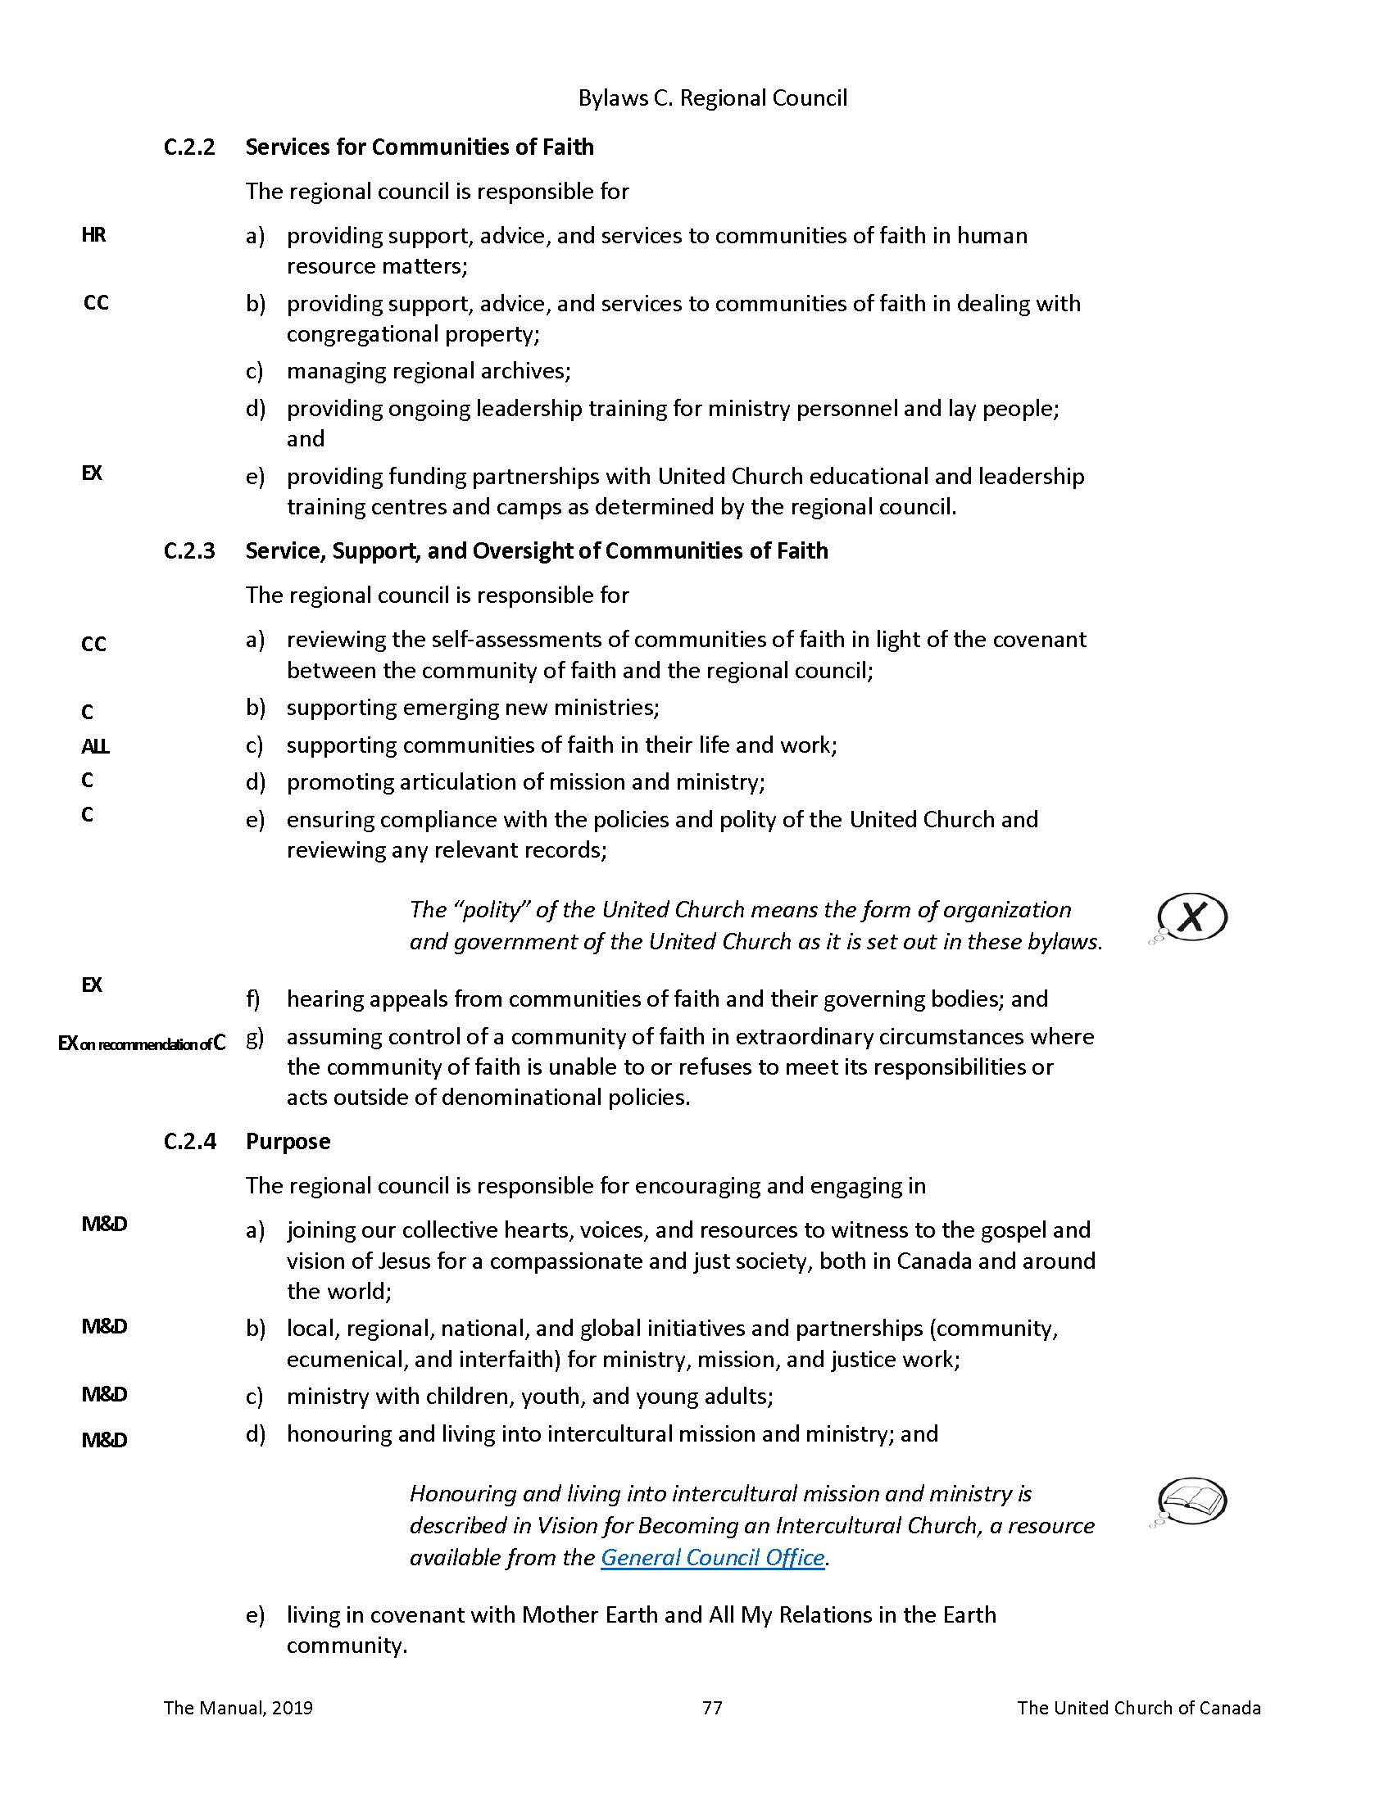

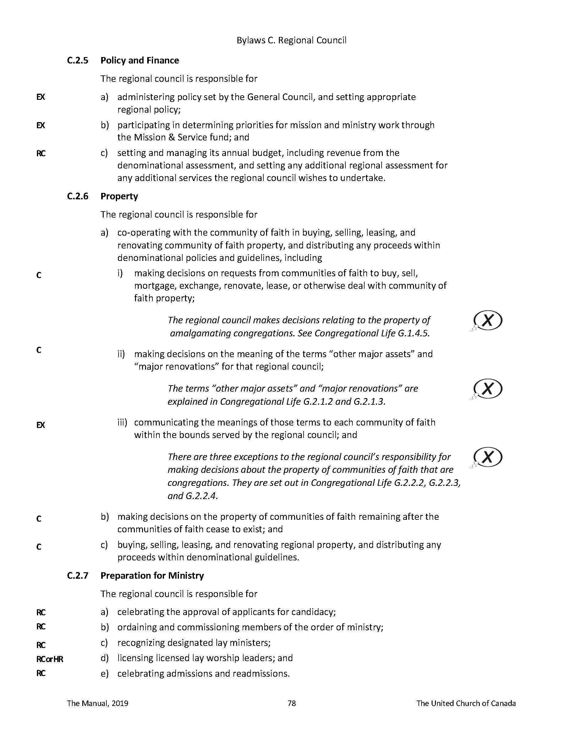

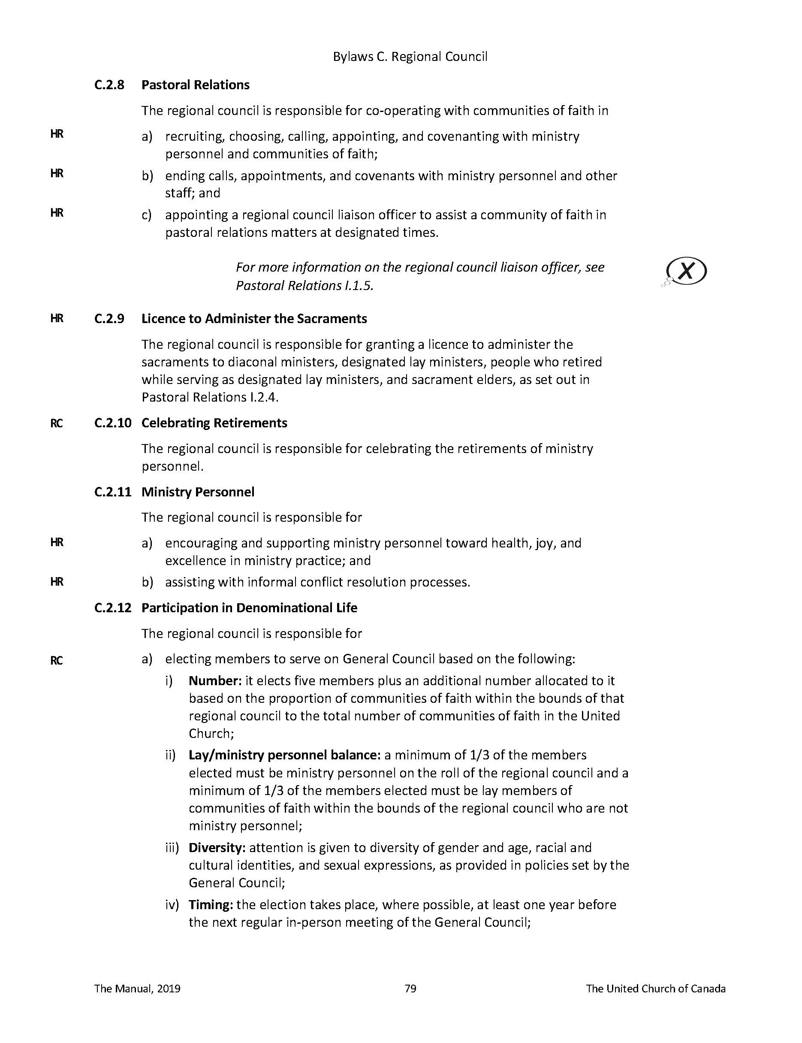
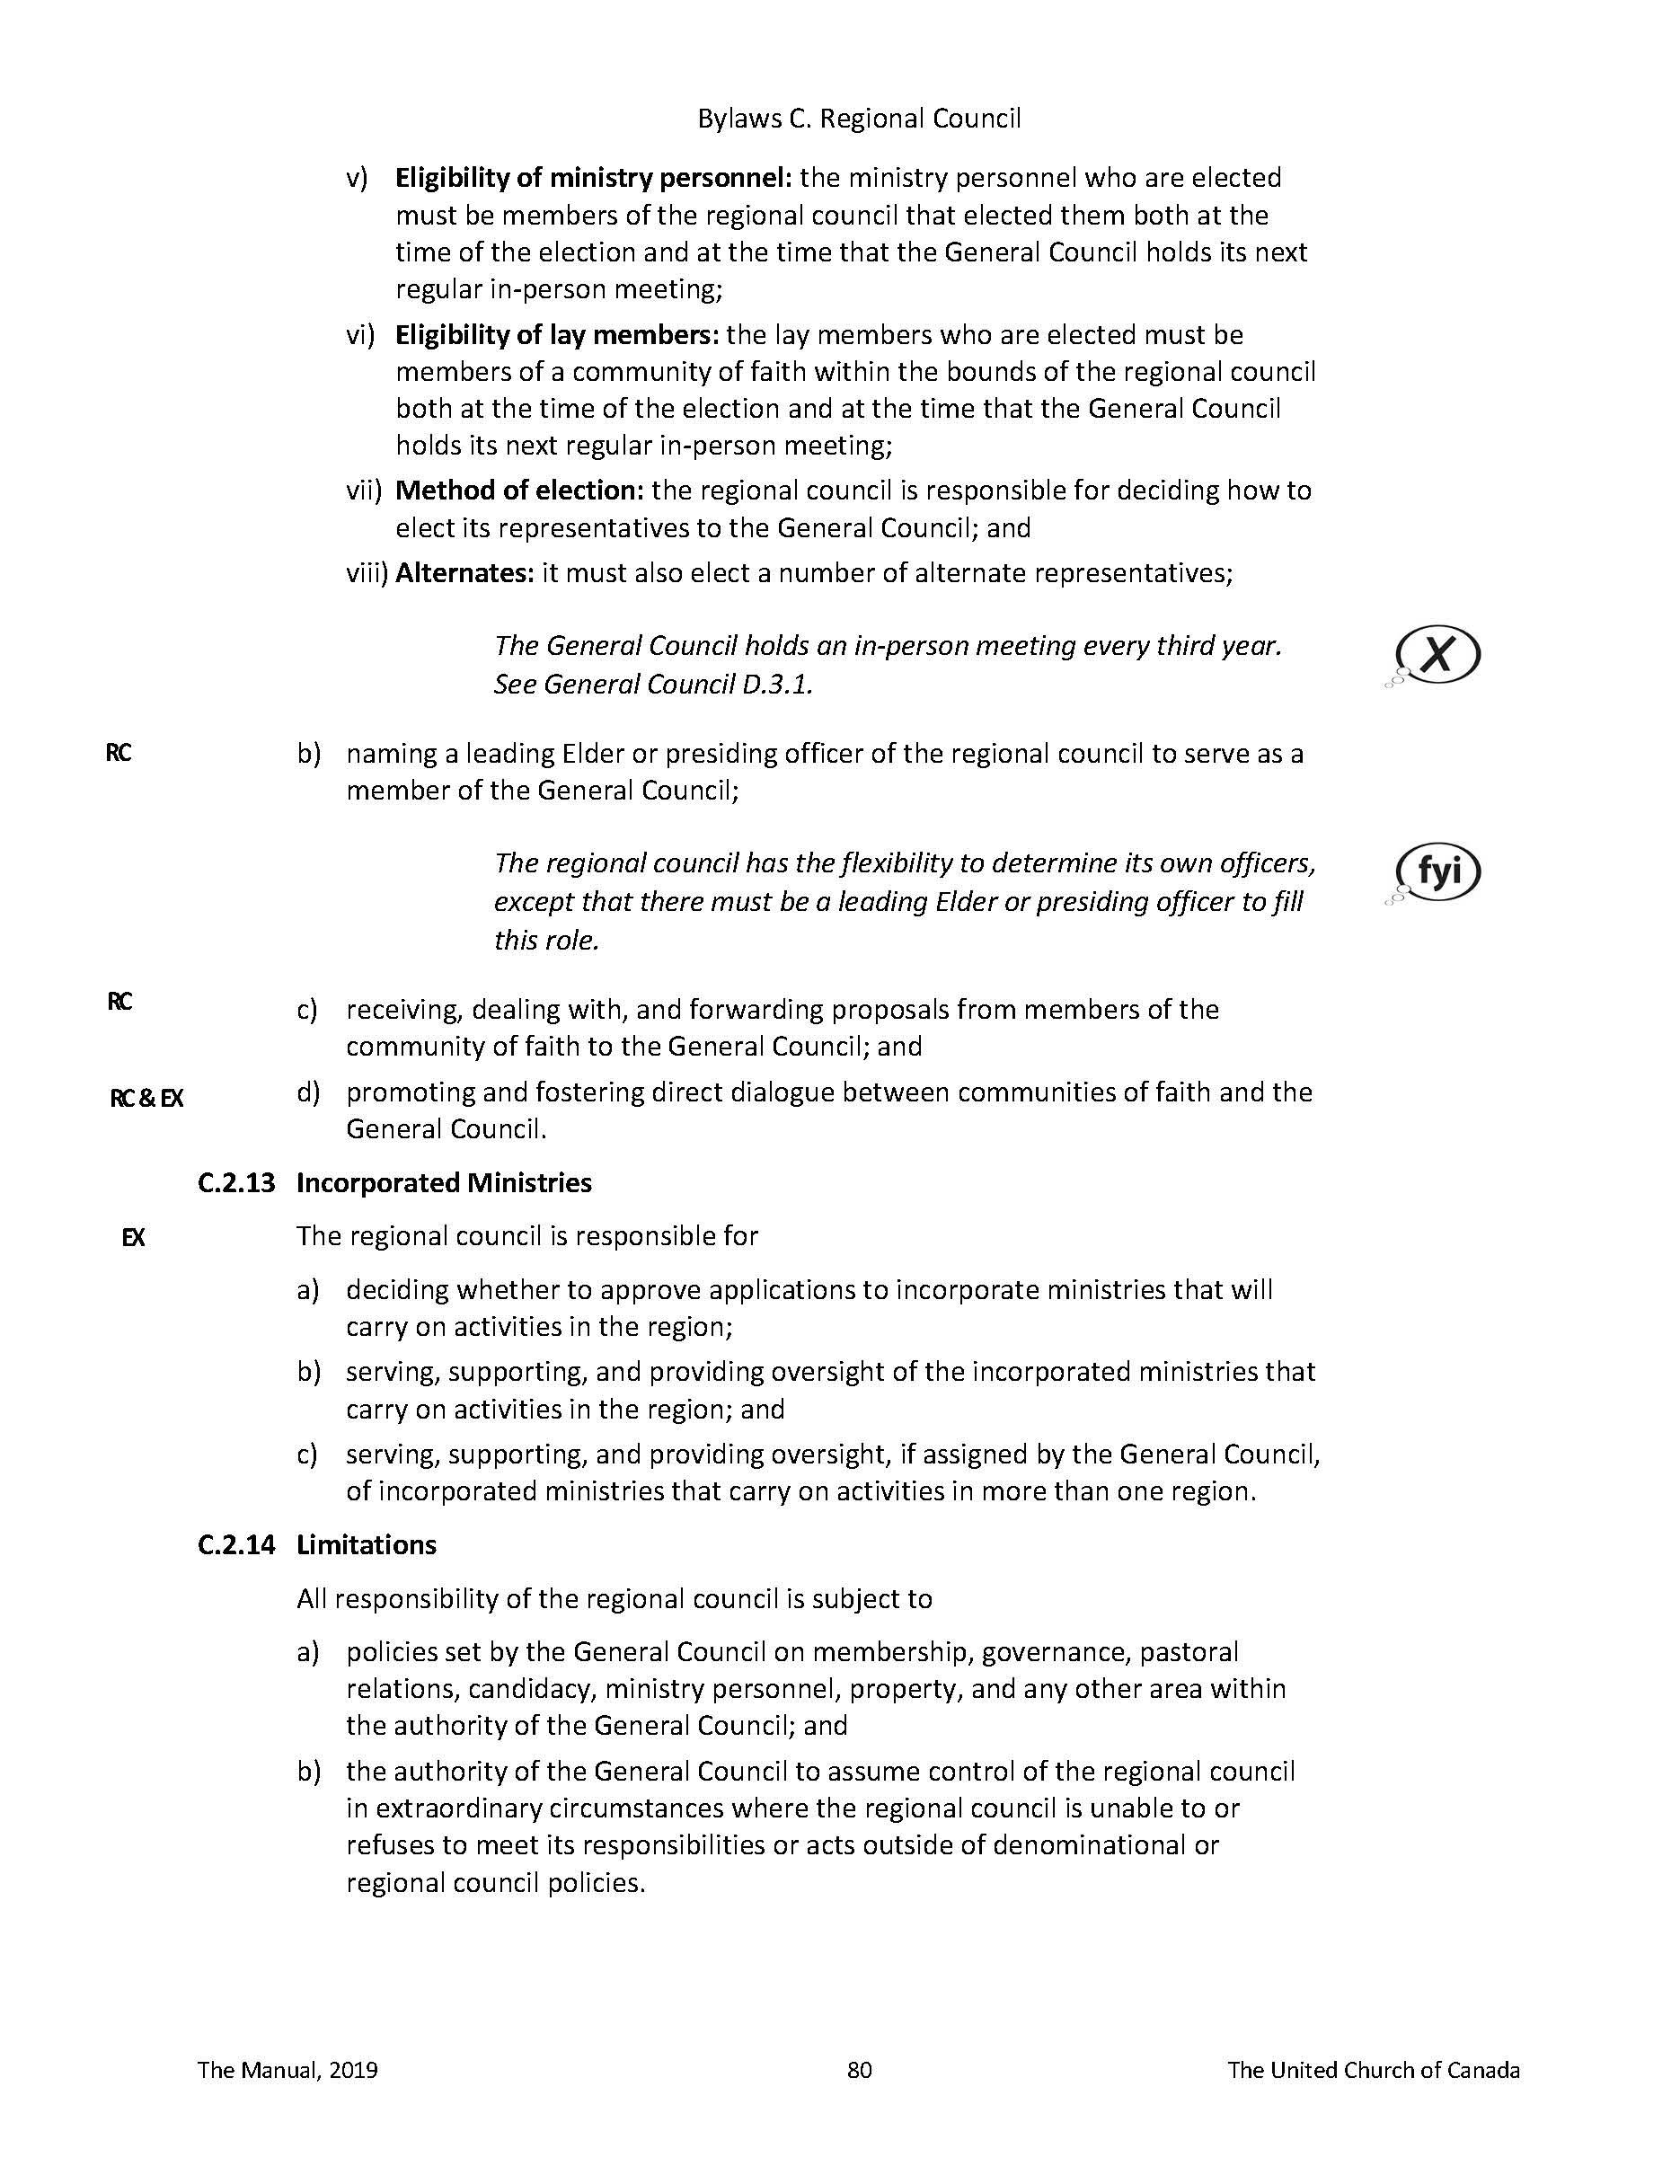

Appendix B ARWRC Investment Policy

Investment Policy
Purpose
The regional council invests money to:
- Support the ministry of the regional council through the generation of income;
- Provide financial resources as necessary to address emerging situations.

Guidelines
- All investments will meet the test of reasonableness as seen by a prudent investor;
- All investment accounts will be managed in partnership with a certified investment advisor;
- There will be no investment in any entity whose operations might reasonably be regarded as
contrary to the mission of the United Church of Canada (arms, tobacco, gambling, fossil
fuels, cannabis).
- The investments will be directed in accordance with this policy by the Treasurer, Executive
Minister, and two appointees named by the regional council Executive. All four will be invited to each consultation with the investment advisor and at least two must be present to take action.
- The investment team is authorized to move financial resources into investment vehicles provided the balance in the current account does not fall below $300,000 (over one quarter of annual expenses).

Investment Portfolio
The investment portfolio will normally be held as follows:
20% Tier 1
15% Tier 2
62% Tier 3
3% Tier 4
Tiers 1, 2 and 3 may vary up to 10% depending upon financial conditions and financial advice. Tier 4 may never exceed 3%.

Tier 1
Definition
Assets that could be turned into cash within one year.

Objectives
Security, liquidity and income.

Eligible Investments
- Deposits in Canadian Chartered banks.
- Debt instruments of the federal and provincial governments of Canada or Crown Corporations
guaranteed by them, maturing with in one year.
- Debt instruments of Canadian Trust Companies up to the limit of the Canadian Deposit Insurance.
- Corporation (CIDC) insurance, maturing within one year.
- Debt instruments of Credit Unions up to a limit of $100,000 maturing within one year.

Tier 2
Definition
Assets which could be required to address a specific situation or fund a new initiative.

Objectives
Security, income and liquidity.

Eligible Investments:
- All investments listed in Tier 1 but with maturities up to 5 years;
- Debt instruments of Canadian companies rated as Investment Grade by Standard and Poor’s or
Canadian Bond Rating Service, maturing within 5 years.

Tier 3
Definition
Assets not likely to be needed in the near future.

Objectives
Return on investments (including both income and capital gains), liquidity and security.

Eligible Investments
- Shares of Canadian Companies listed on the Toronto Stock Exchange (TSX);
- Units of Canadian Income Trusts listed on the TSX;
- Units of Exchange Traded Funds (ETF’s);
- Shares of companies listed on the New York Stock Exchange or Nasdaq.

Tier 4
Definition
Assets that will not be required within 5 years.

Objectives
Return on investments (including income and capital gains), liquidity and security.

Eligible Investments
A maximum of 3% of investments that meet the criteria of Tier 3 be available (if advisable by the investment advisor and those directing the investments) to invest in companies who have the potential to produce higher returns.

Policy Review:
This policy shall be reviewed every 3 years. This will include a review of the appointed investment advisor.

Appendix C ARWRC Business Trust

Business Trust

The Antler River Watershed Regional Trust is for the benefit of the Regional Council. The beneficiary of the Regional Trust is the Regional Council and a wholly-owned affiliate United Property Resource Corporation (UPRC) is the corporate trustee of the Regional Trust.

The United Church of Canada (UCC) incorporated United Property Resource Corporation (UPRC) agrees that, in carrying out its mandate and conducting its operations, it will support and comply with, as fully as possible, the values, applicable policies and priorities of the United Church. This includes, without limitation:
- ensuring continued availability of space for worship and Christian faith formation for United Church communities of faith;
- providing housing in Canada, including affordable housing;
- tailoring facilities and space in the development and redevelopment of church properties to meet community needs, especially the needs of community members who face structural barriers to full inclusion; and
- creating environments that are accessible for all people.
In achieving these goals, the United Church recognizes the need to hold or develop properties to serve ministry needs when financially viable. To achieve these objectives, UPRC, through Kindred Works, has created a professional real estate team to identify, evaluate and institutionally manage and/or develop these properties in cooperation with the Regional Council in a streamlined portfolio approach that can support the above objectives.

The Regional Trust structure allows for one consolidated entity to be managed by Kindred Works on behalf and in cooperation with the Regional Council. In cases in which properties are currently held by the General Council Office on behalf of the Regional Council, the beneficial interest in the properties will be transferred from the Regional Council to the Regional Trust.

In addition, properties of disbanding congregations can also be transferred to the Regional Trust, after consultation between UPRC and the Regional Council with respect to each such property. Where title is still held by the disbanding congregation, title will be transferred to UCC or another nominee designated by UCC from time to time.

This structure is intended to facilitate retention of church properties where the Regional Council deems this to be strategically important and financially feasible. This structure facilitates a systematic and professional portfolio approach to holding property while following the polity of property of the United Church.

