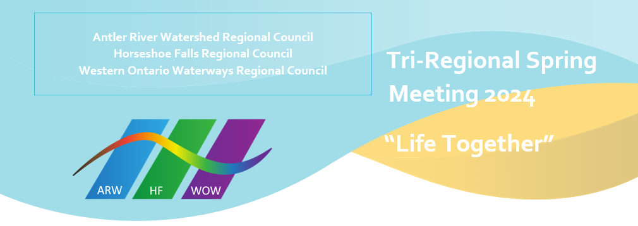DRAFT AGENDA (Subject to change)
Friday May 24: Plenary
2 PM: Welcome
Worship/Covenanting with Executive Minister
Speakers
- Tanya Cameron, Vocational Minister/Tim Hackborn, Office of Vocation Minister - Indigenous Church
- Brenna Baker, Community of Faith Stewardship Support
- Greg Smith-Young, Growth Animator
Introduction of DLMs
Speakers
- Kindred Works
- Tim Hackborn, Martha Pedoniquotte, Community Capacity Development Coordinator (CCDC) – Indigenous Ministries & Justice Unit, Micol Cottrell, Minister Pastoral Relations, Lynne Allin, ARW/HF Minister Congregational Support, John Neff, WOW Minister Congregational Support
5:30-7:30 PM: Dinner
7:30 PM: The Moderator
8:30 PM: Vespers

Saturday May 25
7:30-9 AM: Breakfast
9 AM: Regional Council
Proposal 1 Opening and Procedural Motion
Proposal 2 GC45 Commissioners Slate
10:30 AM: Break
10:50 AM: Plenary
Worship
Introduction of Candidates and Candidates Address the Court
11:20 AM: Plenary
The Moderator and Presentation of Gift to the Moderator
NOON- 2 PM: Lunch (Celebration of Ministries Service rehearsal for those involved Noon-12:30 PM)
2:30 PM: Celebration of Ministries Service
Possible free time following service
5:30-7:30 PM: Dinner
7:30 PM: Regional Council
- President Elect Nominees speeches
- Proposal 3 Executive/Commissions Slate
- Visit from the Moderator

Sunday May 26
7:30-9 AM: Breakfast
9-10:00 AM: Regional Council
- Election of President Elect
- Regional Council Evaluation: Update on regional council follow-up
- New & Unfinished Business
- Proposal 4 Closing Motion
10:00 AM: Break
10:15 AM: Plenary
Worship, honouring In Memoriam, Community of Faith Life Cycle changes, Retirees, Jubilands
Message: Rev. Mark Laird
Noon-12:30 PM: Closing, pick up bagged lunch

