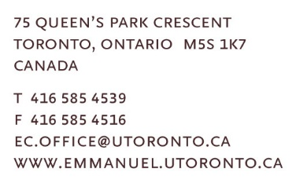
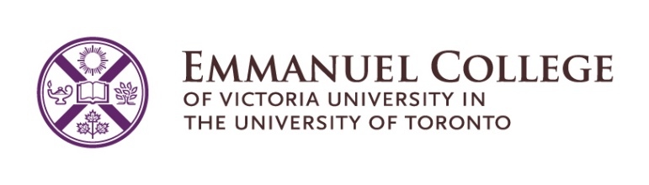

Spring 2024

Dear Friends:

On behalf of Emmanuel College, I want to bring greetings to your region as you meet this spring season. I pray that your meeting goes well and that you experience God’s presence and blessing in this important work of the church. My name is HyeRan Kim-Cragg and it is my privilege to bring you greetings as Emmanuel’s Principal. I hope to see you in person in the near future and share good news of Emmanuel College with you and hear good news of this region’s wonderful ministry.

Faculty Compliment, Trauma Informed Pedagogy & Faculty on the Road
Last year, we completed three significant faculty searches, marking historical milestones for the Toronto School of Theology (TST) of which we are a part. Rev. Dr. Glenn McCullough joined as assistant professor through a partnership with Knox, a first in TST's history. Dr. Jenny Bright became Emmanuel's first assistant professor of Buddhist Spiritual Care and Counseling. The Right Rev. Dr. Carmen Lansdowne will be appointed as the first assistant professor of United Church of Canada studies at Emmanuel after completing her moderator's role in December 2025. Additionally, Néstor Medina was promoted to associate professor, and Pam McCarroll to full professor, holding the Jane and Geoffrey Martin Chair in Practical Theology.

This academic year, the faculty has engaged training in Trauma Informed Pedagogy (TIP), with monthly discussions involving faculty, staff, and Research Fellows. TIP emerged from student discussions in response to our EDIA stance, “DEAR” (Dignity, Equity Accountability, Responsibility) Declaration, and has been supported by grants from the Wabash Center and the Association of Theological Schools. We plan to host a TST-wide conference in May 2024 to share our insights and impact other theological schools.

The current faculty is keen to go out into different communities of faith to promote Emmanuel and share their scholarship and wisdom. Andrew Aitchison as Admissions Counsellor and Recruitment Coordinator will be a liaison connecting faculty with communities. Please let him know if your communities want to invite our Christian, Muslim or Buddhist faculty. That would be so wonderful.

The Indigenous Healing Garden Project
This project, which aligns beautifully with Victoria University’s sustainability strategic framework and Emmanuel’s commitment to right relations with Indigenous communities, is currently underway, thanks to an initial grant from the United Church Foundation’s Seeds of Hope. Brook McKllroy, the architectural firm, has been commissioned to redesign the courtyard which features the Crucified Woman Sculpture. The proposed designs have
received approval from the project's advisory committee in collaboration with the Indigenous Elder circle. We aim to begin construction this summer and anticipate project completion by 2025, as part of the UCC Centennial celebration.

Major Celebrations at Emmanuel College
In the next few years, there are several significant anniversaries we're eagerly looking forward to celebrating! Firstly, in 2024-2025 we'll be commemorating three remarkable milestones: the 10th anniversary of the Buddhist Focus in our Master of Pastoral Studies (MPS) program, the 15th anniversary of the Muslim Focus in the MPS program, and the grand 100th Anniversary of the United Church of Canada. In 2025-26 we will celebrate 30 years of the Committee on Asian/North American Asian Theologies (CANAAT). Then fast forward to 2027-2028, which promises to be another monumental period, marking the 20th anniversary of the Master of Sacred Music Program and the 100th anniversary of Emmanuel College itself. Stay tuned for more information about these celebrations to come.

I envision our celebrations will incorporate multiple fundraising opportunities to establish scholarships, enriching our offerings and supporting marginalized students. Notable progress has already been made in securing scholarships. We proudly unveiled our first named scholarship for Buddhist students in February 2024. Efforts are underway to establish a Korean Scholarship, with an inaugural fundraising dinner held this past fall, and another planned as a music concert commemorating the 100th birth year of the Right Rev. Dr. Sang Chul Lee on October 26, 2024, at Willowdale Emmanuel United Church. Additionally, a special fundraising event is in the works to establish a scholarship for Queer students, scheduled for November 2 for Drag Show paid event, in collaboration with the Drag and Spirituality Summit, to be held at Emmanuel November 1 to 3, 2024.

Hybrid Master of Divinity Program
Our Hybrid Master of Divinity (MDiv) program began this past year which allows for 2 years of a 3-year MDiv can be done online. We hope this will reach more prospective students outside of the Greater Toronto Area. Read this story about two folks who began the Hybrid MDiv this year.

Multi-faith Spiritual Life
Spiritual and religious activities thrive, in person every week, Tuesday and Wednesday. These sessions are led by Buddhist faculty members, guest religious leaders and our dedicated student Spiritual Life Team (SLT), along with students from Christian worship/preaching and Buddhist ritual courses. This SLT is enrolled in a year-long course for credit called "Worship and Ritual Leadership Practicum." Our Wednesday Spiritual Life Gathering continues to be the heartbeat of our week and alternates between Christian Worship and a Multi-faith Gathering. These gatherings are streamed live on YouTube and are open to the public and all are welcome!

Faith Community Partnerships

Over the past year and a half, we've been fortunate to receive community lunch sponsorships from various Christian, Muslim, and Buddhist faith communities. They've joined us at Emmanuel to share food, stories, and teachings about their faith traditions while learning from our students about their interfaith experiences. Addressing food insecurity is crucial today, and providing meals to our students in this manner has been a great blessing. If your church is interested in partnering with Emmanuel, please be in touch!

Financial Support
Emmanuel College continues to provide significant financial support to students. Through the John W. Billes Fund, Emmanuel continues to provide 100% of tuition coverage to all domestic students who are registered full-time in the M.Div. program and who are engaged in The United Church of Canada’s candidacy pathway process. All basic degree domestic full-time students are eligible for our Entering Theological Education grant, which offers 50% tuition coverage to their first year courses. We also offer all (domestic and international) students who are registered in the Ph. D. program, 100% tuition coverage for four years. For more information about studying at Emmanuel College and about the financial support available for all Emmanuel programs, whether one is studying full-time or part-time, please contact Andrew Aitchison, emmanuel.admissions@utoronto.ca.

Emmanuel is offering an increasing number of Continuing Education events online. These events are offered through the Centre for Religion and Its Contexts (CRIC). A list of upcoming offerings are found on the Emmanuel College website. For further information about these events please contact Shawn Kazubowski-Houston: ec.events@utoronto.ca.

Please follow us on social media:
Facebook: @EmmanuelCollegeofVic
Instagram: @emmanuelcollegetoronto
YouTube: @EmmanuelCollege1

If you have questions or are seeking further information about Emmanuel College, please be in touch with us or explore Emmanuel: http://bit.ly/exploremmanuel.

Yours sincerely,

Rev. Dr. HyeRan Kim-Cragg,
Principal
Timothy Eaton Memorial Church Professor of Preaching
Emmanuel College

