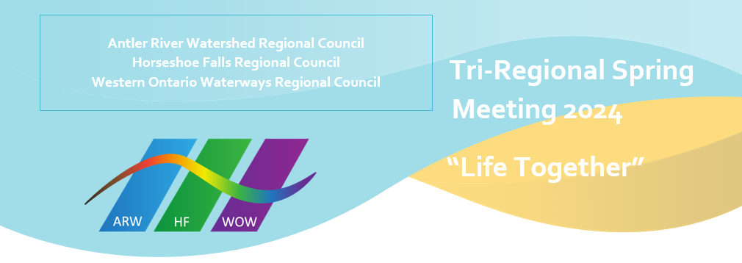
Community of Faith Life Cycle Changes

Antler River Watershed Regional Council
With thanks for their legacy and faithful service
Disbanded Congregations
Belle River United Church, disbanding spring 2024 with final worship service October 29, 2023.

Many blessings as these communities of faith continue their ministries together
Amalgamations and Name Changes
Bryanston United Church and Villages United Church, Granton amalgamated to form Villages United Church.
Central United Church and Emmanuel United Church amalgamated to form Emmanuel United Church, Windsor.
Kerwood-Bethesda United Church and Strathroy United Church amalgamated to form Strathroy United Church.
Parkhill United Church and Thedford United Church amalgamated to form Ausable United Church.
Zion United Church and Thorndale United Church amalgamated to form Thorndale United Church.

Nesting
Wesley United Church, now nesting with Charing Cross United Church.
Fletcher United Church, now nesting with Merlin United Church.

Horseshoe Falls Regional Council
With thanks for their legacy and faithful service
Disbanded Congregations
Trinity United Church, Thorold
Elcho United Church, Wellandport
People’s Memorial United Church, Ridgeway
Mount Carmel United Church

Many blessings as these communities of faith continue their ministries together
Amalgamation
Binkley United Church, Dundas and St. Mark’s United Church, Dundas

Western Ontario Waterways Regional Council
With thanks for their legacy and faithful service
Disbanded Congregations
Goldstone United Church
Oliphant United Church

Amalgamations and Name Changes
Many blessings as these communities of faith continue their ministries together
Shelburne Primrose Pastoral Charge; Trinity United Church, Shelburne and Primrose United Church to Shelburne Primrose Pastoral Charge; Trinity Primrose United Church
Angus United Church with Grenfel United Church. Now Grenfel United Church.
Parkview United Church, Stratford with Avondale United Church, Stratford. New name Avondale United Church, Stratford.
Walters Falls Pastoral Charge to Temple Hill Pastoral Charge; Temple Hill United Church

