Minutes
Congregational Support Commission
Antler River Watershed Regional Council
OF THE UNITED CHURCH OF CANADA

ARWRC Purpose: Holding and Encouraging Communities of Faith
ARWRC Commitment to be: Affirming, Anti-Racist

August 6, 2025 at 9:00 AM via zoom

Roster: (8) Greg Simpson (OM, Chair), Herb deJong (L), Judith Fayter (OM), Jim Stirling (L), Carey Wagner (DM), Dave Whiting (L), Adam Kilner (OM), Joan Golden (OM)
Staff Support:
Krista Ford, Administrative Support
John Egger, Social Justice Minister
John Neff, Congregational Support Minister

Regrets: Dave Whiting

Welcome and Constitute Meeting – Greg

Land Acknowledgement – Greg

Opening Worship – Adam offered opening worship.

Opening Agreements
- Approval of Agenda:
MOTION by Adam Kilner and Carey Wagner that The Congregational Support Commission of Antler River Watershed Regional Council approve the agenda as circulated.
MOTION CARRIED
- Approval Previous Minutes:
The Minutes of the June 4th 2025 meeting were received for information.
MOTION by Carey Wagner and Herb DeJong that The Congregational Support Commission of Antler River Watershed Regional Council approves the minutes of ARW CSC Draf Minutes 25-06-18.docx as circulated.
MOTION CARRIED

Business Arising
- Watford UC.
There was discussion around the listing price and future rental of the Church space. It was decided that further information is still needed and Greg will reach out and ask for a rep to come to the Sept Meeting to answer questions.
- First UC, St. Thomas
At the June 4th 2025 meeting members of Frist United came to offer information about their plans and needs. There were not enough members for quarum at that meeting to pass any motions. The documents were reviewed and discussed.
MOTION by Carey Wagner and Herb DeJong that The Congregational Support Commission of Antler River Watershead supports the applications for the two loans as stated here. Application to TUCC for 1.2 Million, application to the congregational Development fund for $500,000.
MOTION CARRIED
- Courtright-Sixth Line
Greg read a report from Adam.
MOTION: by Carey Wagner and Judith Fayter that the Congregational Support Commission of Antler River Watershed Regional Council, having reviewed the Financial Viability Worksheet for Courtright-Sixth Line Pastoral Charge, approve their request to hire a minister for 20 hours per week, up to category F or equivalent.
MOTION CARRIED
Joan Golden abstained from the vote
- Update: Avondale UC in Tillsonburg
Greg shared an update to the commission about discussions that are happening in this Community of Faith.
- Trinity on Hale in London
Greg provided update and shared some future plans.
- Confirmation of Email Votes
Westminster United Church, Windsor
MOTION: Jim Stirling/ Adam Kilner that the Congregational Support Commission of Antler River Watershed Regional Council agrees to the sale of certain Real Property, known as Westminster United Church, Windsor, the legal description of which is Plan 609, Lots 93 to 97, City of Windsor, N8X 1S3, Essex County, and the municipal address of which is 1680 Dougall Avenue, Windsor, Ontario, N8X 1S3 to Sukhpreet Singh Garcha the terms of which are as follows:
- the sale price of $910,000 (nine hundred ten thousand dollars)
- deposit of $20,000 (twenty thousand dollars),
- the balance due on a closing date of 30 days from the removal of all conditions.
Carried on June 22.

Consent Docket
- Correspondence
- Pastoral Charge Supervisors (PCSs)
- George Bozanich, as PCS, to Tecumseh UC beginning June 26, 2025
- JE: Ken Jackson to Etonia-Princeton UC beginning June 27, 2025
- JE: Mark Marshall to Hickson UC for one meeting, June 29, 2025
- JN: Joy Cowan to Mount Elgin UC beginning July 29, 2025
- GS: Lynne Dunlop as temporary PCS for St. Paul's UC Tillsonburg on Sept 16, as clergy Rev Karlene Brown Palmer is on vacation.
- Documents received for information
- Budget
- Report from Rep to Executive
- Report from Congregational Support Minister
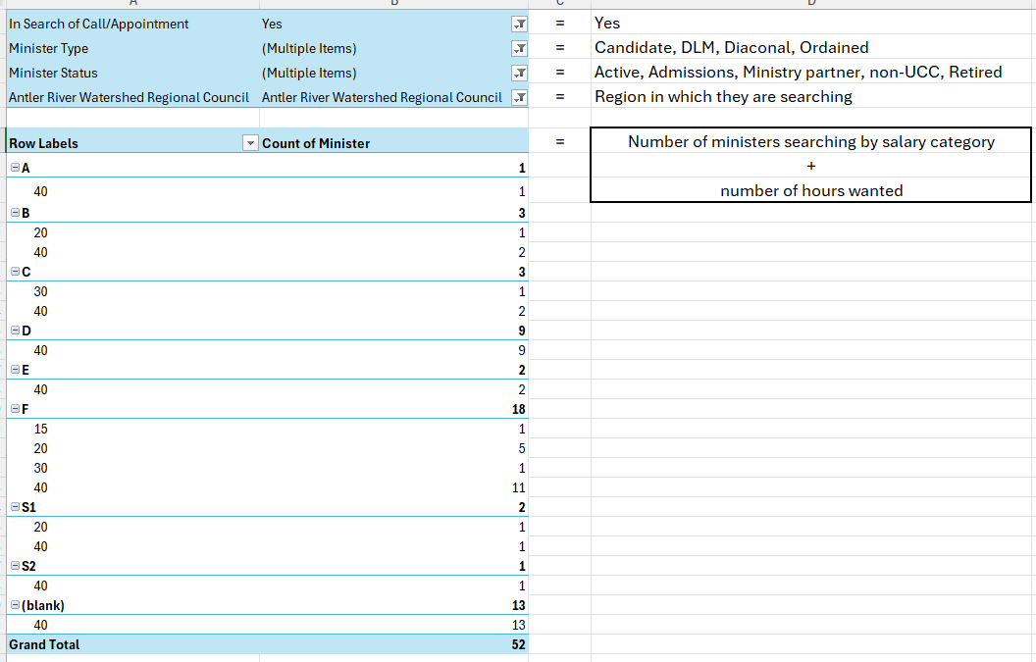

End of Consent Docket
MOTION by Jim Stirling and Carey Wagner that The Congregational Support Commission of Antler River Watershed Regional Council approve the items in the consent docket as circulated.
MOTION CARRIED.

New Business
- Harrietsville-Mossley UC (Belmont, Harrietsville-Mossley Pastoral Charge) Faith Story/Financial Viability
MOTION:by Herb deJong and Carey Wagner that the Congregational Support Commission of Antler River Watershed Regional Council receives the CoF Profile from Harrietsville-Mossley United Church and agrees with the recommendation that Harrietsville-Mossley UC is viable to call/appoint a minister for up to 9 hrs at category D or equivalent.
MOTION has been withdrawn.
The commission needs to receive a Living Faith Storey in order to proceed.
- Belmont UC (Belmont, Harrietsville-Mossley Pastoral Charge) Faith Story/Financial Viability
Same as above the commission will need to receive a Living Faith Storey in order to proceed.
- Melville UC: Governance
MOTION: by Judith Fayter and Jim Stirling that the Congregational Support Commission of Antler River Watershed Regional Council approve the constitution drafted by Melville United Church.
MOTION CARRIED
- Innerkip UC
Nothing further needs to be done with this at this time. They will need to complete the necessary disbanding documents before the commission can pass a motion to officially disband them.
- JE: Corunna UC and Port Lambton UC: Collaboration Agreement
MOTION: by Herb deJong and Jim Stirling that the Congregational Support Commission of Antler River Watershed Regional Council approve the collaborative agreement between Corunna UC & Port Lambton UC from November 1, 2025 to October 31, 2028. (3 years)
MOTION CARRIED

Next Meeting Sept 3rd 2025 at 9:00 am

Adjournment

