Congregational Support Commission
Antler River Watershed Regional Council
of The United Church of Canada
Holding and Encouraging Communities of Faith

Place/Time: 9:00 a.m. Zoom
Roster: (8) Greg Simpson (OM, Chair), Herb deJong (L), Judith Fayter (OM), Jim Stirling (L), Carey Wagner (DM), Dave Whiting (L), Adam Kilner (OM),
Staff Support: Krista Ford, Administrative Support, KFord@united-church.ca
John Neff, Congregational Support Minister JNeff@united-church.ca
John Egger
Guest: Joan Golden (DM)
Regrets: Dave Whiting,

Welcome and Constitute Meeting: Greg Simpson welcomed everyone to the meeting. The meeting was then constituted and opened.

Acknowledging the Land: Territorial lands are acknowledged on behalf of the Congregational Support Commission by Greg Simpson:

Opening Worship: Greg Simpson presented worship.
Approval of Agenda
MOTION by Adam Kilner / Judith Fayter that the agenda be accepted as circulated.
MOTION CARRIED

Consent Docket
Approval of Previous Minutes: Minutes of May 7, 2025, be accepted as circulated
Appointment of Pastoral Charge Supervisors & Companions
Annalee Kerr to Thamesville effective May 12, 2025 to cover a leave
Jim Stirling to Bothwell Wabash effective July 4, 2025
Doug Wright to Ailsa Craig UC effective August 1, 2025
Greg Simpson to Tupperville PC effective May 23, 2025
Richard Golden to Carlisle UC effective August 1, 2025
Richard Golden to Brinsley UC effective August 1, 2025

Annual Reports
The Congregational Support Commission receives the following communities of faith 2024 Annual Reports with thanks:
Courtright-Sixth Line PC

Self-Assessments to be received with thanks:

Community of Faith Profiles to be received with thanks:

--------------------------------------------- End of Consent Docket ---------------------------------------------
MOTION by Carey Wagner / Adam Kilner that the Congregational Support Commission of Antler River Watershed Regional Council approve the consent docket as circulated.
MOTION CARRIED

New Business

Transitions
Richwood UC & St. Paul’s UC, Paris – Collaborative Agreement
MOTION by Herb DeJong/Judith Fayter that the Congregational Support Commission of Antler River Watershed Regional Council approve the collaborative agreement between Richwood UC & St. Paul’s UC, Paris from October 1, 2025 to October 1, 2026.
MOTION CARRIED
There was a request to ask the community of faith to discuss mileage breakdown
Innerkip United Church (Disbursement email)
MOTION by Carey Wagner / Adam Kilner that the Congregational Support Commission of Antler River Watershed Regional Council approve the request from Innerkip United Church to disburse 33% of their assets to the following: Camp Bimini 33%, Operation Sharing 33%, Five Oaks 17% and United Church Account, Canadian Food Grains Bank 17%.
MOTION CARRIED
Update: Princeton UC and Etonia PC Amalgamation (Information Update Pastoral Charge Change..docx)
Statistics update form for information has been sent to GCO
Note change of name for the amalgamated church to be Etonia-Princeton UC, Princeton- Etonia Pastoral Charge
Update: Ausable Pastoral Charge has approved the collaboration agreement with Forest UC and fulfilled the condition of the motion of the CSC approving the agreement on May 7, 2025
Property
Westminster United Church, Windsor (Bloomfield - Opinion, Mcleod - Opinion, Williams - Opinion, Demographics, Financial Viability, Living Faith Story, Property-Resolution, Listing Agreement, Email to Lynne Allin
MOTION by Carey Wagner / Adam Kilner that the Congregational Support Commission of Antler River Watershed Regional Council consent to the request from Westminster United Church, Windsor to the listing for sale of certain Real Property, the legal description of which is Plan 609, Lots 93 to 97, City of Windsor, N8X 1S3, Essex County, and the municipal address of which is 1680 Dougall Avenue, Windsor, Ontario, N8X 1S3, pursuant to an agreement between the Trustees of Westminster United Church, a congregation of the United Church of Canada, as Seller, and Realtor Mark Bloomfield, of Royal-LePage Binder Realty, as Broker, dated the 14th day of May, 2025, and subject to regional council approval, the terms of which are as follows:
Mark Bloomfield, Broker, Royal-LePage Binder at the commission rate of 4 (four) percent,
Asking price $999,999
Net proceeds from the sale to be invested in a restricted fund with interest available to the congregation and access to the principal requiring ARW Regional Council consent.
MOTION CARRIED
Congregation is planning to disband at this point but no formal request yet. Will need someone to be in touch with them.
London: Mount Zion UC – Bridge Loan Request
MOTION: Jim Stirling / Adam Kilner that the Congregational Support Commission of Antler River Watershed Regional Council agree with the Bridge Loan request from Mount Zion UC, London in the amount of $30,000.
MOTION CARRIED
Watford UC – Listing of Property (email, Letter to CSC, Sale info, Letter of Opinion 1, Letter of Opinion 2, Letter of Opinion 3)
MOTION: Carey Wagner /Adam Kilner that the Congregational Support Commission of Antler River Watershed Regional Council agree in principle to the listing of Watford UC property for the purposes of redevelopment. Market value listing price to be approved by Congregational Support Commission (CSC) prior to sale request.

MOTION CARRIED

DISCUSSED confidential property sale.
Community of Faith Profile
Courtright-Sixth Line PC (Financial Viability, Annual Report, Proposed Budget, Email, position description)
MOTION by Jim Stirling / Herb deJong that the Congregational Support Commission of Antler River Watershed Regional Council having reviewed the Financial Viability Worksheet for Courtright-Sixth Line Pastoral Charge approve their request to hire a minister for 20 hours per week, up to category F or equivalent.
MOTION VOTED DOWN
Adam Kilner is going to reach out to Courtright-Sixth Line for further discussion.

Other Business
DSM Tilbury Property Estimates and motion to approve.
The motion from the Annual Meeting minutes on January 26, 2025: Kathy Misener moved the following motion and seconded by Elaine Blaine, “To have the Darrel S. Moffat Trustees “List for Sale” the property known as Darrel S. Moffat Memorial United Church, 27 Canal Street, Tilbury Ontario. Carried.
MOTION by Carey Wagner / Jim Stirling that the Congregational Support Commission of Antler River Watershed Regional Council approve in principle the listing of the Darrel S. Moffat Memorial United Church, 27 Canal Street, Tilbury Ontario, at market value. Property Resolution to be received by Congregational Support Commission (CSC).
MOTION CARRIED

Executive Report: Greg Simpson
Updated on Trinity United Church, and ongoing matters related to that. Adam Kilner is going to be keeping in touch on the work to be done there as a extension of the commission.
There is a need to recruit new members for the CSC commission.
Congregational Support Minister Report:
The following is a List of CoF that have not sent in statistics. Lynne Allin had emailed everyone on the previous list and reminders have been in the newsletter. Suggestions on how to address? There was conversation that before passing motions for any decisions connected with a Community of Faith this list is checked to see if they have completed their statistics.

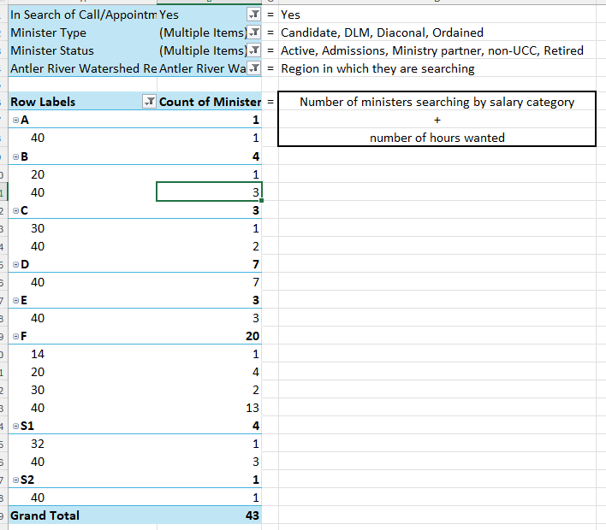

Next Meeting: August 6, 2025 at 9:00 a.m. if necessary otherwise September 3, 2025
Worship by: Name
MOTION that the Congregational Support Commission of Antler River Watershed Regional Council having concluded its business, be adjourned at 10:54 a.m.
MOTION AGREED

