Congregational Support Commission
Antler River Watershed Regional Council
OF THE UNITED CHURCH OF CANADA
Minutes

ARWRC Purpose: Holding and Encouraging Communities of Faith
ARWRC Commitment to be: Affirming, Anti-Racist

Wednesday, January 7th, 2026 at 9:00 AM via Zoom

Roster: (8) Greg Simpson (OM, Chair), Herb deJong (L), Judith Fayter (OM), Jim Stirling (L), Carey Wagner (DM), Dave Whiting (L), Adam Kilner (OM), Joan Golden (DM)
Staff Support: Karlene Kimber, Minister, Congregational Support
Krista Ford, Administrative Support
Regrets:

Welcome and Constitute Meeting

Land Acknowledgement – Greg Simpson offered land acknowledgment

Opening Worship – Greg Simpson opened the meeting with prayer

Opening Motions
Approval of Agenda:
MOTION Adam Kilner and Judith Fayter moved that the Congregational Support Commission of Antler River Watershed Regional Council approves the Agenda as presented.
MOTION CARRIED

Approval Previous Minutes:
MOTION by Jim Stirling and Herb deJong that the Congregational Support Commission of Antler River Watershed Regional Council approves the minutes as circulated.
MOTION CARRIED

Business Arising

Consent Docket
- Correspondence
- Email Votes

- Pastoral Charge Supervisors appointed:

- Pastoral Charge Supervisors needed:
- Dutton: Dunwich United Church 2026-01-01, Rev. Laurie O’Leary
- Reynolds Creek (Putnam) PC 2026-03-01 (*have a maybe)
- London: Trinity Pastoral Charge, 2026-01-06, Rev. Laurie O’Leary

- Pastoral Charge Supervisor reports received:
PCS Report. Bedford PC Windsor.pdf
Camlachie PCS Report.pdf
MoraviantownUC. PCS Report.pdf
Oneida UC.PCS Report.pdf

- Documents and updates received for information:
First United Church Funding Update
First UC Reporting Letter Dec 12 2025.pdf

Mt. Zion (London) Funding Update
Mt Zion UC Reporting Letter Dec 12 2025.pdf
Paid in Full - Promissory Note.pdf

Westminster UC Information for December Disbursements
Disbanding-Information-and-Asset-Disbursement-Calculator(1a).xlsx
statement-9499237-25Nov01.pdf
statement-5727425-25Nov01.pdf
Sale of Westminster UC(1).pdf

White Oaks UC Financial Update
6 month & YTD financials.WOUC.xlsx

Metropolitan United Church London, Congregational minutes confirming congregational support of job posting/financial viability for Cat F, 40 hours, ministry position (we approved pending congregational approval at the Nov 5 2025 CSC meeting)
Congregational Mtg Nov 2025 Rev A.docx

- Budget
- Report from Rep to Executive
- Report from Congregational Support Minister
- Expense Payment Processing
*Important for Commission members and Pastoral Charge Supervisors*
ALL 2025 expenses must be submitted to Krista no later than Jan 7th, 2026, to be properly recorded in the 2025 year and budget.

- Chart for ministers searching in ARWRC:
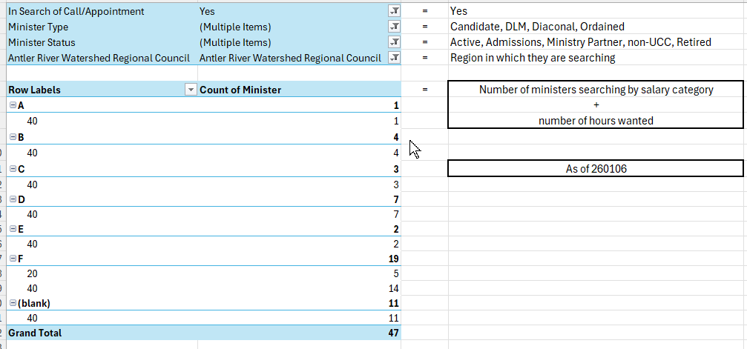
- Report from South Kent Group meetings in November: I met with several churches in the area including: Charing Cross UC/Wesley UC and Merlin UC/Fletcher UC (two different sets of two congregation who have been nesting and are moving towards amalgamation, a member of DSM and the minister (Eric Skillings) re: redevelopment/renewing possibilities, the South Kent are group of churches at their scheduled meeting for sharing news, supporting each other, and connecting about how they might work together in various ways.

End of Consent Docket

MOTION by Judith Fayter and Carey Wagner that the Congregational Support Commission of Antler River Watershed Regional Council approve the consent docket as ​amended​.
MOTION CARRIED

New Business
- Belmont & Harrietsville-Mossley Pastoral Charge This two-point pastoral charge currently has a supply ministry position posted on ChurchHub. This documentation is for a permanent ministry position.

MOTION: Herb deJong and Joan Golden moved that the Congregational Support Commission of Antler River Watershed Regional Council receives the CoF Profiles from Belmont United Church and Harrietsville-Mossley United Church and agrees with the recommendation that the Belmont, Harrietsville-Mossley Pastoral Charge is viable to call/appoint a minister for up to 30 hrs at category D or equivalent.
MOTION CARRIED

- First St. Andrews United Church, London New Governance
MOTION by Carey Wagner and Jim Stirling that the Congregational Support Commission of Antler River Watershed Regional Council supports First St. Andrew’s proposal for Rethinking the governance of First St Andrew’s and the plan to implement in a trial phase until January 2027, pending congregation approval.
MOTION CARRIED
- Merlin-Fletcher Amalgamation document
Karlene met with representatives from Merlin and Fletcher United Church’s leadership in November regarding their questions around amalgamation. Fletcher UC has been nesting with Merlin UC since Fletcher UC sold their building in 2024.

MOTION Judith Fayter and Carey Wagner moved that the Congregational Support Commission of Antler River Watershed Regional Council support the amalgamation agreement between Merlin and Fletcher pending congregational approval.
MOTION CARRIED

- Mount Zion ELC Lease
MOTION by Adam Kilner and Herb DeJong that the Congregational Support Commission of Antler River Watershed Regional Council approves the lease agreement between Mount Zion and Mount Zion ELC.
MOTION Tabled – pending more information and required documents. Karlene to follow up

- Darrel S. Moffat UC Property Evaluations,
The congregation continues to seek support and guidance from the ARWRC CSC regarding the sale of their building as outlined in the December 2025 CSC meeting. They are submitting property valuations for us to review and offer feedback, along with their previous submitted offer of sale.
Greg to reach out with further direction.
6. Roseland Trinity
Greg will reach out to the PCS for Roseland Trinity.

Next Meeting
February 4th, 2026
Joan Golden to do Worship

Adjournment

