Congregational Support Commission:
Community of Faith Profile Preparation



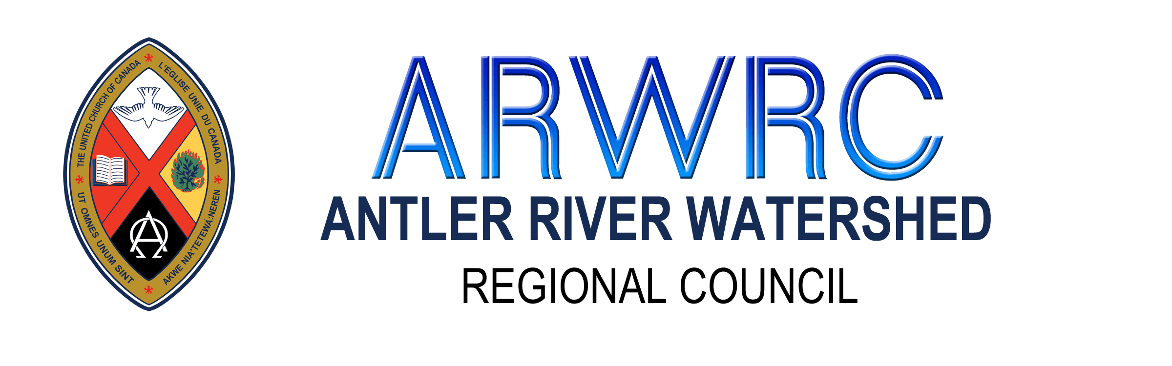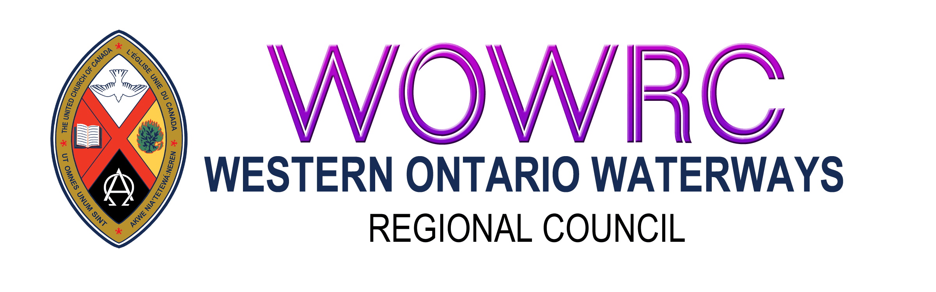

Contents
Community of Faith Profile 2
Financial Viability and Property Review 4
Demographics 6
Living Faith Story 6
Why are we being asked to create a Living Faith Story? 6
What is a Living Faith Story? 6
Submitting the Package 6
Annual Update Submission 7
Search Process Submission 7

Community of Faith Profile
The Community of Faith (CoF) Profile is not just about searching for a new minister. It is about faithful reflection and prayerful discernment about your ministry and community context.
The governing body is responsible for preparing the community of faith profile, updating it yearly and sending it to the Congregational Support Minister (CSM). The purpose of the community of faith profile is:
- to articulate the community of faith’s witness to the gospel;
- to articulate the ministry needs of the community of faith; and
- to summarize the community of faith’s resources and community context.
- is required background for decisions involving regional council.
This work may be divided up in any way that suits the community of faith. The governing body may prepare the profile or appoint a team to prepare the profile, or the whole community of faith may participate in preparing the profile.
In each section of the community of faith profile, honesty is important. Together, the various pieces of the profile express: This is who we are, and these are the resources we have.
A community of faith profile includes:
- financial viability and property worksheet
- demographics worksheet
- living faith story worksheet
The people tasked with creating the profile will want to consult with several groups.
- The community of faith: It is mandatory to consult with the community of faith. The profile should reflect the desires of the community of faith. For consultation with the community of faith, you can choose from a variety of approaches:
- written requests for feedback (e.g., given out with the Sunday bulletin and collected during coffee hour)
- phone interviews
- face-to-face conversations: one large group, small group conversations, or focus groups
- identifying a group of people in your faith community as listeners and asking them to speak with as many people as possible about a specific set of questions or ideas and report back to the team.
- Consult with the current ministry personnel (including an intentional interim minister if you have one), or Pastoral Charge Supervisor. They will often have insight into your community of faith and its current and future needs.
- Ministry and Personnel (M&P) Committee: You may wish to consult with the M&P Committee. Its members will be familiar with your previous ministry personnel and their roles, responsibilities, and leadership.
Try to plan your consultation in such a way that it is easy for everyone to participate, not just people who are already leaders. It is important to hear from everyone: youth, young adults, children, adherents, seniors, people who only attend on Sunday, families who come to the church for all their life passages (weddings, baptisms, funerals) but don’t attend regularly.
In a multi-point pastoral charge each Community of Faith (CoF) will submit a Community of Faith (CoF) Profile independently.

Financial Viability and Property Review
The financial viability and property review continues to summarize the community of faith’s resources. This worksheet will help the Regional Commissions; the governing body and the search team (when searching) consider the financial situation of the community of faith and of each point in a multi-point charge.
It is important to make informed financial decisions. Once you have collected the data, discuss the patterns you see and their implications, and meet at least once with the treasurer to discuss them. Use your observations to make recommendations. If you have completed a narrative budget that is distinct from your living faith story, you can attach it along with your financial viability review.
As you complete the financial viability and property worksheet, the following guidance related to the questions on the worksheet may be helpful:
- Question 1: Your expenses, revenues, and balances can be found for past years in the financial statements of your annual meetings. If you had capital changes, please include them in the comments. The treasurer will appreciate assistance in gathering this information.
  - Total revenue to include: PAR, envelopes, fundraising, other income. Do not include one-time bequests.
- Question 2: Include all investments, funds from the sale of a manse or other church property. Please identify if the amounts are designated (for a specific purpose) or restricted (locally or regionally).
- Question 4: Maintenance is the regular work for keeping your building(s) running. If your building(s) are heated electrically, you probably can’t separate utilities and fuel. Include the one number under Utilities (power & water) on the worksheet.
- Question 5: If you have experienced a deficit, consider the following: How have you managed your finances? Did you borrow from yourselves? From others? If the deficits were in the last three years, what are your plans for turning this situation around? How long has your Community of Faith struggled with deficits?
Question 6: If you have outstanding loans, how much is still owing? To whom? At what interest rate? Does the interest plus the principal exceed 20% of the community of faith’s income? What is the repayment plan?
- Questions 7–11: It is sometimes difficult to remember how contributors donated in past years. Please do your best. Please indicate if you do not track the information. This information is valuable for projecting your future financial resources.
- Questions 12-21: Real Property refers to any land or buildings held in trust. Include the church building, manse, outbuildings, cemetery, and any other land held. This does not include contents.
Review
Your treasurer or stewardship committee, and your governing body should be asked to help look at the data to make observations. Consider the following:
- Patterns seen in donation amounts over the years
- Patterns seen in the community of faith contributors
- Patterns in expenses
- Cost of the building(s)
- Efficiency of your buildings and upgrades that might be needed soon
This tool is part of your community of faith profile and if in search, the pastoral relations process. Consider your staffing costs and ongoing viability. Also consider how this information might inform your Living Faith Story. Other observations might include the need for a stewardship program or property upgrades. If in search, consider how the community’s call of ministry personnel is supported by these financial viability findings.
Recommendation (If for Search Process)
Consider what recommendation(s) you will make about the amount of ministry time (hrs per week) and in what category (A-F). This information must be included for your profile to be complete if you are entering into a search process.
Take into consideration that negotiations may lead to a percentage above the minimum salary. Remember that salary will increase incrementally over time (cost of living and the years of service category). Ensure that the Search team is aware of the upper financial limit the congregation can sustainably support for a minimum of three years.
Please review the following before making your recommendation:
Having examined your current financial situation, you will want to examine the minister’s salary schedule and your Cost of Living Assignment and work with your treasurer to determine the cost of ministry personnel at different increment categories. This will include salary, allowances, and employer contributions to government plans, pension, and benefits. Your treasurer will perhaps understand these tools more clearly than members of the search team:
- The United Church of Canada provides Budgeting Tools for Treasurers on the General Council website for both ministry personnel and lay employees.
- Please note that in addition to the employer costs noted in the tables in these United Church tools, there are employee and employer premiums for Employment Insurance and Canada Pension Plan. (Tables for these costs are available on the Canada Revenue Agency website.
- Please see Toolkit #1 on your regional council website for helpful resources.

Demographics
The demographics worksheet summarizes the community of faith’s resources and context of ministry. It should also be used to help prepare the community of faith’s living faith story.

Living Faith Story

Why are we being asked to create a Living Faith Story?
The creation of a Living Faith Story can be a spiritual practice for the community of faith as it reflects on its ministry, call/purpose (values, goals), and faithful witness to the Gospel. It is an intentional way of engaging communities of faith in articulating their purpose and faith. The Living Faith Story provides an opportunity ask questions about how communities of faith understand their ministry. Creating a Living Faith Story is an invitation to articulate, assess, and perhaps even reframe how we are being church.

What is a Living Faith Story?
The Living Faith Story articulates the community of faith’s ministry focus. The Living Faith Story is your opportunity to share why you exist as a community of faith. All communities of faith are expected to develop a Living Faith Story, review it annually, and share it with the regional council so that support can be programmed. The Living Faith Story is an opportunity to tell a story about where God is leading the community of faith.
Ask the “WHY” questions
Why do we gather as a community of faith?
Why am I a participant in the life and ministry of this community of faith?
Why does God’s purpose need our community of faith?

The Financial & Property and Demographic worksheets are part of the information gathering to understand the bigger picture of your community of faith and community context. These worksheets help inform the Living Faith Story and assist the region in determining needed supports. The creation of a Living Faith Story is an invitation for your community of faith to engage intentionally in conversations about your call/purpose, vision, goals, ministry, and context.
The Living Faith Story can be supplemented with an audio or video recording of the community of faith telling their story or other visioning reports. Remember, if you are entering a search, this is what ministry personnel will look at to determine if you are a good fit.

Submitting the Package

Annual Update Submission
- Once the governing body gathers all the information and agrees on its content, it is approved by the governing body and submitted to the regional Congregational Support Minister (ARWCSM, HFCSM, WOWCSM).
  - All the documents will be received for information by the Congregational Support Commission.

Search Process Submission
- The governing body approves to bring the Community of Faith (CoF) Profile to the congregation.
- The Congregation approves the Community of Faith (CoF) Profile.
  - The motion to be approved by the congregation should include approval of the Community of Faith Profile and the recommendation of the hours and category for the ministry position.
(e.g.) MOTION: ____ / ____ that ____________ United Church, approves the Community of Faith Profile and agrees _____ United Church is viable to call/appoint a minister up to Category (A-F) ____ for ___ hours per week or equivalent.
- The community of faith emails all the information to the Regional Congregational Support Minister (ARWCSM, HFCSM, WOWCSM) and uploads the worksheets to the published folder in ChurchHub (This cannot be seen by other churches).
  - All documentation will be forwarded to the Commissions to be reviewed and the recommendation approved.
  - When copying the information to ChurchHub, consider including hyperlinks to the documents you have stored in ChurchHub published folder.

