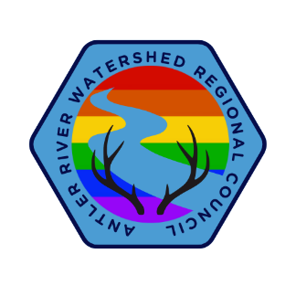
President’s Message - Connections
Welcome to this Hybrid In-person, Spring, Joint Meeting with Horseshoe Falls! Many meetings take place online and provide some means of connecting, but it is these in-person gatherings which allow us to truly connect with one another. This is a special meeting in that we are gathering with Horseshoe Falls Regional Council. We share many staff members with them, so it makes sense to reduce the number of gatherings.
Instead of having a Western Ontario Waterways Region, Horseshoe Falls Region and Antler River Watershed Region Spring Meeting we are joining together on a rotational basis. What a great way to increase our connections with one another. This meeting is also special in that we celebrate several individuals who are joining or continuing their work with the church through ministry.
Additionally, we welcome our current Moderator, the Right Reverend Dr. Kimberly Heath to our gathering and we look forward to hearing from her throughout the weekend. As well, we get to elect the next President of our Regional Council. The opportunity to serve is always on the table, but here we have the chance to deepen your understanding of the operations of the broader United Church through submitting an Expression of Interest and joining one of our Commissions: Discipleship & Justice, Congregational Support or Pastoral Relations or by putting your name forth for President.
The church is changing, but the people are still people. Take the time this weekend to connect or reconnect with individuals from across the Regions. Welcome and enjoy our time together.

Richard Auckland
President, Antler River Watershed Regional Council
of The United Church of Canada

