Congregational Support Commission
Antler River Watershed Regional Council
OF THE UNITED CHURCH OF CANADA
Minutes

ARWRC Purpose: Holding and Encouraging Communities of Faith
ARWRC Commitment to be: Affirming, Anti-Racist

Wednesday, February 4th, 2026 at 9:00 AM via zoom
Roster: (8) Greg Simpson (OM, Chair), Herb deJong (L), Judith Fayter (OM), Jim Stirling (L), Carey Wagner (DM), Dave Whiting (L), Adam Kilner (OM), Joan Golden (DM)

Staff Support: Karlene Kimber, Minister, Congregational Support
Krista Ford, Administrative Support

Regrets: Jim Stirling, Carey Wagner

Welcome and Constitute Meeting - Greg Simpson opened and constituted the meeting

Land Acknowledgement - Greg Simpson offered a land acknowledgment.

Opening Worship Joan Golden offered an opening worship about Candlemass.

Opening Motions
Approval of Agenda:
MOTION by Herb deJong and Judith Fayter that the Congregational Support Commission of Antler River Watershed Regional Council approves the Agenda as presented.
MOTION CARRIED

Approval Previous Minutes:
MOTION by Joan Golden and Judith Fayter that the Congregational Support Commission of Antler River Watershed Regional Council approves the minutes of the Jan 7th 2026 meeting.
MOTION CARRIED

Business Arising
Guest: Richard Auckland from St. Thomas: First United Church joined the meeting at 9:15 and presented and update about the ongoing project at the church and related financial matters.
Consent Docket
- Correspondence:

- Email Votes: (none)

- Pastoral Charge Supervisors appointed:
  - Tupperville PC, 2026-01-07, Rev. Carey Wagner
  - Avon-Putnam PC (Reynolds Creek UC), 2026-03-01, Rev. Joy Cowan
  - Watford Warwick PC & Wyoming PC, 2026-02-01, Rev. Carey Wagner

- Pastoral Charge Supervisors needed:
- London: Metropolitan PC, 2026-05-01

- Pastoral Charge Supervisor updated information received:
- Lillian Rowe

- Documents and updates received for information:
Melville and Ilderton United Churches
Minutes from Congregational Meetings to approve new Shared Ministry Agreement between Ilderton and Melville United Churches and signed Shared Ministry Agreement (agreement approved, pending congregational approvals at 11-05-2025 CSC meeting)

2025 11 02 Ild UC Congregational Mtg Minutes.pdf
2025 11 04 Melville UC - Ilderton UC Executed Shared Ministry Agreement(1).pdf
Melville United Church Congregational Meeting - November 2_ 2025.pdf

- 2026 - ARW CSC Budget.xlsx
*Please note, change in mileage rate for 2026 to $.60/km

- Report from Rep to Executive

- Report from Congregational Support Minister

Community of Faith Updates:
- Update from London: Trinity United Church and Community Centre
At a congregational meeting on January 26, 2026, Trinity UC voted to disband. They are beginning the work towards this. Trinity had it’s final service on February 1, 2026.

- Update: London: Mount Zion United Church
Mount Zion UC has been waiting for TUCC lawyers to review their lease agreement. They are expected to send in a revised lease agreement and Property Trustee before the March 2026 CSC meeting
- London United Churches Collaboration/Cluster
This group gathered (online) on January 28th 2026, continuing to learn, share and connect for mutual support and strengthening. They plan to meet again in April 2026, in person hosted by Riverside UC.

- Glencoe United Church Shared Ministry Agreement
The Anglicans have reached out to connect and update the Shared ministry Agreement. There is a new priest and a need to review some pieces of the agreement to meet their polity and liturgy requirements. We are in the process of setting up a time to have an initial conversation.

Chart for ministers currently searching in ARWRC:
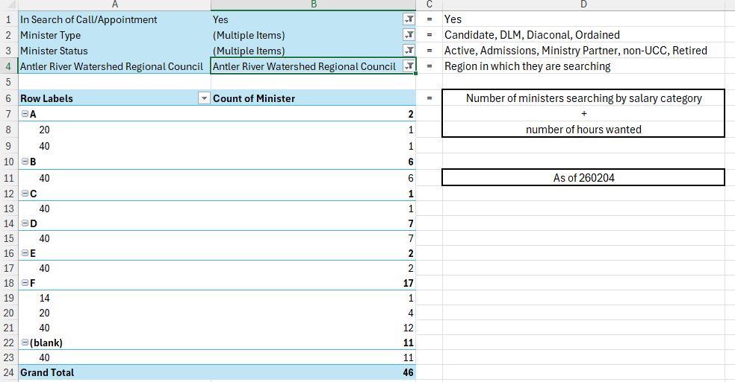

End of Consent Docket
MOTION by ​Adam Kilner and Herb deJong that the Congregational Support Commission of Antler River Watershed Regional Council approve the consent docket as ​circulated.
MOTION CARRIED

New Business
- St. Thomas First United Church
The commission discussed the circulated documents and information shared by Richard which included a Mortgage Update and Lease Agreement

MOTION by Joan Golden and Adam Kilner that the Congregational Support Commission of Antler River Watershed Regional Council approves the lease agreement between St: Thomas: First United Church and First Place Early Learning Centre INC..
MOTION CARRIED

The commission also discussed property renovations as shared by Richard and circulated documents.

MOTION by Judith Fayter and Dave Whiting that the Congregational Support Commission of Antler River Watershed Regional Council approve the proposed electrical (up to $100,000) and elevator upgrades (up to $ 250,000) proposed by St: Thomas: First United Church.
MOTION CARRIED

- Carlisle United Church
MOTION by Herb deJong and Adam Kilner that the Congregational Support Commission of Antler River Watershed Regional Council approves Carlisle United Church’s (located in Denfield, ON) request to access restricted funds in the amount of $10,284.13 to cover the cost of the repair of the church basement floor with an epoxy finish.
MOTION CARRIED

- Siloam United Church Property Sale

MOTION by Adam Kilner and Herb deJong that the Congregational Support Commission of Antler River Watershed Regional Council approve the sale of to the sale of 1.07 acres of certain Real Property, the legal description of which is legally described in Schedule A of the Agreement of Purchase and Sale (attached), and the municipal address of which is 1240 Fanshawe Park Road East, London, Ontario, pursuant to an agreement between the Trustees of Siloam United Church, a congregation of The United Church of Canada, as Seller, and Masar Development Inc., as Buyer, dated the 8th day of December, 2025, and subject to regional council approval, the terms of which are as follows:

  - See attached Agreement of Purchase and Sale; in summary
  - Price: $1,160,000 plus $12,500 for number of
approved units greater than 30 units.
  - Total Deposit: $ I00,000
  - Initial Deposit: $10,000 (received)
  - First Closing Date: Six Months from Siloam Waiving its Conditions (Congregation and Antler River Approval) or October 31, 2027 whichever comes first.
  - Remaining Deposit: $90,000 on first closing date
  - Final Closing: No Later than October 31, 2030.
  - Extension Fee: 4.5 % of the amount of outstanding principal owing paid on Anniversary dates (October 31, 2028, 2029, and 2030). Note: extension fees are payable to Siloam United
Church as a condition of the Agreement and do not reduce Principal owing.
  - Agreement is Null and Void if Extension fees are not paid or Buyer or Seller Default.
All proceeds arising from the land sale to be held in trust by the Trustees of Siloam United Church in a restricted fund as per the regional property policy.
The Real Property referred to in the above resolution is within the bounds of Antler River Watershed Regional Council; The said Real Property is held by the Trustees of Siloam United Church, a congregation of The United Church of Canada and part of the Antler River Watershed Pastoral Charge, in trust for Siloam United Church congregation as a part of The United Church of Canada;
MOTION CARRIED

- Sarnia: St. Luke’s
The commission reviewed documents submitted for rethinking Governance, new model proposal. There was no motion made at this time just discussion which Adam Kilner chose to abstain from due to conflict of interest.
- Hebron United
Greg Simpson provided an update since the December meeting, still just discussion and no formal motion or action has been made.
- Disbanding Updates
        - Essex United Church – Windsor
Karlene shared that the final steps of disbanding are in place and a motion should be coming to the commission in March to officially disband them.

        - Innerkip United Church
Karlene shared that some financial matters are hoping to conclude this month and hopefully a motion can be made at the March meeting to officially disband them.

        - Westminster United Church – Windsor
Karlene shared that they are in process and hopefully will be able to officially disband them later in the Spring.

        - Trinity United Church – London
Karlene shared that the congregation has made the decision to officially disband later this year following the sale of the building later this Spring.

....................................................
Next Meeting
Next meeting: March 4th, 2026. 9 am

Adjournment – meeting was adjourned at 10:45 am

